|  |  |
| --- | --- |
|  | MINISTRY OF EDUCATION AND TRAINING |

|  |
| --- |
| **FPT University** |
| Capstone Project Document |
| Develop Linux Driver in Embedded Kit |
| |  |  | | --- | --- | | Group 6 – Embedded System | | | Group Members | Tran Minh Duc – Leader – SE60861  Nguyen Van Tung – Member – 60382  Nguyen Van Tuong – Member – SE60616  Nguyen Huu Tai – Member – 60042 | | Supervisor | Tran Khanh Ninh | | Ext Supervisor | N/A | | Capstone Project Code | LINUXDRIVER | |

Ho Chi Minh City, September 2013

Acknowledgments

We wish to give special thanks to Mr. Tran Khanh Ninh – our mentor of this project.

He was patiently guide us from the beginning of the project and gave us a basic

foundation in design and implementation circuit boards. He proposed some useful and valuable ideas that helped us realize important points of the project.

List of abbreviations and acronyms

Table 1: List of abbreviations and acronyms

|  |  |  |
| --- | --- | --- |
| LIST OF ABBREVIATIONS AND ACRONYMS | | |
| **No** | **Abbreviations and acronyms** | **Definition** |
| 1 | I/O | Input / Output |
| 2 | GPIO | General purpose input output |
| 3 | PC | Personal computer |
| 4 | IPC | Industrial PC |
| 5 | USB | Universal Serial Bus |
| 6 | UART | Universal Asynchronous Receiver/Transmitter |

Contents

Acknowledgments 1

List of abbreviations and acronyms 2

Contents 3

Figures 9

Tables 12

Introduction 14

I. Project information 14

II. Team members 14

III. Project introduction 14

1. Existing Solutions 14

2. Limitation of existing solutions 18

3. Project’s concept 19

4. Project's advantages 21

Software Project Management Plan 22

I. Problem definition 22

1. Name of this capstone project 22

II. Problem abstract 22

III. Problem overview 22

1. The current system 22

2. The proposed system 22

3. The boundary of the system 22

The requirement for embedded kit 22

The requirement for the hardware 23

4. Development environment 23

Hardware environment 23

Software environment 23

III. Project organization 23

1. Software process model 23

2. Roles and responsibilities 24

3. Tools and technique 25

For development 25

For management 25

For communications 26

IV. Project Management Plan 26

1. Task 26

1.1 Initiating and planning 26

1.2 Software requirement analyst 26

1.3 Creating software design document 27

1.4 Coding 27

1.5 Testing 28

1.6 Deployment 28

ARM ROBOT CONTROLLER 29

Software requirement specification (SRS) 29

I. User requirement specification 29

II. Hardware requirements 29

III. Functional requirement 29

1. Communication protocols 29

2. Use case 30

2.1 Edit value 31

2.2 Reset 33

2.3 Load table data list 34

2.4 Edit table data list 36

2.5 Save table data list 38

2.6 Run individually 39

2.7 Run all at once 42

2.8 Run automation 43

2.9 Stop 45

2.10 Help 46

IV. Activity diagram 48

V. Main flow 49

VI. Non-functional requirement 50

Software design description (SDD) 52

I. Design overview 52

II. Hardware description 52

1. AM335x ARM® Cortex-A8 Microprocessor 52

2. BeagleBone black embedded development kit 53

2.1 Overview 53

2.2 Hardware description 53

2.3 Connectivity 53

2.4 Software compatibility 54

2.5 Features 54

2.6 I/O descriptions 55

3. The simulation arm robot 57

4. UART half duplex converted board 58

4.1 IC 7404 60

4.2 IC 74126 61

4.3 IC 74122 61

4.4 The UART half duplex schematic 62

4.5 The UART half duplex layout board 63

Software test document (STD) 64

I. Introduction 64

1. System overview 64

2. Test approach 64

2.1 Test goals 64

2.2 Test type 64

2.3 Test level 64

II. Test plan 64

1. Features to be tested 64

1.1 Manual mode 64

1.2 Automation mode 65

1.3 Game Pad mode 65

2. Features not to be tested 65

3. Test tools and environment 66

3.1 Test tool 66

3.2 Environment 66

III. Test case 67

1. Manual mode 67

2. Automation mode 86

3. Game pad mode 88

IV. Check list 92

1. Check list of validation 92

2. Submit check list 92

V. Others material (if any) (Including append) 92

User's manual 93

I. Installation guide 93

II. User's guide 93

1. Manual tab 93

2. Automation tab 95

2.1 Start 95

2.2 Load data from file to table 96

2.3 Edit value in table 97

2.4 Save data from table to file 98

2.5 Stop 99

3. Game pad tab 100

ARM ROBOT WITH CAMERA CONTROLLER 101

Software requirement specification (SRS) 101

I. User requirement specification 101

II. Hardware requirement 101

III. Functional requirement 102

1. Communication protocol 102

2. System features (use case) 102

2.1 Capture image 103

2.2 Show video 105

2.3 Add new color 106

2.4 Detect item 108

2.5 Get detect object 109

IV. Activity diagram 111

V. Main flow 112

VI. Non-functional requirement 113

Software design description (SDD) 114

I. Design overview 114

II. Hardware description 114

1. AM335x ARM® Cortex-A8 Microprocessor 114

2. BeagleBone black embedded development kit 114

3. The simulation arm robot 114

4. UART half duplex converted board 114

5. USB Web cam – Colorvis ND40 115

Software test document (STD) 116

I. Introduction 116

1. System overview 116

2. Test approach 116

2.1 Test goals 116

2.2 Test type 116

2.3 Test level 116

II. Test plan 116

1. Features to be tested 116

2. Features not to be tested 117

3 Test Tools and Environment 117

3.1. Test tools 117

3.2. Environment 117

III. Test case 118

IV. Check lists 121

1. Check list of Validation 121

2. Submit check list 121

V. Other material (is any) (Including Appended) 121

User's manual 122

I. Installation guide 122

II. User's guide 122

GPIO CONTROLLER 124

Software requirement specification (SRS) 124

I. User requirement specification 124

II. Functional requirement 125

1. System features overview (Use case) 125

1.1 Turn on port 125

1.2 Turn off port 127

1.3 Edit time to open port 128

1.4 Edit time to close port 130

1.5 Set time to change port status 132

2. Sequence diagram 133

2.1 Turn on port 133

2.2 Turn off port 134

2.3 Manage time to change port status 135

III. Activity diagram 136

III. Main flow 137

IV. Non-functional requirement 138

Software design description (SDD) 139

I. Design overview 139

II. Hardware description 139

1. AM335x ARM® Cortex-A8 Microprocessor 139

2. BeagleBone black embedded development kit 139

3. GPIO board 139

3.1 IC 7414 140

3.2 IC ULN2803 141

3.3 IC TLP521-4 142

3.4 RY12W-K 142

3.5 GPIO schematic design 143

3.6 GPIO board layout design 144

Software test document (STD) 145

I. Introduction 145

1. System overview 145

2. Test approach 145

2.1 Test goals 145

2.2 Test type 145

2.3 Test level 145

II. Test plan 145

1. Features to be tested 145

1.1 Manual mode 145

1.2 Automation mode 146

2. Features not to be tested 146

3. Test tools and environment 147

3.1 Test tool 147

3.2 Environment 147

III. Test case 148

1. Manual mode 148

User's manual 190

I. Installation guide 190

II. User's guide 190

1. GPIO controller 190

2. Change port status 191

3. Set time to change port status 192

4. Change time to change port 193

5. Disable time to change port status 194

Reference 195

Figures

Figure 1: Habey BIS-6922 Industrial PC 15

Figure 2: Habey BIS-6650LC Overview 17

Figure 3: Use of embedded kit in phones and tablet PCs 19

Figure 4: The illustration of the use of embedded kit in industrial environment 20

Figure 5: SPIRAL process model 24

Figure 6: Basic control connector 30

Figure 7: Use case diagram 30

Figure 8: Edit value use case diagram 31

Figure 9: Reset use case diagram 33

Figure 10: Load table data list use case diagram 34

Figure 11: Edit table data list use case diagram 36

Figure 12: Save table data list use case diagram 38

Figure 13: Run individually use case diagram 39

Figure 14: Run all at once use case diagram 42

Figure 15: Run automation use case diagram 43

Figure 16: Stop use case diagram 45

Figure 17: Help use case diagram 46

Figure 18: Rotate motor activity diagram 48

Figure 19: Arm Robot main flow chart 50

Figure 20: AM335x ARM® Cortex-A8 microprocessor 52

Figure 21: BeagleBone black overview 53

Figure 22: BeagleBone black features 54

Figure 23: BeagleBone black P8 header 55

Figure 24: BeagleBone black P9 header 56

Figure 25: Dynamixel Servo Motor description 57

Figure 26: The simulation arm robot 58

Figure 27: Retriggerable monostable multivibrator illustration 59

Figure 28: Non-retriggerable monostable multivibrator illustration 59

Figure 29: IC 7404 schematic 60

Figure 30: IC 74126 schematic 61

Figure 31: IC 74122 schematic 61

Figure 32: UART half duplex schematic 62

Figure 33: UART half duplex layout board 63

Figure 34: Arm robot controller installation file 93

Figure 35: Arm robot - Manual user interface 93

Figure 36: Arm robot - Automation user interface - Start 95

Figure 37: Load data user interface 96

Figure 38: Edit value user interface 97

Figure 39: Save data user interface 98

Figure 40: Stop automation user interface 99

Figure 41: Arm robot - Game pad user interface 100

Figure 42: Basic control connector 102

Figure 43: Use case diagrams 103

Figure 44: Capture image use case diagram 103

Figure 45: Show video use case diagram 105

Figure 46: Add new color use case diagram 106

Figure 47: Detect item use case diagram 108

Figure 48: Get detect object use case diagram 109

Figure 49: Detect objects activity diagram 111

Figure 50: Arm Robot automation with camera 112

Figure 51: USB Web cam Colorvis ND40 115

Figure 52: Arm robot with camera controller installation file 122

Figure 53: Arm robot with camera user interface 122

Figure 54: System features overview 125

Figure 55: Turn on port use case diagram 125

Figure 56: Turn off port use case diagram 127

Figure 57: Edit time to open port use case diagram 128

Figure 58: Edit time to close port 130

Figure 59: Set time to change port status 132

Figure 60: Turn on port sequence diagram 133

Figure 61: Turn off port sequence diagram 134

Figure 62: Manage time to change port status sequence diagram 135

Figure 63: GPIO control activity diagram 136

Figure 64: GPIO main flow 137

Figure 65: IC 7414 schematic 140

Figure 66: IC ULN2803 schematic 141

Figure 67: IC TLP521-4 schematic 142

Figure 68: Relay RY12W-K schematic 142

Figure 69: GPIO board schematic 143

Figure 70: GPIO board layout design 144

Figure 71: GPIO controller installation file 190

Figure 72: GPIO user interface 190

Figure 73: Change port status user interface 191

Figure 74: Set time to change port status user interface 192

Figure 75: Change time to change port user interface 193

Figure 76: Enabling setting time user interface 194

Tables

Table 1: List of abbreviations and acronyms 2

Table 2: List of team members 14

Table 3: BIS-6922 Specification 15

Table 4: Habey BIS-6650LC Specification 17

Table 5: Roles and responsibilities 24

Table 6: Task - Initiating and planning 26

Table 7: Task - Software requirement analyst 26

Table 8: Task - Creating software design document 27

Table 9: Task - Coding 27

Table 10: Task - Testing 28

Table 11: Task – Deployment 28

Table 12: Edit value use case specification 31

Table 13: Reset use case specification 33

Table 14: Load table data list use case specification 35

Table 15: Edit table data list use case specification 36

Table 16: Save table data list use case specification 38

Table 17: Run individually use case specification 39

Table 18: Run all at once use case specification 42

Table 19: Run automation use case specification 44

Table 20: Stop use case specification 45

Table 21: Help use case specification 46

Table 22: Manual mode test case 67

Table 23: Automation mode test case 86

Table 24: Game pad mode test case 88

Table 25: Arm robot – Manual user's guide 94

Table 26: Arm robot – Automation user's guide - start 95

Table 27: Load data user's guide 96

Table 28: Edit value user's guide 97

Table 29: Save data user's guide 98

Table 30: Stop automation user's guide 99

Table 31: Arm robot – Game pad user's guide 100

Table 32: Capture image use case specification 104

Table 33: Show video use case specification 105

Table 34: Add new color use case specification 106

Table 35: Detect item use case specification 108

Table 36: Get detect object use case specification 110

Table 37: Detect item test case 118

Table 38: Arm robot with camera – User's guide 123

Table 39: Turn off port use case specification 127

Table 40: Edit time to open Port 129

Table 41: Edit time to close port 130

Table 42: Set time to change port status 132

Table 43: Manual mode test case 148

Table 44: GPIO controller user's guide 191

Table 45: Change port status user's guide 191

Table 46: Set time to change port status user's guide 192

Table 47: Change time to change port user's guide 193

Table 48: Enabling setting time user's guide 194

Introduction

I. Project information

Project name: Design and making some driver boards for Linux development embedded system.

Project code: LINUXDRIVER

Product type: Controller Graphical User Interfaces and Libraries.

Time line: From September 2013 to December 2013

II. Team members

Table 2: List of team members

|  |  |  |  |
| --- | --- | --- | --- |
| Team members | | | |
| No. | Name | Role | Contact |
| 1 | Tran Minh Duc | Leader | Email: [901stt@gmail.com](mailto:901stt@gmail.com) |
| 2 | Nguyen Van Tung | Member | Email: [skyztungnv@gmail.com](mailto:skyztungnv@gmail.com) |
| 3 | Nguyen Ngoc Tuong | Member | Email: [tuongnnse60616@fpt.edu.vn](mailto:tuongnnse60616@fpt.edu.vn) |
| 4 | Nguyen Huu Tai | Member | Email: |

III. Project introduction

1. Existing Solutions

Nowadays, most of industrial companies have used automation robots in their chain productions to increase production rate and reduce the errors occur during making products. The automation robots can work anytime, non-stop, in dangerouse environments, etc.

To control those automation robots, we need an Industrial PC to operate.

An Industrial PC is the computer similar to normal PC, but has some I/O ports (GPIO, UART, SPI, etc) to control mechanics.

*Some existing IPC products:*

Habey BIS-6922 Industrial PC

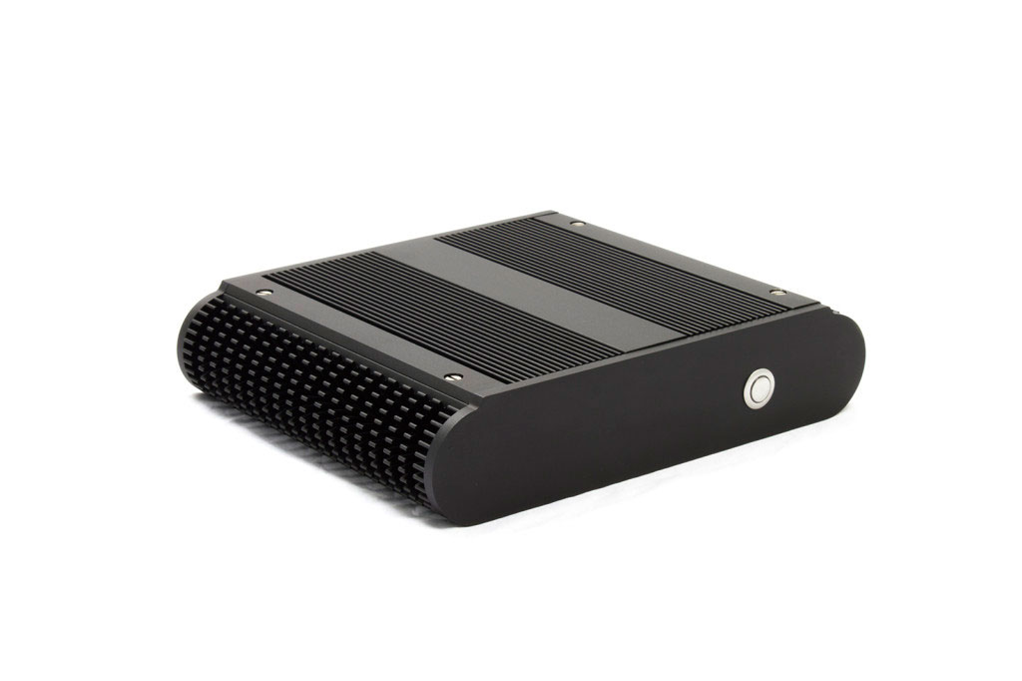Figure 1: Habey BIS-6922 Industrial PC

**Description:**

Table 3: BIS-6922 Specification

|  |  |
| --- | --- |
| BIS-6922 SPECIFICATION | |
| **Essentials** | |
| **Platform Codename** | Ivy Bridge |
| **Board Model** | MITX-6922 |
| **Processor** | Intel 2nd & 3rd Gen. Core i3/i5/i7 (Socket G2 rPGA988) |
| **Chipset** | Intel QM77 |
| **System Memory** | 2x 204-Pin DDR3 SO-DIMM, up to 16GB |
| **Ethernet** | 2x RJ45, Intel 82579LM GbE x1, Intel 82574L GbE x1 |
| **Storage** | 1x 2.5” SATA II/III HDD Bay, 1x mSATA (optional) |
| **Expansion** | 2x mini-PCIe, 1x SIM slot |
| **Cooling System** | Fanless, supports up to 35W TDP CPUs |
| **Power Supply** | 12V DC 2.5mm Power Jack |
| **Graphic** | |
| **Graphic Controller** | Intel Integrated HD Graphics 4000 |
| **Video Memory** | Shared, up to 1686MB |
| **Display Interface** | 1x VGA, 1x DVI-D, 1x HDMI |
| **LCD Interface** | 1x 24bit LVDS Internal Header |
| **Display Resolution** | VGA - 2048 x 1536, DVI-D - 1920 x 1200, HDMI - 1920 x 1200 |
| **I/O** | |
| **Serial Port** | 1x RS-232 DB9, 4x RS-232 and 1x RS-232/422/485 Internal Header |
| **USB** | 4x USB2.0, 4x USB2.0 Internal Header |
| **PS/2 Port** | 1x PS/2 KB/MS Internal Header |
| **Digital I/O** | 16bit GPIO Internal Header |
| **Audio** | HD Audio, Realtek ALC888, Line-out, Line-in, MIC-in |
| **Rear Panel** | 1x VGA, 1x DVI-D, 1x HDMI, 1x COM, 2x RJ45, 4x USB, 3x Audio, 1x 12VDC |
| **Mechanical and Environmental** | |
| **Enclosure Materials** | Aluminum + Steel |
| **Operating Temperature** | 0 ~ 60° C (32 ~ 122° F) |
| **Dimensions** | 245 x 194 x 58 mm (9.65”x 7.68”x 2.17” WxDxH) |
| **Price** | ~ $1500 (Varies depending on customization) |

**Habey** **BIS-6650LC Intel Dual Core Atom D2550™**

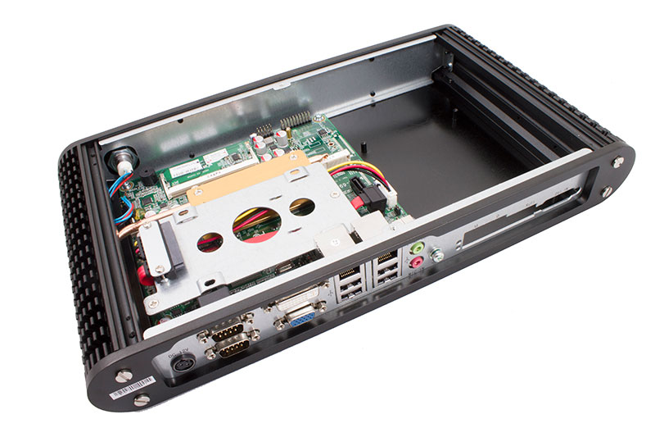Figure 2: Habey BIS-6650LC Overview

**Description:**

Table 4: Habey BIS-6650LC Specification

|  |  |
| --- | --- |
| BIS-6650LC SPECIFICATION | |
| **Essentials** | |
| **Platform Codename** | Cedar Trail |
| **Board Model** | MITX-6936 |
| **Processor** | Intel Atom D2550 |
| **Chipset** | Intel NM 10 |
| **System Memory** | 1x 204-pin DDR3 SODIMM, Up to 4GB |
| **Ethernet** | 2x RJ45, Realtek RTL8111E GbE |
| **Storage** | 1x 2.5” SATA HDD Bay, 1x mSATA (optional) |
| **Expansion** | 2x mini-PCIe, 1x SIM slot |
| **Cooling System** | Fanless |
| **Power Supply** | DC 12V adapter |
| **Graphic** | |
| **Graphic Controller** | Intel integrated GMA3650 |
| **Video Memory** | Shared, up to 384MB |
| **Display Interface** | 1x VGA, 1x DVI-D, 1x HDMI |
| **LCD Interface** | 1x 24bit LVDS Internal Header |
| **Display Resolution** | VGA - 1920x 1200, DVI-D - 1920x 1200 |
| **I/O** | |
| **Serial Port** | 1x RS-232 DB9 and 1x RS-232/422/485 DB9 |
| **USB** | 4x USB2.0 |
| **PS/2 Port** | 1x PS/2 KB/MS Internal Header |
| **Digital I/O** | 8bit GPIO header |
| **Audio** | HD Audio, Realtek ALC887, Line-out, MIC-in |
| **Rear Panel** | 1x VGA, 1x DVI-D, 2x DB9 COM, 2x RJ45, 4x USB, 2x Audio, 1x 12V DC |
| **Mechanical and Environmental** | |
| **Enclosure Materials** | Aluminum + Steel |
| **Operating Temperature** | 0 ~ 60° C (32 ~ 122° F) |
| **Dimensions** | 355x 194x 55mm (14”x 7.63”x 2.17” WxDxH) |
| **Price** | ~ $850 (Varies depending on customization) |

2. Limitation of existing solutions

After having a glance at those Industrial PCs (IPC), we can list some limitations:

* Most of IPC products are very big (leading the spacing, portable problems).
* The price for an IPC is very expensive (in all manner: retail price, addition component price, repair price).
* It is hard to replace the components if the manufacturer does not support those products anymore, so the company must consider to buy a new one.
* Those IPC consume a lot of energy.

To overcome the limitations but still keep the advantages of current IPCs, we choose a new technology.

3. Project’s concept

Currently, most of embedded kits have been used for everyday works (Office, Design) and entertainments (Games, Music, Film, Camera), such as tablet PCs, or smart phones, etc.



Figure 3: Use of embedded kit in phones and tablet PCs

The main purpose of this project is: Applying the embedded kit that has been used for work or entertainment in the industrial environment, replacing the old industrial PCs.

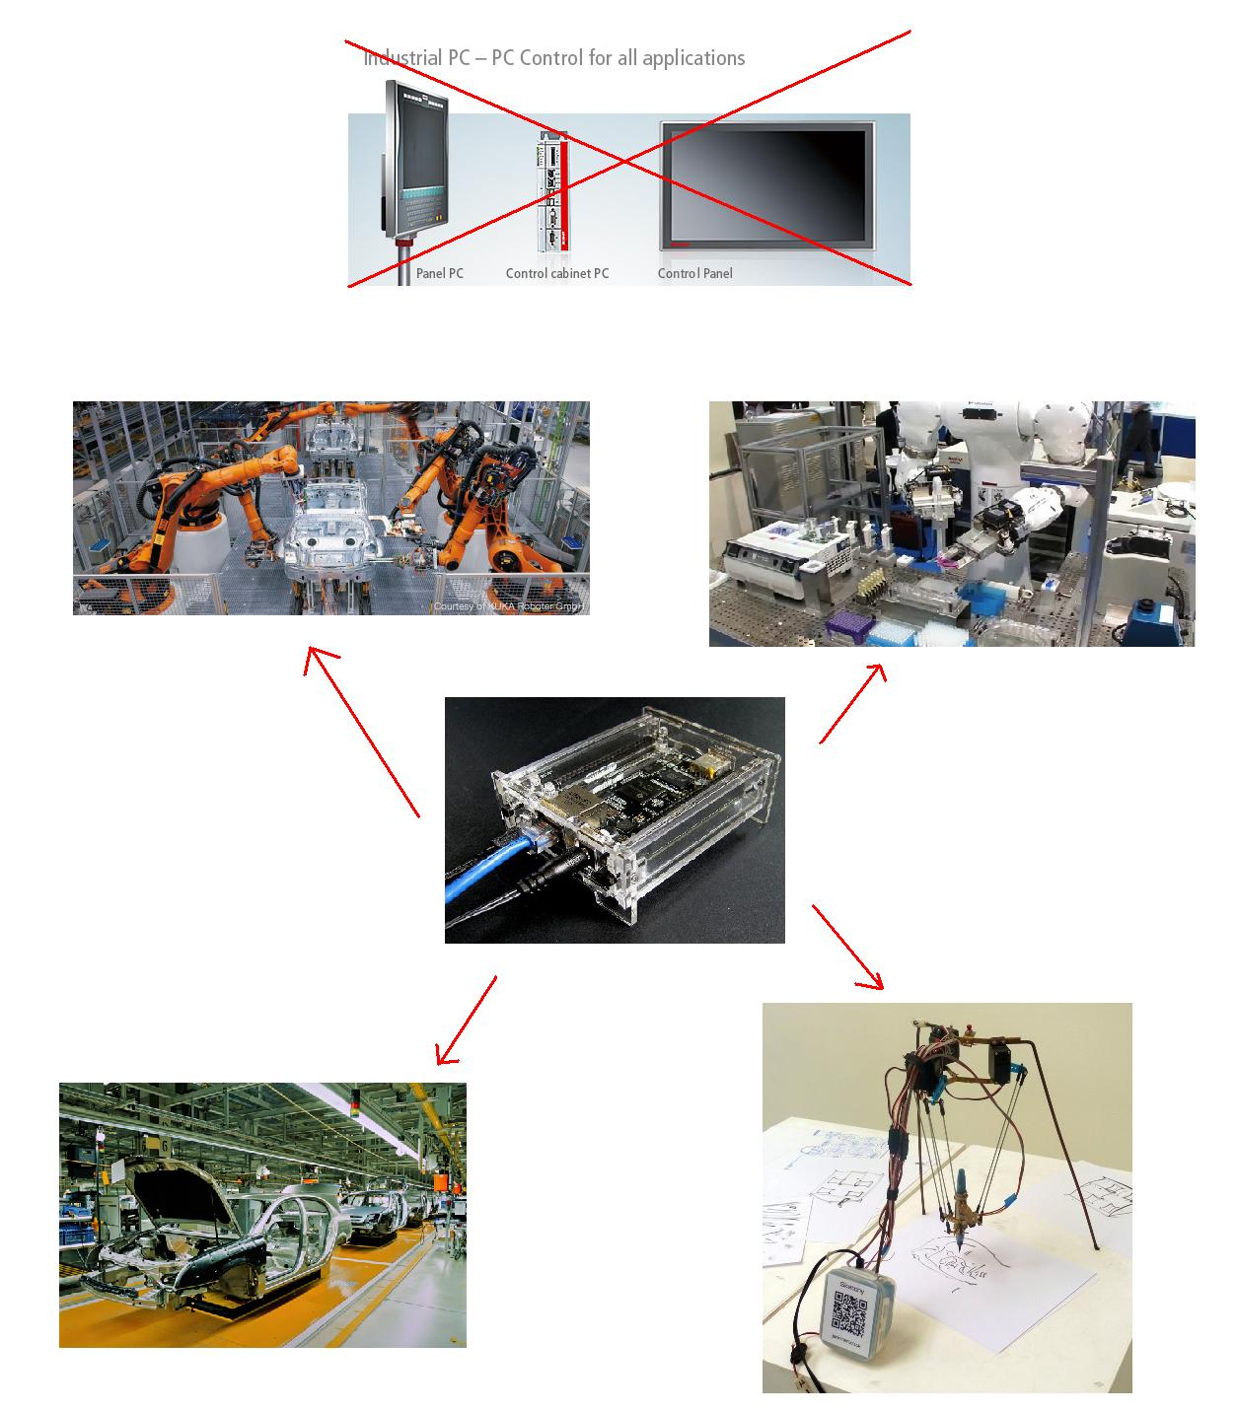Figure 4: The illustration of the use of embedded kit in industrial environment

4. Project's advantages

As the project requirement, the embedded kit must at least have the same functions as the Industrial PC. Moreover, it has advantages those overcome the limitations from the Industrial PC.

* The embedded kits are small, solving the work spacing problems.
* The cost for an embedded kit is cheaper than an Industrial PC in all aspects (retail price, replacement price, repair price)
* The replacement for an embedded kit is easier: just find another embedded kit that has similar functions.
* The energy consumption of an embedded kit is less than an industrial PC's.

Software Project Management Plan

I. Problem definition

1. Name of this capstone project

The official name of this project is: “Develop drivers, libraries, and user interface on Linux embedded operating system environment”.

The project code is: “LINUXDRIVER”

II. Problem abstract

For many decades, a lot of factories or industry corporations have used big computers in there automation works or in chain productions (we call them are Industry Computers). They are very big (not all of them, some are the same size as the Personal Computer (PC)), so it is hard to place in industry chains, hard to replace (some components are unique in some specific computers), expensive to buy, replace, or upgrade, and they consume a lot of energy to run.

III. Problem overview

1. The current system

Most of industry companies are currently using very big computers to control the machine or using for automation jobs. This leads the spacing, and hard to replacing problems.

2. The proposed system

The system will use an existing development kit using ARM microprocessor with Linux operating system support. The main purpose is using that embedded kit to do the jobs that normal industry computer could do.

3. The boundary of the system

Develop both development kit and simulation hardware: the development kit can run with Linux operating system and control the hardware using GPIO or communication interface (UART, USB).

The requirement for embedded kit

* Can run Linux operating system
* Have necessary newest packages.
* Have necessary available pinmuxes to control the hardware.

The requirement for the hardware

* Have been developed with any microcontroller such as PIC, AVR, ARM, etc.
* Have necessary available GPIOs to communicate with the development kit.

4. Development environment

Our team’s product will be the development kit and the simulation hardware. This is developed with following hardware and software environment.

Hardware environment

* Beagle bone Black kit with main line production Linux kernel.
* 4 laptops with appropriate configuration for embedded development.
* The simulation hardware.

Software environment

* Linux.
* Qt library 4.8 and 5.1 series, QtCreator.
* GTK+ version 2 and 3 series.
* Emacs.

III. Project organization

1. Software process model

The process model used for developing this project is Spiral Model.

The spiral model is a software development process combining elements of both design and prototyping-in-stages, in an effort to combine advantages of top-down and bottom-up concepts. Also known as the spiral lifecycle model (or spiral development), it is a systems development method (SDM) used in information technology (IT). This model of development combines the features of the prototyping and the waterfall model. The spiral model is intended for large, expensive and complicated projects.

Figure 5: SPIRAL process model

2. Roles and responsibilities

Table 5: Roles and responsibilities

|  |  |  |  |
| --- | --- | --- | --- |
| Roles and responsibilities | | | |
| **No** | **Name** | **Role** | **Responsibilities** |
| **1** | Tran Minh Duc | Leader | - Prepare development hardware  - Maintain and upgrade drivers and soft wares with main line kernel.  - Specific pinmuxes and GPIOs, and port drivers.  - Develop libraries to easy communicate between users pace program and hardware  (backend)  - Develop GTK  - Create introduce document  - Create software design description document |
| **2** | Nguyen Van Tung | Member | - Design Arm Robot Controller interface  - Develop Qt GUI front-end for Arm Robot Controller  - Design Arm Robot has Camera Controller interface  - Develop Qt GUI front-end for Arm Robot has Camera Controller  - Prepare objects kit  - Design all use case diagrams, sequence diagrams, flow charts for software  - Create software project management plan document  - Create software requirement specification document  - Create software test document  - Create the user’s manual document |
| **3** | Nguyen Ngoc Tuong | Member | - Specific description requirements and develop controller for simulation hardware  - Design GPIO Controller interface  - Develop Qt GUI front-end for GPIO Controller |

3. Tools and technique

For development

Hardware environment:

* Beagle bone Black kit with production Linux kernel.
* 4 laptops with appropriate configuration for embedded development.
* The Simulation hardware.

Software environment:

* Linux.
* Qt library 4.8 and 5.1 series, QtCreator.
* GTK+ version 3.10 series.
* Emacs.

For management

Microsoft Project: Task tracking

Git: Source version control

Bitbucket: Connect, synchronize source code and documents

For communications

Gmail for daily report and meeting minute.

Skype, Yahoo chat system.

IV. Project Management Plan

1. Task

1.1 Initiating and planning

Table 6: Task - Initiating and planning

|  |  |
| --- | --- |
| TASK - INITIATING AND PLANNING | |
| **Description** | Registering project, kick-off meeting and planning |
| **Output** | Registered project, team spirit, overview plan |
| **Deliverable** | Draft project plan |
| **Effort (man-month[1])** | 0.8 mm |
| **Dependencies and Constrains** | N/A |
| **Risks** | Some members may be absent |

1.2 Software requirement analyst

Table 7: Task - Software requirement analyst

|  |  |
| --- | --- |
| TASK - SOFTWARE REQUIREMENT ANALYST | |
| **Description** | Analyzing software requirements based on available embedded system and simulation hardware to create software requirements specification document |
| **Output** | Software Requirement Specification document |
| **Deliverables** | SRS document file |
| **Effort (man-month)** | 1.5 mm |
| **Dependencies and Constrains** | N/A |
| **Risks** | - Lack of knowledge about simulation hardware |

1.3 Creating software design document

Table 8: Task - Creating software design document

|  |  |
| --- | --- |
| TASK - CREATING SOFTWARE DESIGN DOCUMENT | |
| **Description** | Designing the libraries interface to communicate between Linux operating system and simulation hardware based on actual requirements |
| **Output** | Architecture design, circuits diagram, board diagram, algorithms and design specification |
| **Deliverables** | SDD document |
| **Effort (man-month)** | 3.0 mm |
| **Dependencies and Constrains** | Completion of SRS |
| **Risks** | - Choosing inappropriate algorithms and design patterns  - The hardware is hard to maintain  - Causing high coding efforts |

1.4 Coding

Table 9: Task - Coding

|  |  |
| --- | --- |
| TASK - CODING | |
| **Description** | Implementation phase |
| **Output** | Source code |
| **Deliverables** | Source code is successfully loaded into chip  Executable program and source code in embedded system hardware and simulation hardware. |
| **Effort (man-month)** | 8.5 mm |
| **Dependencies and Constrains** | Completion of SRS, SDD |
| **Risks** | - Lack of experience in ES developing  - Hardware‘s limitations and errors  - Working without the lab  - Lack of knowledge to resolve the circuit ‘s errors |

1.5 Testing

Table 10: Task - Testing

|  |  |
| --- | --- |
| TASK - TESTING | |
| **Description** | Creating test case and execute test |
| **Output** | Test plan, test case document, test report, all tested modules and tested system |
| **Deliverables** | Test plan, test report |
| **Effort (man-month)** | 2.2 mm |
| **Dependencies and Constrains** | Completion of SRS, SDD, coding |
| **Risks** | - Lack of professional testers in team  - Unit test may not be performed thoroughly causing spending many efforts in system test phase.  - Hardware ‘s limitations and errors  - ES testing is different with IS testing |

1.6 Deployment

Table 11: Task – Deployment

|  |  |
| --- | --- |
| TASK – DEPLOYMENT | |
| **Description** | Deploying system include : hexapod robot and hexapod controller simulator |
| **Output** | Software packages, user manual |
| **Deliverables** | Software packages, user manual |
| **Effort (man-month)** | 0.3 mm |
| **Dependencies and Constrains** | Completion of all other tasks |
| **Risks** | - Hardware’s errors |

ARM ROBOT CONTROLLER

Software requirement specification (SRS)

I. User requirement specification

* Control via touch screen
* Modify position number for each motor
* Choose the desire position from slider
* Control each motor with different value
* Control all the motors at once
* Load and show the value data table from file
* Edit the value data table
* Save value data table to file
* Run the Arm robot automation with value data from table
* Control the motor with Game Pad key

II. Hardware requirements

The system contains an embedded kit connecting to simulation hardware by UART communication or an USB port.

The simulation Arm robot contains:

* 1 x haft duplex UART connection .
* 7 x serve motor.

III. Functional requirement

1. Communication protocols

N/A

2. Use case

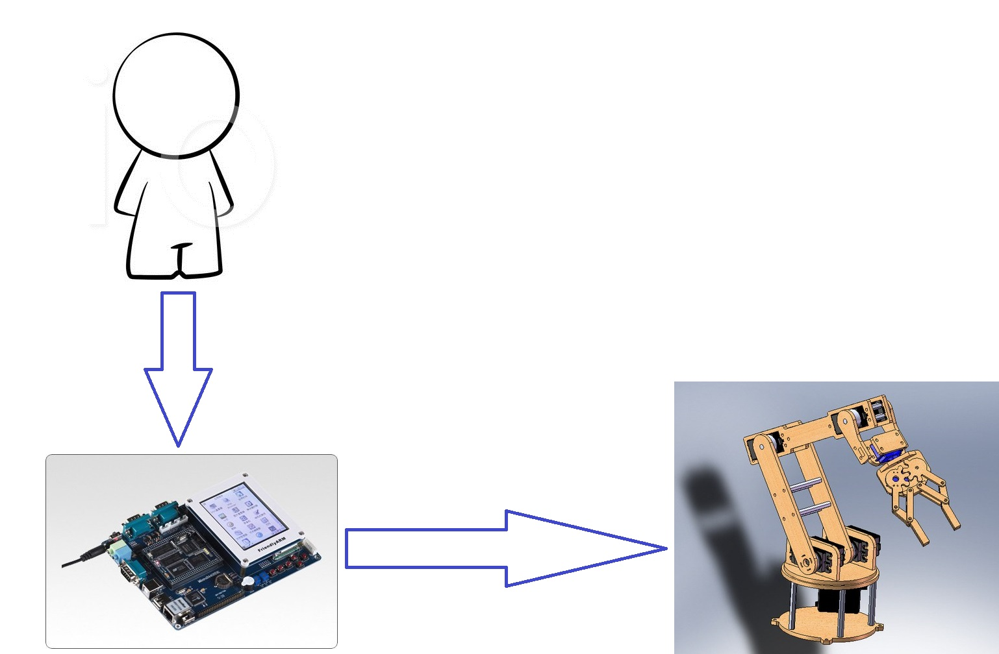Figure 6: Basic control connector

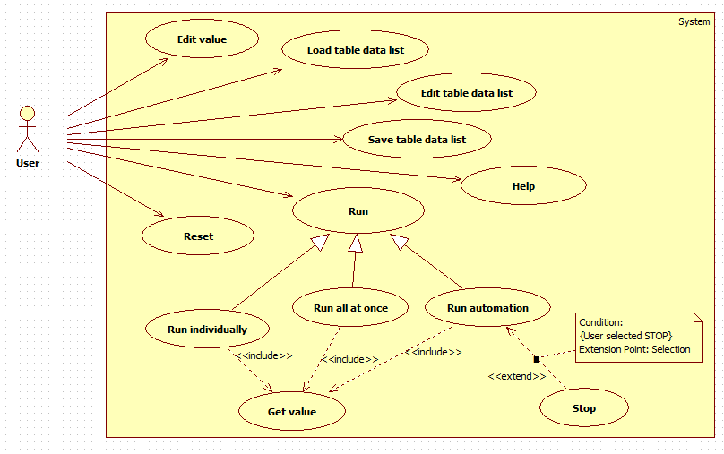Figure 7: Use case diagram

2.1 Edit value

a) Edit value use case diagram

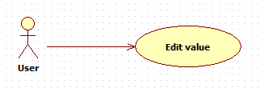Figure 8: Edit value use case diagram

b) Edit value use case specification

Table 12: Edit value use case specification

|  |  |  |  |
| --- | --- | --- | --- |
| EDIT VALUE USE CASE SPECIFICATION | | | |
| **Use-case No.** | UC001 | **Use-case Version** | 1.0 |
| **Use-case Name** | Edit Value | | |
| **Author** | TungNV | | |
| **Date** | 10/10/2013 | **Priority** | Normal |
| **Actor:**  User  **Requirement:**  This use case allows user edit value for each motor  **Goal:**  Value of all motors can edit by user  **Triggers**  User enter new value on value box below each motor to edit  **Preconditions:**  Arm Robot Controller application is opened successfully  Arm Robot and Linux KIT are connected  **Post Conditions:** N/A  **Main Success Scenario:**   |  |  |  | | --- | --- | --- | | **Step** | **Action** | **Result** | | **1** | Enter new value on value box of motor 1 | Value on value box of motor 1 is changed | | **2** | Enter new value on value box of motor 2 | Value on value box of motor 2 is changed | | **3** | Enter new value on value box of motor 3 | Value on value box of motor 3 is changed | | **4** | Enter new value on value box of motor 4 | Value on value box of motor 4 is changed | | **5** | Enter new value on value box of motor 5 | Value on value box of motor 5 is changed |   **Alternative Scenario:**   |  |  |  | | --- | --- | --- | | **Step** | **Action** | **Result** | | **1** | Drag slider of motor 1 | Value on value box of motor 1 is changed | | **2** | Drag slider of motor 2 | Value on value box of motor 2 is changed | | **3** | Drag slider of motor 3 | Value on value box of motor 3 is changed | | **4** | Drag slider of motor 4 | Value on value box of motor 4 is changed | | **5** | Drag slider of motor 5 | Value on value box of motor 5 is changed |   **Exceptions:**   |  |  |  | | --- | --- | --- | | **Exception** | **Action** | **Solution** | | **1** | The input number is out of value | If the input number is smaller than minimum accepting value, input number is change to minimum value automation. If input number is bigger than maximum accepting value, input number is change to maximum value automation. |   **Relationships:**  Edit value use case  **Business Rules:** N/A | | | |
| **Description:**   |  |  |  | | --- | --- | --- | | **Field name** | **Data type And Constraints** | **Required** | | **Value box of motor 1** | Integer | Yes | | **Value box of motor 2** | Integer | Yes | | **Value box of motor 3** | Integer | Yes | | **Value box of motor 4** | Integer | Yes | | **Value box of motor 5** | Integer | Yes | | | | |

2.2 Reset

a) Reset use case diagram

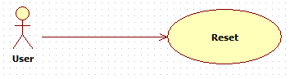Figure 9: Reset use case diagram

b) Reset use case specification

Table 13: Reset use case specification

|  |  |  |  |  |
| --- | --- | --- | --- | --- |
| RESET USE CASE SPECIFICATION | | | | |
| **Use-case No.** | UC002 | **Use-case Version** | | 1.0 |
| **Use-case Name** | Reset | | | |
| **Author** | TungNV | | | |
| **Date** | 10/10/2013 | **Priority** | Normal | |
| **Actor:**  User  **Requirement:**  This use case allows user to reset the Arm Robot same as initial  **Goal:**  The Arm Robot is roll back same as initial  **Triggers**  User use [Reset] button to reset system  **Preconditions:**  Arm Robot Controller application is opened successfully  Arm Robot and Linux KIT are connected  **Post Conditions:**  Current tab of application is “Manual” tab  **Main Success Scenario:**   |  |  |  | | --- | --- | --- | | **Step** | **Action** | **Result** | | **1** | Press [Reset] button on “Manual” tab | The Arm Robot is roll back same as initial |   **Alternative Scenario:** N/A  **Exceptions:** N/A  **Relationships:**  Reset object use case  **Business Rules:** N/A | | | | |
| **Description:** N/A | | | | |

2.3 Load table data list

a) Load table data list use case diagram

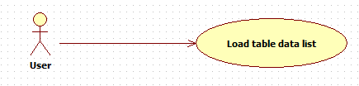Figure 10: Load table data list use case diagram

b) Load table data list use case specification

Table 14: Load table data list use case specification

|  |  |  |  |  |
| --- | --- | --- | --- | --- |
| LOAD TABLE DATA LIST USE CASE SPECIFICATION | | | | |
| **Use-case No.** | UC003 | **Use-case Version** | | 1.0 |
| **Use-case Name** | Load Table Data List | | | |
| **Author** | TungNV | | | |
| **Date** | 10/10/2013 | **Priority** | Normal | |
| **Actor:**  User  **Summary:**  This use case allows user to load file data from memory and display it on table view  **Goal:**  Load file data and show it on table view  **Triggers**  User use [Load File] button, then select file data to load  **Preconditions:**  Arm Robot Controller application is opened successfully  Arm Robot and Linux KIT are connected  **Post Conditions:**  Current tab of application is “Automation” tab  **Main Success Scenario:**   |  |  |  | | --- | --- | --- | | **Step** | **Action** | **Result** | | **1** | Press on [Load File] button | The windows is displayed | | **2** | Select file data and press [Open] button | Data file is loaded and showed on table view |   **Alternative Scenario:** N/A  **Exceptions:** N/A  **Relationships:**  Load table data list use case  **Business Rules:** N/A | | | | |
| **Description:**   |  |  |  | | --- | --- | --- | | **Field name** | **Data type And Constraints** | **Required** | | **Table view** | Integer | Yes | | **File data** | .txt | Yes | | | | | |

2.4 Edit table data list

a) Edit table data list use case diagram

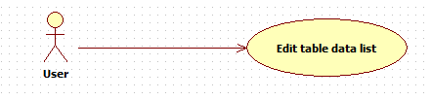Figure 11: Edit table data list use case diagram

b) Edit table data list use case specification

Table 15: Edit table data list use case specification

|  |  |  |  |  |
| --- | --- | --- | --- | --- |
| EDIT TABLE DATA LIST USE CASE SPECIFICATION | | | | |
| **Use-case No.** | UC004 | **Use-case Version** | | 1.0 |
| **Use-case Name** | Edit Table Data List | | | |
| **Author** | TungNV | | | |
| **Date** | 10/10/2013 | **Priority** | Normal | |
| **Actor:**  User  **Summary:**  This use case allows user to edit value on table data list  **Goal:**  Success to edit value on table data list  **Triggers**  User click left mouse on cell want to edit and change the number by an integer number  **Preconditions:**  Arm Robot Controller application is opened successfully  Arm Robot and Linux KIT are connected  Table data list is loaded  **Post Conditions:**  Current tab of application is “Automation” tab  **Main Success Scenario:**   |  |  |  | | --- | --- | --- | | **Step** | **Action** | **Result** | | **1** | Click left mouse on cell want to edit | Table cell is selected | | **2** | Change the current number by an integer number | The value is changed successful |   **Alternative Scenario:** N/A  Exceptions:   |  |  |  | | --- | --- | --- | | **Exception** | **Action** | **Solution** | | **1** | The input number is out of value | If the input number is smaller than minimum accepting value, input number is change to minimum value automation. If input number is bigger than maximum accepting value, input number is change to maximum value automation. |   Relationships:  Edit table data list use case  **Business Rules:** N/A | | | | |
| Description:   |  |  |  | | --- | --- | --- | | **Field name** | **Data type And Constraints** | **Required** | | **Value Data** | Integer | Yes | | | | | |

2.5 Save table data list

a) Save table data list use case diagram

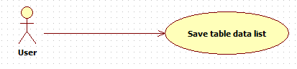Figure 12: Save table data list use case diagram

b) Save table data list use case specification

Table 16: Save table data list use case specification

|  |  |  |  |  |
| --- | --- | --- | --- | --- |
| SAVE TABLE DATA LIST USE CASE SPECIFICATION | | | | |
| **Use-case No.** | UC005 | **Use-case Version** | | 1.0 |
| **Use-case Name** | Save Table Data List | | | |
| **Author** | TungNV | | | |
| **Date** | 10/10/2013 | **Priority** | Normal | |
| **Actor:**  User  **Summary:**  This use case allows user to save table data list to file  **Goal:**  Success to save table data list to file  **Triggers**  User use [Save to File] button, then choose location and enter a name to save  **Preconditions:**  Arm Robot Controller application is opened successfully  Arm Robot and Linux KIT are connected  Table data list is loaded  **Post Conditions:**  Current tab of application is “Automation” tab  **Main Success Scenario:**   |  |  |  | | --- | --- | --- | | **Step** | **Action** | **Result** | | **1** | Press [Save to File] button | The windows explorer is display to save file | | **2** | Enter a name and Press [Save] button | Table data list is saved successful |   **Alternative Scenario:** N/A  **Exceptions:** N/A  **Relationships:**  Save table data list use case  **Business Rules:** N/A | | | | |
| **Description:** N/A | | | | |

2.6 Run individually

a) Run individually use case diagram

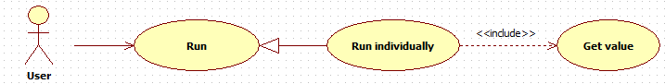Figure 13: Run individually use case diagram

b) Run individually use case specification

Table 17: Run individually use case specification

|  |  |  |  |  |
| --- | --- | --- | --- | --- |
| RUN INDIVIDUALLY USE CASE SPECIFICATION | | | | |
| **Use-case No.** | UC006 | **Use-case Version** | | 1.0 |
| **Use-case Name** | Run Individually | | | |
| **Author** | TungNV | | | |
| **Date** | 10/10/2013 | **Priority** | Normal | |
| **Actor:**  User  **Summary:**  This use case allows user to control each motor at time  **Goal:**  Success to control each motor at time  **Triggers**  Press [OK] button below each motor  Drag slider below each motor  **Preconditions:**  Arm Robot Controller application is opened successfully  Arm Robot and Linux KIT are connected  **Post Conditions:**  Current tab of application is “Manual” tab  **Main Success Scenario:**   |  |  |  | | --- | --- | --- | | **Step** | **Action** | **Result** | | **1** | Change the value on value box below motor 1 to different integer number | Value on value box below motor 1 is changed | | **2** | Press [OK] button below motor 1 | Motor 1 of Arm Robot is rotated to different location | | **3** | Change the value on value box below motor 2 to different integer number | Value on value box below motor 2 is changed | | **4** | Press [OK] button below motor 2 | Motor 2 of Arm Robot is rotated to different location | | **5** | Change the value on value box below motor 3 to different integer number | Value on value box below motor 3 is changed | | **6** | Press [OK] button below motor 3 | Motor 3 of Arm Robot is rotated to different location | | **7** | Change the value on value box below motor 4 to different integer number | Value on value box below motor 4 is changed | | **8** | Press [OK] button below motor 4 | Motor 4 of Arm Robot is rotated to different location | | **9** | Change the value on value box below motor 5 to different integer number | Value on value box below motor 5 is changed | | **10** | Press [OK] button below motor 5 | Motor 5 of Arm Robot is rotated to different location |   **Alternative Scenario:**   |  |  |  | | --- | --- | --- | | **Step** | **Action** | **Result** | | **1** | Drag slider below motor 1 to different location | Motor 1 of Arm Robot is rotated to different location | | **2** | Drag slider below motor 2 to different location | Motor 2 of Arm Robot is rotated to different location | | **3** | Drag slider below motor 3 to different location | Motor 3 of Arm Robot is rotated to different location | | **4** | Drag slider below motor 4 to different location | Motor 4 of Arm Robot is rotated to different location | | **5** | Drag slider below motor 5 to different location | Motor 5 of Arm Robot is rotated to different location |   **Exceptions:**   |  |  |  | | --- | --- | --- | | **Exception** | **Action** | **Solution** | | **1** | The input number is out of value | If the input number is smaller than minimum accepting value, input number is change to minimum value automation. If input number is bigger than maximum accepting value, input number is change to maximum value automation. |   **Relationships:**  Run individually use case  **Business Rules:** N/A | | | | |
| **Description:** N/A | | | | |

2.7 Run all at once

a) Run all at once use case diagram

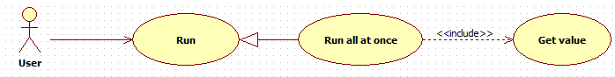Figure 14: Run all at once use case diagram

b) Run all at once use case specification

Table 18: Run all at once use case specification

|  |  |  |  |  |
| --- | --- | --- | --- | --- |
| RUN ALL AT ONCE USE CASE SPECIFICATION | | | | |
| **Use-case No.** | UC006 | **Use-case Version** | | 1.0 |
| **Use-case Name** | Run All At Once | | | |
| **Author** | TungNV | | | |
| **Date** | 10/10/2013 | **Priority** | Normal | |
| **Actor:**  User  **Summary:**  This use case allows user accept to all motor run at once  **Goal:**  Success to make all motor run at once  **Triggers**  Press [Run All At Once] button  **Preconditions:**  Arm Robot Controller application is opened successfully  Arm Robot and Linux KIT are connected  **Post Conditions:**  Current tab of application is “Manual” tab  **Main Success Scenario:**   |  |  |  | | --- | --- | --- | | **Step** | **Action** | **Result** | | **1** | Change the value on value box below all motors to different integer number | Value on value box below all motors is changed | | **2** | Press [Run All At Once] button | All motor is rotated at once |   **Alternative Scenario:** N/A  **Exceptions:**   |  |  |  | | --- | --- | --- | | **Exception** | **Action** | **Solution** | | **1** | The input number is out of value | If the input number is smaller than minimum accepting value, input number is change to minimum value automation. If input number is bigger than maximum accepting value, input number is change to maximum value automation. |   **Relationships:**  Run all at once use case  **Business Rules:** N/A | | | | |
| **Description:** N/A | | | | |

2.8 Run automation

a) Run automation use case diagram

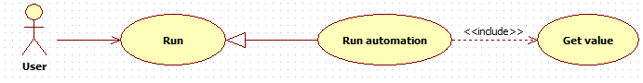Figure 15: Run automation use case diagram

b) Run automation use case specification

Table 19: Run automation use case specification

|  |  |  |  |  |
| --- | --- | --- | --- | --- |
| RUN AUTOMATION USE CASE SPECIFICATION | | | | |
| **Use-case No.** | UC006 | **Use-case Version** | | 1.0 |
| **Use-case Name** | Run Automation | | | |
| **Author** | TungNV | | | |
| **Date** | 10/10/2013 | **Priority** | Normal | |
| **Actor:**  User  **Summary:**  This use case allows user to make the Arm Robot run automation  **Goal:**  Arm Robot is run automation  **Triggers**  Press [Start] button  **Preconditions:**  Arm Robot Controller application is opened successfully  Arm Robot and Linux KIT are connected  Table data list is loaded  **Post Conditions:**  Current tab of application is “Automation” tab  **Main Success Scenario:**   |  |  |  | | --- | --- | --- | | **Step** | **Action** | **Result** | | **1** | Press [Start] button | Arm Robot is run automation |   **Alternative Scenario:** N/A  **Exceptions:** N/A  **Relationships:**  Run automation use case  **Business Rules:** N/A | | | | |
| **Description:** N/A | | | | |

2.9 Stop

a) Stop use case diagram

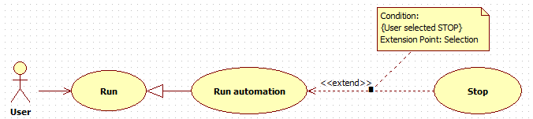Figure 16: Stop use case diagram

b) Stop use case specification

Table 20: Stop use case specification

|  |  |  |  |  |
| --- | --- | --- | --- | --- |
| STOP USE CASE SPECIFICATION | | | | |
| **Use-case No.** | UC006 | **Use-case Version** | | 1.0 |
| **Use-case Name** | Stop | | | |
| **Author** | TungNV | | | |
| **Date** | 10/10/2013 | **Priority** | Normal | |
| **Actor:**  User  **Summary:**  This use case allows user to stop the Arm Robot when Arm Robot running  **Goal:**  Stop the job of Arm Robot  **Triggers**  Press [Stop] button  **Preconditions:**  Arm Robot Controller application is opened successfully  Arm Robot and Linux KIT are connected  Table data list is loaded  Arm Robot is working the automation job  **Post Conditions:**  Current tab of application is “Automation” tab  **Main Success Scenario:**   |  |  |  | | --- | --- | --- | | **Step** | **Action** | **Result** | | **1** | Press [Stop] button | Arm Robot is stopped |   **Alternative Scenario:** N/A  **Exceptions:** N/A  **Relationships:**  Help use case  **Business Rules:** N/A | | | | |
| **Description:** N/A | | | | |

2.10 Help

a) Help use case diagram

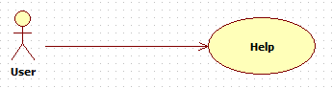Figure 17: Help use case diagram

b) Help use case specification

Table 21: Help use case specification

|  |  |  |  |  |
| --- | --- | --- | --- | --- |
| HELP USE CASE SPECIFICATION | | | | |
| **Use-case No.** | UC006 | **Use-case Version** | | 1.0 |
| **Use-case Name** | Help | | | |
| **Author** | TungNV | | | |
| **Date** | 10/10/2013 | **Priority** | Normal | |
| **Actor:**  User  **Summary:**  This use case allows user to open help tab  **Goal:**  Open the help tab  **Triggers**  Press [Help] button  **Preconditions:**  Arm Robot Controller application is opened successfully  Arm Robot and Linux KIT are connected  **Post Conditions:** N/A  **Main Success Scenario:**   |  |  |  | | --- | --- | --- | | **Step** | **Action** | **Result** | | **1** | Press [Help] button | “Help” tab is opened successful |   **Alternative Scenario:** N/A  **Exceptions:** N/A  **Relationships:**  Help use case  **Business Rules:** N/A | | | | |
| **Description:** N/A | | | | |

IV. Activity diagram

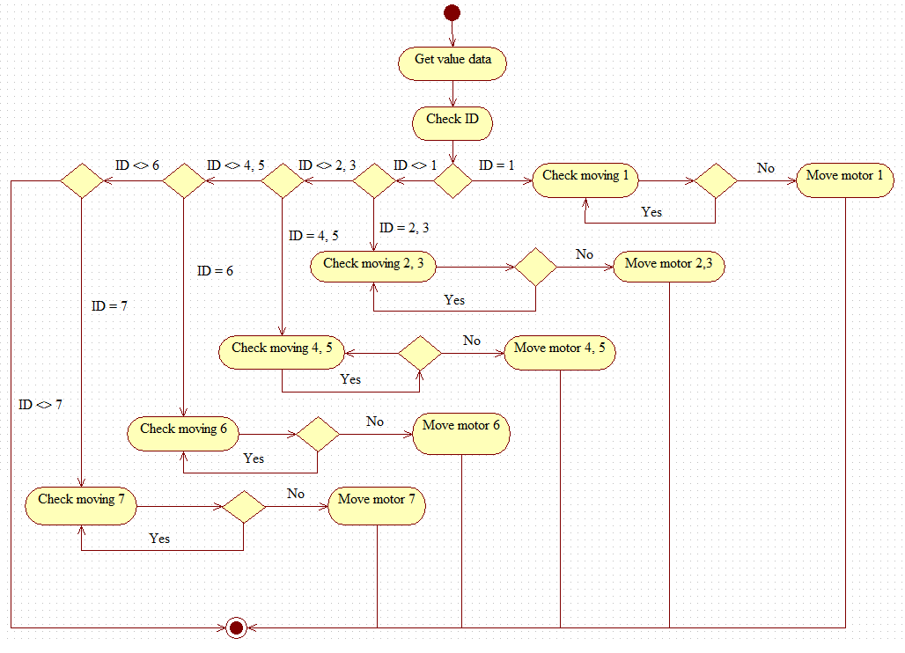Figure 8: Rotate motor activity diagram

V. Main flow

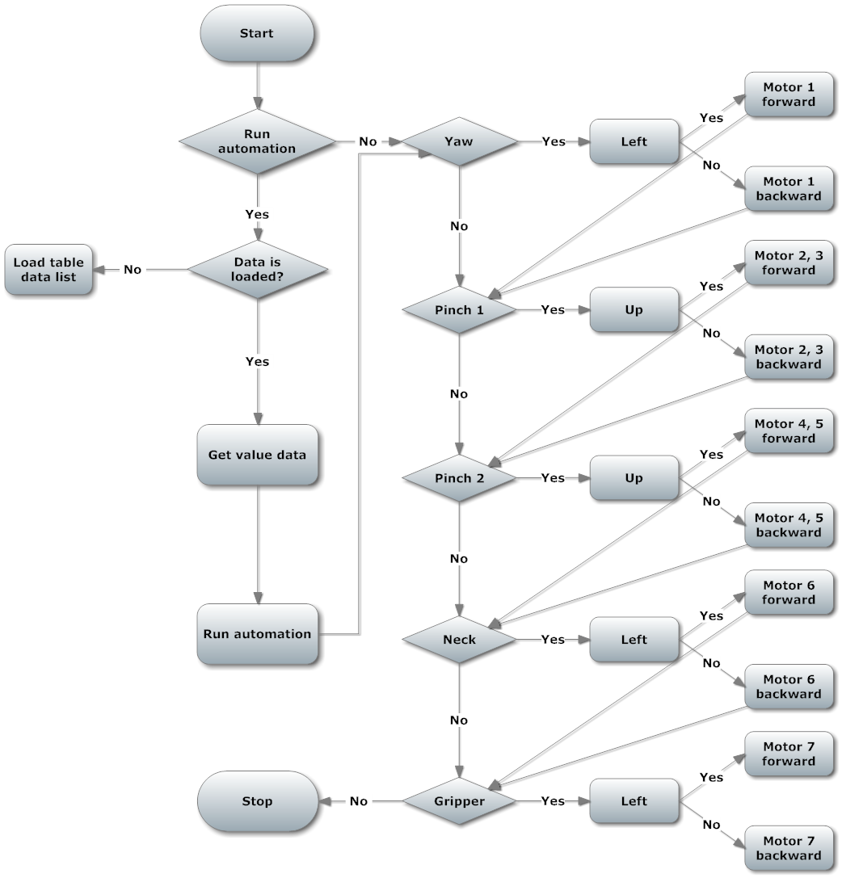Figure 9: Arm Robot main flow chart

VI. Non-functional requirement

Reliability

* All Controller Applications are easily to upgrade firmware.
* All Controller Applications can be replaced easily by loaded into chip if the controller has problem.
* All Controller Applications are guarantee by quality testing in:
  + Stability constraints.
  + Functionality.
  + Reliability.
* It’s mostly depending on hardware reliability.

Availability

* The embedded kit is every where to buy, or can buy ones which have similar function.

Security

N/A

Maintainability

* Easy to upgrade or replace hardware.
* Easy to update software.

Portability

* The embedded kit is small to be moved easily.

Performance

* Arm Robot Controller can control multiple motors at the same time

Software design description (SDD)

I. Design overview

This document describes the technical, board design and UI design of the Linux Driver Controller project. It includes the introduction of AM335x 1Ghz ARM Cortex A-8, BeagleBone Black, Dynamixel Arm Robot. It also includes sequence diagrams of the main use cases and overall design of user interface.

II. Hardware description

1. AM335x ARM® Cortex-A8 Microprocessor

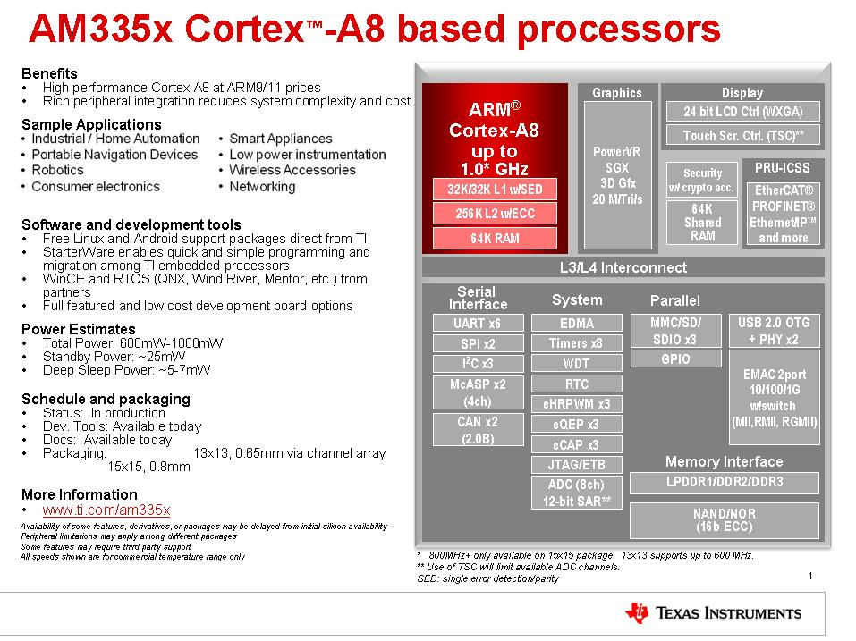Figure 20: AM335x ARM® Cortex-A8 microprocessor

2. BeagleBone black embedded development kit

2.1 Overview

From: <http://beagleboard.org/Products/BeagleBone%20Black>

BeagleBone Black is a $45 MSRP community-supported development platform for developers and hobbyists. Boot Linux in under 10 seconds and get started on development in less than 5 minutes with just a single USB cable.

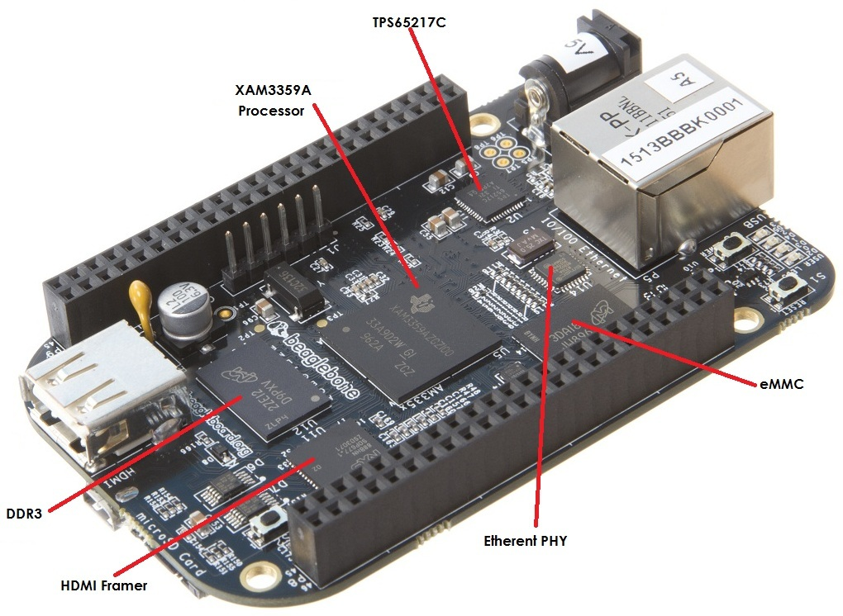Figure 21: BeagleBone black overview

2.2 Hardware description

Microprocessor: 1. AM335x ARM® Cortex-A8 Microprocessor

1. 512MB DDR3 RAM
2. 2GB 8-bit eMMC on-board flash storage
3. 3D graphics accelerator
4. NEON floating-point accelerator
5. 2x PRU 32-bit microcontrollers.

2.3 Connectivity

1. USB client for power & communications
2. USB host
3. Ethernet
4. HDMI
5. 2x 46 pin header

2.4 Software compatibility

1. Ångström Linux
2. Android
3. Ubuntu
4. Cloud9 IDE on Node.js w/ BoneScript library
5. plus much more.

2.5 Features

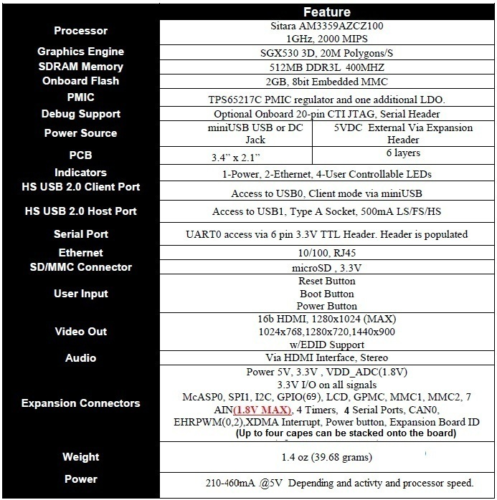Figure 22: BeagleBone black features

2.6 I/O descriptions

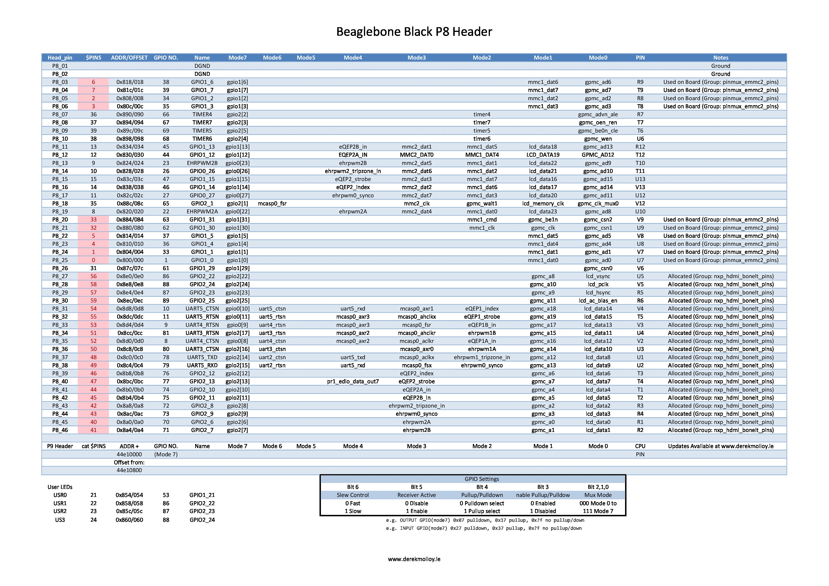Figure 23: BeagleBone black P8 header

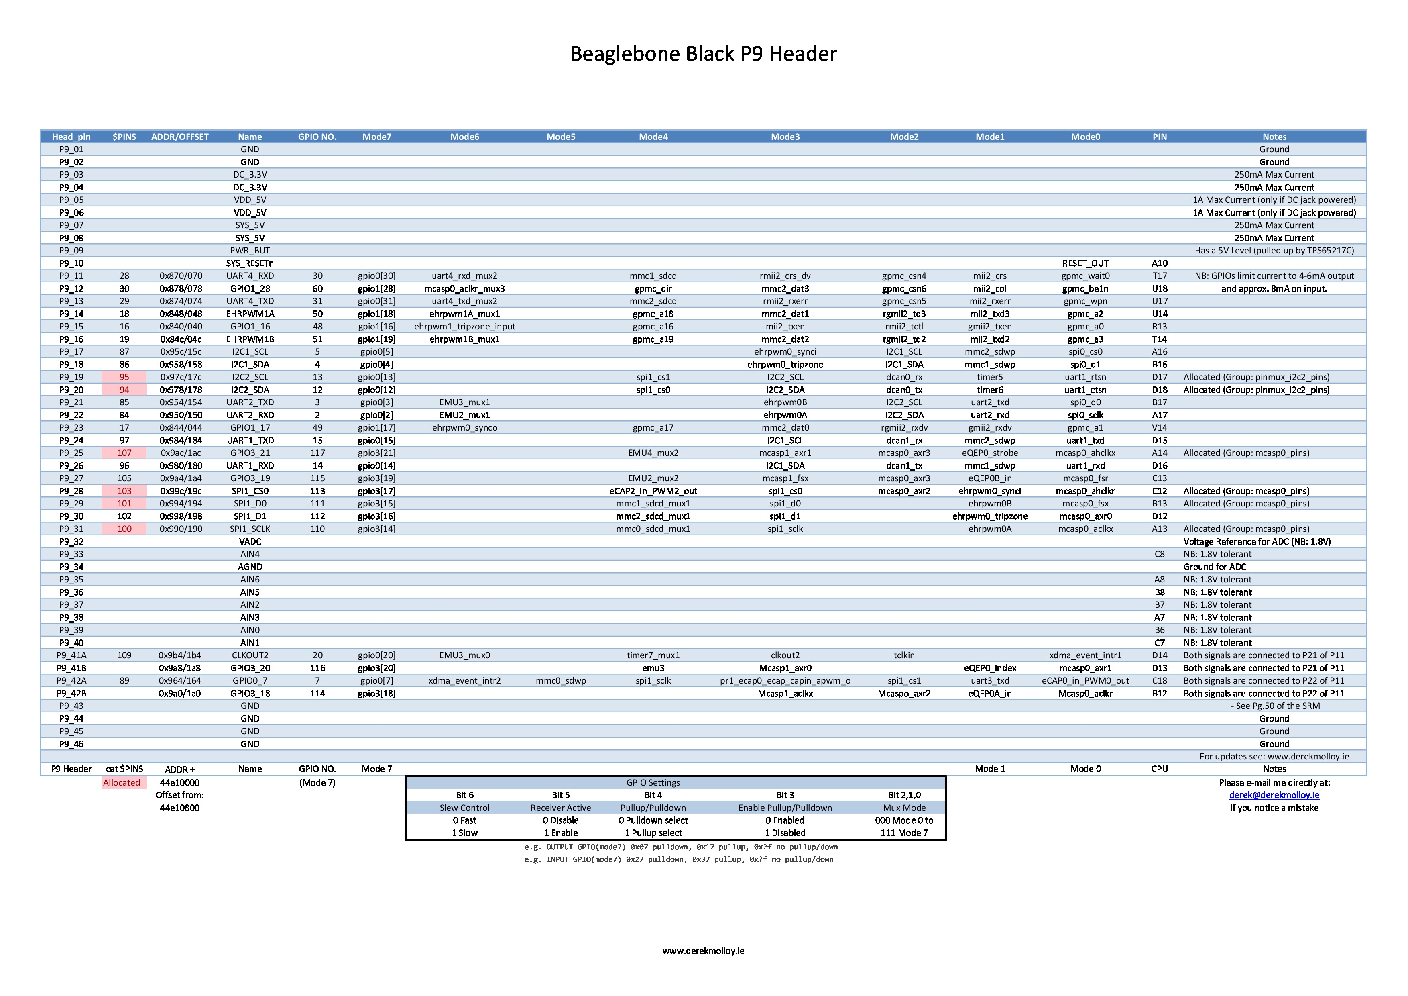Figure 24: BeagleBone black P9 header

3. The simulation arm robot

The simulation Arm Robot is a combination from 7 dynamixel servo AX-18A motors.

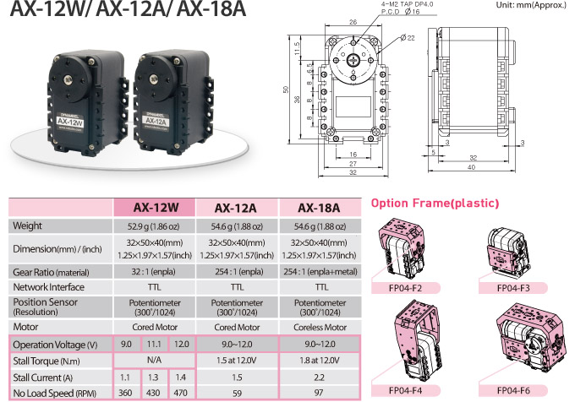Figure 25: Dynamixel Servo Motor description

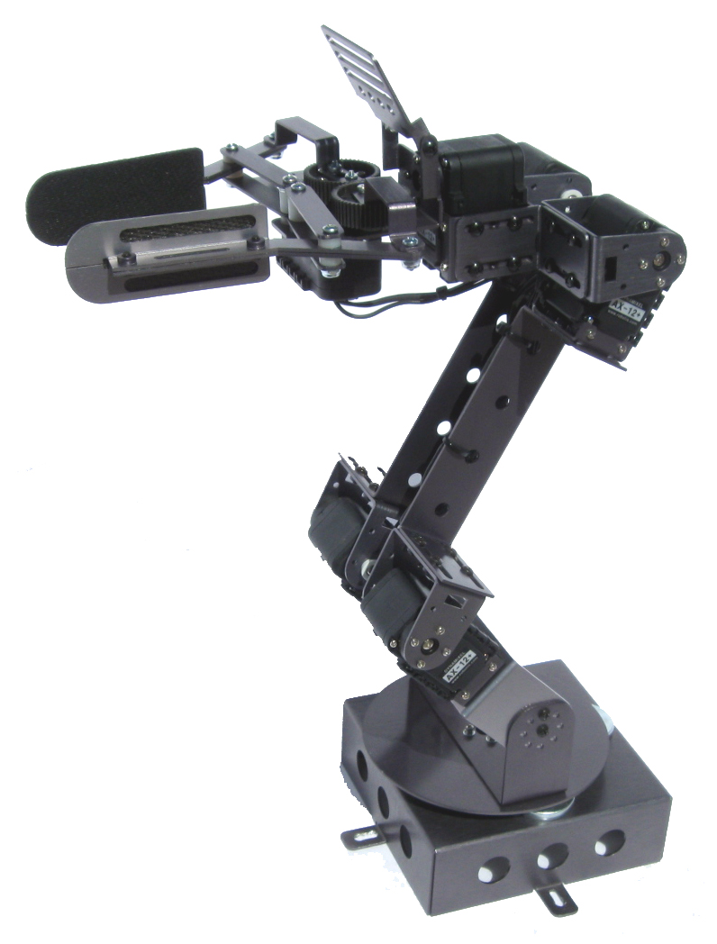Figure 26: The simulation arm robot

4. UART half duplex converted board

To control send and receiver data to each dynamixel because hardware only have one line to transfer data so we make this board to control data send and receiver exactly, and reduce lost data when it transfer. Cause we have only one line to transfer data so in same time we only send data or only receiver data so we make a circuit to active only send or receiver data in one time to reduce lost data.

Other problem is when we active send or receiver data gate, To resolve it we use monostable multibrator circuit.It’s make depended one-shot circuit, it generate a single output pulse of a specified width, when external trigger signal or pulse is applied. This trigger signal initiates a timing cycle which causes the output of the monostable to change its state at the start of the timing cycle and will remain in this second state. The timing cycle of the monostable is determined by the time constant of the timing capacitor, CT and the resistor, RT until it resets or returns itself back to its original (stable) state. The monostable multivibrator will then remain in this original stable state indefinitely until another input pulse or trigger signal is received.

Board have 2 different one-shot circuit, retriggerable monostable multivibrator and non-retriggerable monostable multibrator.

Retriggerable monostable multivibrator when have a new trigger during a pulse will restart the pulse time, so it will extend the current pulse.

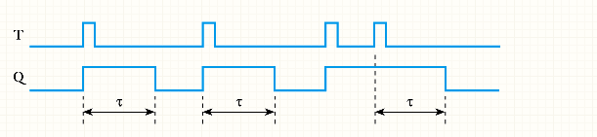Figure 27: Retriggerable monostable multivibrator illustration

Non-retriggerable monostable multivibrator when have a new trigger in pulse time, it will ignored it.

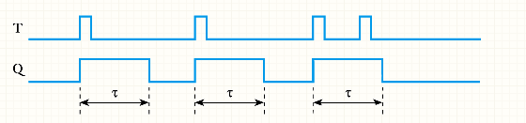Figure 28: Non-retriggerable monostable multivibrator illustration

We can easily calculate the period of pulse time by

T = 0.693RC

So we can edit resistor value or capacitor value to have pulse time suitable which we want.

4.1 IC 7404

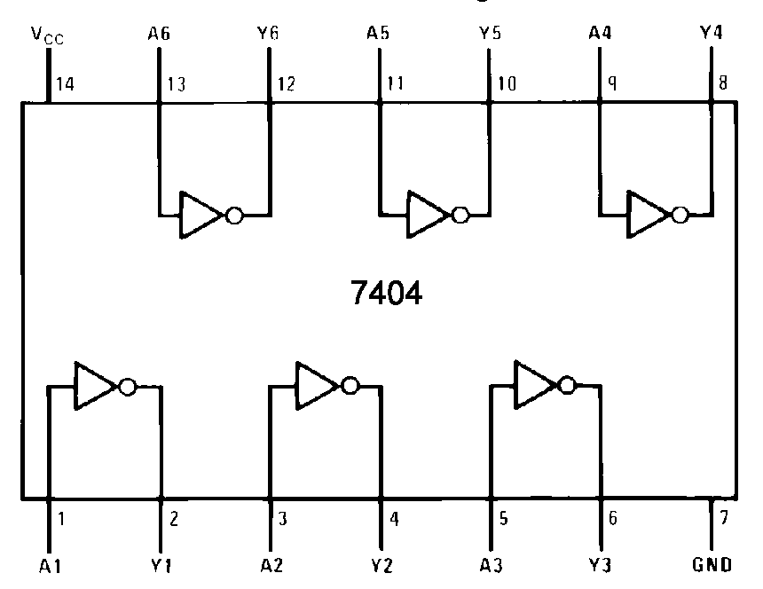Figure 10: IC 7404 schematic

**Description:**

* The device contains six independent inverters.

**The implementation of IC 7404 in UART half duplex board:**

* Use to convert the TXDEN signal.

4.2 IC 74126

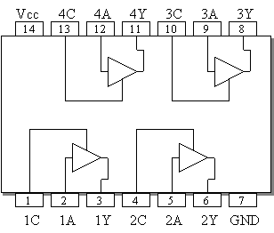Figure 11: IC 74126 schematic

**Description:**

* Quad Bus Buffers
* 3-State Outputs
* Separate Control for Each Channel

**The implementation of IC 74126 in UART half duplex board:**

* Use to choose between the TXD or RXD signals.

4.3 IC 74122

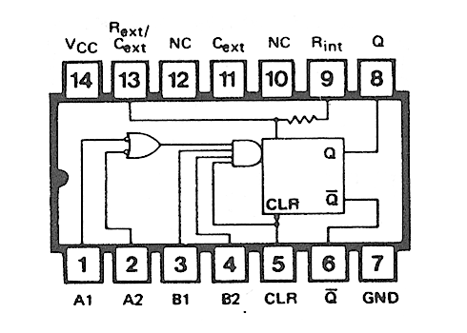Figure 12: IC 74122 schematic

**Description:**

* D-C Triggered from Active-High or Active-Low Gated Logic Inputs
* Retriggerable for Very Long Output Pulses, Up to 100% Duty Cycle
* Overriding Clear Terminates Output Pulse
* '122 and 'LS122 Have Internal Timing Resistors

**The implementation of IC 74122 in UART half duplex board:**

4.4 The UART half duplex schematic

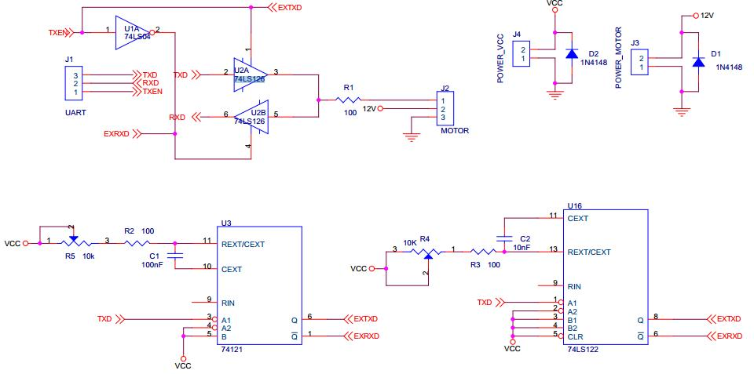Figure 13: UART half duplex schematic

4.5 The UART half duplex layout board

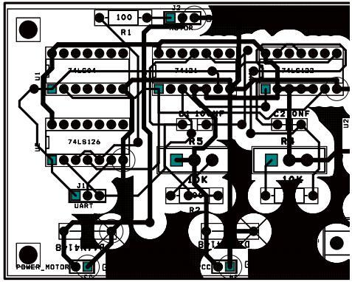Figure 14: UART half duplex layout board

Software test document (STD)

I. Introduction

1. System overview

This document describes the technical, board design and UI design of the Linux Driver Controller project. It includes the introduction of AM335x 1Ghz ARM Cortex A-8, BeagleBone Black, Dynamixel Arm Robot. It also includes sequence diagrams of the main use cases and overall design of user interface.

2. Test approach

2.1 Test goals

To discover system defects as much as possible before releasing.

To increase system’s reliability.

2.2 Test type

Black box

2.3 Test level

II. Test plan

1. Features to be tested

1.1 Manual mode

User’s interface

Motor 1

* Turn left
* Turn right

Motor 2

* Up
* Down

Motor 3

* Up
* Down

Motor 4

* Roll left
* Roll right

Motor 5

* Pick
* Drop

1.2 Automation mode

User’s interface

Load data from file

Edit data in table

Save data to file

Execute automation mode with data

1.3 Game Pad mode

User’s interface

Motor 1

* Turn left
* Turn right

Motor 2

* Up
* Down

Motor 3

* Up
* Down

Motor 4

* Roll left
* Roll right

Motor 5

* Pick
* Drop

2. Features not to be tested

N/A

3. Test tools and environment

3.1 Test tool

GDB

3.2 Environment

Linux kit

UART connection

III. Test case

1. Manual mode

Table 22: Manual mode test case

|  |  |  |  |  |  |  |
| --- | --- | --- | --- | --- | --- | --- |
| MANUAL MODE TEST CASE | | | | | | |
| **ID** | **Test Case Description** | **Pre-Condition** | **Test Case Procedure** | **Expected Output** | **Result** | **Day** |
| **[Manual-1]** | Test user’s interface of Manual mode | 1. Linux Kit and Arm Robot is connect by UART | 1. Open Arm Robot Controller  2. Move to Manual tab | 2. All images, buttons, fonts is displayed successfully, do not have any error occur |  |  |
| **[Manual-2]** | Test control motor 1 turn left by slider bar | 1. Linux Kit and Arm Robot is connect by UART  2. Arm Robot Controller is opened  3. Current tab is Manual tab  4. Current value of motor 1 is 512  5. Speed of motor 1 is 100 | 1. Drag slider bar below motor 1 left | 1. Motor 1 of Arm Robot is turn left |  |  |
| **[Manual-3]** | Test control motor 1 turn right by slider bar | 1. Linux Kit and Arm Robot is connect by UART  2. Arm Robot Controller is opened  3. Current tab is Manual tab  4. Current value of motor 1 is 512  5. Speed of motor 1 is 100 | 1. Drag slider bar below motor 1 right | 1. Motor 1 of Arm Robot is turn right |  |  |
| **[Manual-4]** | Test control motor 1 turn left by input number and click [OK] button | 1. Linux Kit and Arm Robot is connect by UART  2. Arm Robot Controller is opened  3. Current tab is Manual tab  4. Current value of motor 1 is 512  5. Speed of motor 1 is 100 | 1. Enter 800 in value data Box below motor 1  2. Click [OK] button | 2. Motor 1 of Arm Robot is turn left |  |  |
| **[Manual-5]** | Test control motor 1 turn right by input number and click [OK] button | 1. Linux Kit and Arm Robot is connect by UART  2. Arm Robot Controller is opened  3. Current tab is Manual tab  4. Current value of motor 1 is 512  5. Speed of motor 1 is 100 | 1. Enter 300 in value data Box below motor 1  2. Click [OK] button | 2. Motor 1 of Arm Robot is turn right |  |  |
| **[Manual-6]** | Test control motor 1 turn left by slider bar when change speed of motor 1 | 1. Linux Kit and Arm Robot is connect by UART  2. Arm Robot Controller is opened  3. Current tab is Manual tab  4. Current value of motor 1 is 512  5. Speed of motor 1 is 100 | 1. Drag slider bar below motor 1 left  2. Change value in speed box of motor 1 to 200  3. Drag slider bar below motor 1 left  4. Change value in speed box of motor 1 to 400  5. Drag slider bar below motor 1 left  6. Change value in speed box of motor 1 to 100  7. Drag slider bar below motor 1 left | 1. Motor 1 of Arm Robot is turn left  3. Motor 1 of Arm Robot is turn left with speed faster step 1  5. Motor 1 of Arm Robot is turn left with speed faster step 3  7. Motor 1 of Arm Robot is turn left with speed same step 1 |  |  |
| **[Manual-7]** | Test control motor 1 turn right by slider bar when change speed of motor 1 | 1. Linux Kit and Arm Robot is connect by UART  2. Arm Robot Controller is opened  3. Current tab is Manual tab  4. Current value of motor 1 is 512  5. Speed of motor 1 is 100 | 1. Drag slider bar below motor 1 right  2. Change value in speed box of motor 1 to 200  3. Drag slider bar below motor 1 right  4. Change value in speed box of motor 1 to 400  5. Drag slider bar below motor 1 right  6. Change value in speed box of motor 1 to 100  7. Drag slider bar below motor 1 right | 1. Motor 1 of Arm Robot is turn right  3. Motor 1 of Arm Robot is turn right with speed faster step 1  5. Motor 1 of Arm Robot is turn right with speed faster step 3  7. Motor 1 of Arm Robot is turn right with speed same step 1 |  |  |
| **[Manual-8]** | Test control motor 1 turn left by [OK] button when change speed of motor 1 | 1. Linux Kit and Arm Robot is connect by UART  2. Arm Robot Controller is opened  3. Current tab is Manual tab  4. Current value of motor 1 is 512  5. Speed of motor 1 is 100 | 1. Enter 700 in value data Box below motor 1  2. Click [OK] button  3. Change value in speed box of motor 1 to 200  4. Enter 800 in value data Box below motor 1  5. Click [OK] button  6. Change value in speed box of motor 1 to 400  7. Enter 900 in value data Box below motor 1  8. Click [OK] button  9. Change value in speed box of motor 1 to 100  10. Enter 1000 in value data Box below motor 1  11. Click [OK] button | 2. Motor 1 of Arm Robot is turn left  5. Motor 1 of Arm Robot is turn left with speed faster step 2  8. Motor 1 of Arm Robot is turn left with speed faster step 5  11. Motor 1 of Arm Robot is turn left with speed same step 2 |  |  |
| **[Manual-9]** | Test control motor 1 turn right by [OK] button when change speed of motor 1 | 1. Linux Kit and Arm Robot is connect by UART  2. Arm Robot Controller is opened  3. Current tab is Manual tab  4. Current value of motor 1 is 512  5. Speed of motor 1 is 100 | 1. Enter 400 in value data Box below motor 1  2. Click [OK] button  3. Change value in speed box of motor 1 to 200  4. Enter 300 in value data Box below motor 1  5. Click [OK] button  6. Change value in speed box of motor 1 to 400  7. Enter 200 in value data Box below motor 1  8. Click [OK] button  9. Change value in speed box of motor 1 to 100  10. Enter 100 in value data Box below motor 1  11. Click [OK] button | 2. Motor 1 of Arm Robot is turn right  5. Motor 1 of Arm Robot is turn right with speed faster step 2  8. Motor 1 of Arm Robot is turn right with speed faster step 5  11. Motor 1 of Arm Robot is turn right with speed same step 2 |  |  |
| **[Manual-10]** | Test control motor 2 go up by slider bar | 1. Linux Kit and Arm Robot is connect by UART  2. Arm Robot Controller is opened  3. Current tab is Manual tab  4. Current value of motor 2 is 512  5. Speed of motor 2 is 100 | 1. Drag slider bar below motor 2 left | 1. Motor 2 of Arm Robot is go up |  |  |
| **[Manual-11]** | Test control motor 2 go down by slider bar | 1. Linux Kit and Arm Robot is connect by UART  2. Arm Robot Controller is opened  3. Current tab is Manual tab  4. Current value of motor 2 is 512  5. Speed of motor 2 is 100 | 1. Drag slider bar below motor 2 right | 1. Motor 2 of Arm Robot is go down |  |  |
| **[Manual-12]** | Test control motor 2 go up by input number and click [OK] button | 1. Linux Kit and Arm Robot is connect by UART  2. Arm Robot Controller is opened  3. Current tab is Manual tab  4. Current value of motor 2 is 512  5. Speed of motor 2 is 100 | 1. Enter 800 in value data Box below motor 2  2. Click [OK] button | 2. Motor 2 of Arm Robot is go up |  |  |
| **[Manual-13]** | Test control motor 2 go down by input number and click [OK] button | 1. Linux Kit and Arm Robot is connect by UART  2. Arm Robot Controller is opened  3. Current tab is Manual tab  4. Current value of motor 2 is 512  5. Speed of motor 2 is 100 | 1. Enter 300 in value data Box below motor 2  2. Click [OK] button | 2. Motor 2 of Arm Robot is go down |  |  |
| **[Manual-14]** | Test control motor 2 go up by slider bar when change speed of motor 2 | 1. Linux Kit and Arm Robot is connect by UART  2. Arm Robot Controller is opened  3. Current tab is Manual tab  4. Current value of motor 2 is 512  5. Speed of motor 2 is 100 | 1. Drag slider bar below motor 2 left  2. Change value in speed box of motor 2 to 200  3. Drag slider bar below motor 2 left  4. Change value in speed box of motor 2 to 400  5. Drag slider bar below motor 2 left  6. Change value in speed box of motor 2 to 100  7. Drag slider bar below motor 2 left | 1. Motor 2 of Arm Robot is go up  3. Motor 2 of Arm Robot is go up with speed faster step 1  5. Motor 2 of Arm Robot is go up with speed faster step 3  7. Motor 2 of Arm Robot is go up with speed same step 1 |  |  |
| **[Manual-15]** | Test control motor 2 go down by slider bar when change speed of motor 2 | 1. Linux Kit and Arm Robot is connect by UART  2. Arm Robot Controller is opened  3. Current tab is Manual tab  4. Current value of motor 2 is 512  5. Speed of motor 2 is 100 | 1. Drag slider bar below motor 2 right  2. Change value in speed box of motor 2 to 200  3. Drag slider bar below motor 2 right  4. Change value in speed box of motor 2 to 400  5. Drag slider bar below motor 2 right  6. Change value in speed box of motor 2 to 100  7. Drag slider bar below motor 2 right | 1. Motor 2 of Arm Robot is go down  3. Motor 2 of Arm Robot is go down with speed faster step 1  5. Motor 2 of Arm Robot is go down with speed faster step 3  7. Motor 2 of Arm Robot is go down with speed same step 1 |  |  |
| **[Manual-16]** | Test control motor 2 go up by [OK] button when change speed of motor 2 | 1. Linux Kit and Arm Robot is connect by UART  2. Arm Robot Controller is opened  3. Current tab is Manual tab  4. Current value of motor 2 is 512  5. Speed of motor 2 is 100 | 1. Enter 700 in value data Box below motor 2  2. Click [OK] button  3. Change value in speed box of motor 2 to 200  4. Enter 800 in value data Box below motor 2  5. Click [OK] button  6. Change value in speed box of motor 2 to 400  7. Enter 900 in value data Box below motor 2  8. Click [OK] button  9. Change value in speed box of motor 2 to 100  10. Enter 1000 in value data Box below motor 2  11. Click [OK] button | 2. Motor 2 of Arm Robot is go up  5. Motor 2 of Arm Robot is go up with speed faster step 2  8. Motor 2 of Arm Robot is go up with speed faster step 5  11. Motor 2 of Arm Robot is go up with speed same step 2 |  |  |
| **[Manual-17]** | Test control motor 2 go down by [OK] button when change speed of motor 2 | 1. Linux Kit and Arm Robot is connect by UART  2. Arm Robot Controller is opened  3. Current tab is Manual tab  4. Current value of motor 2 is 512  5. Speed of motor 2 is 100 | 1. Enter 400 in value data Box below motor 2  2. Click [OK] button  3. Change value in speed box of motor 2 to 200  4. Enter 300 in value data Box below motor 2  5. Click [OK] button  6. Change value in speed box of motor 2 to 400  7. Enter 200 in value data Box below motor 2  8. Click [OK] button  9. Change value in speed box of motor 2 to 100  10. Enter 100 in value data Box below motor 2  11. Click [OK] button | 2. Motor 2 of Arm Robot is go down  5. Motor 2 of Arm Robot is go down with speed faster step 2  8. Motor 2 of Arm Robot is go down with speed faster step 5  11. Motor 2 of Arm Robot is go down with speed same step 2 |  |  |
| **[Manual-18]** | Test control motor 3 go up by slider bar | 1. Linux Kit and Arm Robot is connect by UART  2. Arm Robot Controller is opened  3. Current tab is Manual tab  4. Current value of motor 3 is 512  5. Speed of motor 3 is 100 | 1. Drag slider bar below motor 3 left | 1. Motor 3 of Arm Robot is go up |  |  |
| **[Manual-19]** | Test control motor 3 go down by slider bar | 1. Linux Kit and Arm Robot is connect by UART  2. Arm Robot Controller is opened  3. Current tab is Manual tab  4. Current value of motor 3 is 512  5. Speed of motor 3 is 100 | 1. Drag slider bar below motor 3 right | 1. Motor 3 of Arm Robot is go down |  |  |
| **[Manual-20]** | Test control motor 3 go up by input number and click [OK] button | 1. Linux Kit and Arm Robot is connect by UART  2. Arm Robot Controller is opened  3. Current tab is Manual tab  4. Current value of motor 3 is 512  5. Speed of motor 3 is 100 | 1. Enter 800 in value data Box below motor 3  2. Click [OK] button | 2. Motor 3 of Arm Robot is go up |  |  |
| **[Manual-21]** | Test control motor 3 go down by input number and click [OK] button | 1. Linux Kit and Arm Robot is connect by UART  2. Arm Robot Controller is opened  3. Current tab is Manual tab  4. Current value of motor 3 is 512  5. Speed of motor 3 is 100 | 1. Enter 300 in value data Box below motor 3  2. Click [OK] button | 2. Motor 3 of Arm Robot is go down |  |  |
| **[Manual-22]** | Test control motor 3 go up by slider bar when change speed of motor 3 | 1. Linux Kit and Arm Robot is connect by UART  2. Arm Robot Controller is opened  3. Current tab is Manual tab  4. Current value of motor 3 is 512  5. Speed of motor 3 is 100 | 1. Drag slider bar below motor 3 left  2. Change value in speed box of motor 3 to 200  3. Drag slider bar below motor 3 left  4. Change value in speed box of motor 3 to 400  5. Drag slider bar below motor 3 left  6. Change value in speed box of motor 3 to 100  7. Drag slider bar below motor 3 left | 1. Motor 3 of Arm Robot is go up  3. Motor 3 of Arm Robot is go up with speed faster step 1  5. Motor 3 of Arm Robot is go up with speed faster step 3  7. Motor 3 of Arm Robot is go up with speed same step 1 |  |  |
| **[Manual-23]** | Test control motor 3 go down by slider bar when change speed of motor 3 | 1. Linux Kit and Arm Robot is connect by UART  2. Arm Robot Controller is opened  3. Current tab is Manual tab  4. Current value of motor 3 is 512  5. Speed of motor 3 is 100 | 1. Drag slider bar below motor 3 right  2. Change value in speed box of motor 3 to 200  3. Drag slider bar below motor 3 right  4. Change value in speed box of motor 3 to 400  5. Drag slider bar below motor 3 right  6. Change value in speed box of motor 3 to 100  7. Drag slider bar below motor 3 right | 1. Motor 3 of Arm Robot is go down  3. Motor 3 of Arm Robot is go down with speed faster step 1  5. Motor 3 of Arm Robot is go down with speed faster step 3  7. Motor 3 of Arm Robot is go down with speed same step 1 |  |  |
| **[Manual-24]** | Test control motor 3 go up by [OK] button when change speed of motor 3 | 1. Linux Kit and Arm Robot is connect by UART  2. Arm Robot Controller is opened  3. Current tab is Manual tab  4. Current value of motor 3 is 512  5. Speed of motor 3 is 100 | 1. Enter 700 in value data Box below motor 3  2. Click [OK] button  3. Change value in speed box of motor 3 to 200  4. Enter 800 in value data Box below motor 3  5. Click [OK] button  6. Change value in speed box of motor 3 to 400  7. Enter 900 in value data Box below motor 3  8. Click [OK] button  9. Change value in speed box of motor 3 to 100  10. Enter 1000 in value data Box below motor 3  11. Click [OK] button | 2. Motor 3 of Arm Robot is go up  5. Motor 3 of Arm Robot is go up with speed faster step 2  8. Motor 3 of Arm Robot is go up with speed faster step 5  11. Motor 3 of Arm Robot is go up with speed same step 2 |  |  |
| **[Manual-25]** | Test control motor 3 go down by [OK] button when change speed of motor 3 | 1. Linux Kit and Arm Robot is connect by UART  2. Arm Robot Controller is opened  3. Current tab is Manual tab  4. Current value of motor 3 is 512  5. Speed of motor 3 is 100 | 1. Enter 400 in value data Box below motor 3  2. Click [OK] button  3. Change value in speed box of motor 3 to 200  4. Enter 300 in value data Box below motor 3  5. Click [OK] button  6. Change value in speed box of motor 3 to 400  7. Enter 200 in value data Box below motor 3  8. Click [OK] button  9. Change value in speed box of motor 3 to 100  10. Enter 100 in value data Box below motor 3  11. Click [OK] button | 2. Motor 3 of Arm Robot is go down  5. Motor 3 of Arm Robot is go down with speed faster step 2  8. Motor 3 of Arm Robot is go down with speed faster step 5  11. Motor 3 of Arm Robot is go down with speed same step 2 |  |  |
| **[Manual-26]** | Test control motor 4 roll right by slider bar | 1. Linux Kit and Arm Robot is connect by UART  2. Arm Robot Controller is opened  3. Current tab is Manual tab  4. Current value of motor 4 is 512  5. Speed of motor 4 is 100 | 1. Drag slider bar below motor 4 left | 1. Motor 4 of Arm Robot is roll right |  |  |
| **[Manual-27]** | Test control motor 4 roll left by slider bar | 1. Linux Kit and Arm Robot is connect by UART  2. Arm Robot Controller is opened  3. Current tab is Manual tab  4. Current value of motor 4 is 512  5. Speed of motor 4 is 100 | 1. Drag slider bar below motor 4 right | 1. Motor 4 of Arm Robot is roll left |  |  |
| **[Manual-28]** | Test control motor 4 roll right by input number and click [OK] button | 1. Linux Kit and Arm Robot is connect by UART  2. Arm Robot Controller is opened  3. Current tab is Manual tab  4. Current value of motor 4 is 512  5. Speed of motor 4 is 100 | 1. Enter 800 in value data Box below motor 4  2. Click [OK] button | 2. Motor 4 of Arm Robot is roll right |  |  |
| **[Manual-29]** | Test control motor 4 roll left by input number and click [OK] button | 1. Linux Kit and Arm Robot is connect by UART  2. Arm Robot Controller is opened  3. Current tab is Manual tab  4. Current value of motor 4 is 512  5. Speed of motor 4 is 100 | 1. Enter 300 in value data Box below motor 4  2. Click [OK] button | 2. Motor 4 of Arm Robot is roll left |  |  |
| **[Manual-30]** | Test control motor 4 roll right by slider bar when change speed of motor 4 | 1. Linux Kit and Arm Robot is connect by UART  2. Arm Robot Controller is opened  3. Current tab is Manual tab  4. Current value of motor 4 is 512  5. Speed of motor 4 is 100 | 1. Drag slider bar below motor 4 left  2. Change value in speed box of motor 4 to 200  3. Drag slider bar below motor 4 left  4. Change value in speed box of motor 4 to 400  5. Drag slider bar below motor 4 left  6. Change value in speed box of motor 4 to 100  7. Drag slider bar below motor 4 left | 1. Motor 4 of Arm Robot is roll right  3. Motor 4 of Arm Robot is roll right with speed faster step 1  5. Motor 4 of Arm Robot is roll right with speed faster step 3  7. Motor 4 of Arm Robot is roll right with speed same step 1 |  |  |
| **[Manual-31]** | Test control motor 4 roll left by slider bar when change speed of motor 4 | 1. Linux Kit and Arm Robot is connect by UART  2. Arm Robot Controller is opened  3. Current tab is Manual tab  4. Current value of motor 4 is 512  5. Speed of motor 4 is 100 | 1. Drag slider bar below motor 4 right  2. Change value in speed box of motor 4 to 200  3. Drag slider bar below motor 4 right  4. Change value in speed box of motor 4 to 400  5. Drag slider bar below motor 4 right  6. Change value in speed box of motor 4 to 100  7. Drag slider bar below motor 4 right | 1. Motor 4 of Arm Robot is roll left  3. Motor 4 of Arm Robot is roll left with speed faster step 1  5. Motor 4 of Arm Robot is roll left with speed faster step 3  7. Motor 4 of Arm Robot is roll left with speed same step 1 |  |  |
| **[Manual-32]** | Test control motor 4 roll right by [OK] button when change speed of motor 4 | 1. Linux Kit and Arm Robot is connect by UART  2. Arm Robot Controller is opened  3. Current tab is Manual tab  4. Current value of motor 4 is 512  5. Speed of motor 4 is 100 | 1. Enter 600 in value data Box below motor 4  2. Click [OK] button  3. Change value in speed box of motor 4 to 200  4. Enter 650 in value data Box below motor 4  5. Click [OK] button  6. Change value in speed box of motor 4 to 400  7. Enter 700 in value data Box below motor 4  8. Click [OK] button  9. Change value in speed box of motor 4 to 100  10. Enter 800 in value data Box below motor 4  11. Click [OK] button | 2. Motor 4 of Arm Robot is roll right  5. Motor 4 of Arm Robot is roll right with speed faster step 2  8. Motor 4 of Arm Robot is roll right with speed faster step 5  11. Motor 4 of Arm Robot is roll right with speed same step 2 |  |  |
| **[Manual-33]** | Test control motor 4 roll left by [OK] button when change speed of motor 4 | 1. Linux Kit and Arm Robot is connect by UART  2. Arm Robot Controller is opened  3. Current tab is Manual tab  4. Current value of motor 4 is 512  5. Speed of motor 4 is 100 | 1. Enter 500 in value data Box below motor 4  2. Click [OK] button  3. Change value in speed box of motor 4 to 200  4. Enter 450 in value data Box below motor 4  5. Click [OK] button  6. Change value in speed box of motor 4 to 400  7. Enter 400 in value data Box below motor 4  8. Click [OK] button  9. Change value in speed box of motor 4 to 100  10. Enter 200 in value data Box below motor 4  11. Click [OK] button | 2. Motor 4 of Arm Robot is roll left  5. Motor 4 of Arm Robot is roll left with speed faster step 2  8. Motor 4 of Arm Robot is roll left with speed faster step 5  11. Motor 4 of Arm Robot is roll left with speed same step 2 |  |  |
| **[Manual-34]** | Test control motor 5 go drop by slider bar | 1. Linux Kit and Arm Robot is connect by UART  2. Arm Robot Controller is opened  3. Current tab is Manual tab  4. Current value of motor 5 is 512  5. Speed of motor 5 is 100 | 1. Drag slider bar below motor 5 left | 1. Motor 5 of Arm Robot is go drop |  |  |
| **[Manual-35]** | Test control motor 5 go pick by slider bar | 1. Linux Kit and Arm Robot is connect by UART  2. Arm Robot Controller is opened  3. Current tab is Manual tab  4. Current value of motor 5 is 300  5. Speed of motor 5 is 100 | 1. Drag slider bar below motor 5 right | 1. Motor 5 of Arm Robot is go pick |  |  |
| **[Manual-36]** | Test control motor 5 go drop by input number and click [OK] button | 1. Linux Kit and Arm Robot is connect by UART  2. Arm Robot Controller is opened  3. Current tab is Manual tab  4. Current value of motor 5 is 300  5. Speed of motor 5 is 100 | 1. Enter 380 in value data Box below motor 5  2. Click [OK] button | 2. Motor 5 of Arm Robot is go drop |  |  |
| **[Manual-37]** | Test control motor 5 go pick by input number and click [OK] button | 1. Linux Kit and Arm Robot is connect by UART  2. Arm Robot Controller is opened  3. Current tab is Manual tab  4. Current value of motor 5 is 300  5. Speed of motor 5 is 100 | 1. Enter 220 in value data Box below motor 5  2. Click [OK] button | 2. Motor 5 of Arm Robot is go pick |  |  |
| **[Manual-38]** | Test control motor 5 go drop by slider bar when change speed of motor 5 | 1. Linux Kit and Arm Robot is connect by UART  2. Arm Robot Controller is opened  3. Current tab is Manual tab  4. Current value of motor 5 is 300  5. Speed of motor 5 is 100 | 1. Drag slider bar below motor 5 left  2. Change value in speed box of motor 5 to 200  3. Drag slider bar below motor 5 left  4. Change value in speed box of motor 5 to 400  5. Drag slider bar below motor 5 left  6. Change value in speed box of motor 5 to 100  7. Drag slider bar below motor 5 left | 1. Motor 5 of Arm Robot is go drop  3. Motor 5 of Arm Robot is go drop with speed faster step 1  5. Motor 5 of Arm Robot is go drop with speed faster step 3  7. Motor 5 of Arm Robot is go drop with speed same step 1 |  |  |
| **[Manual-39]** | Test control motor 5 go pick by slider bar when change speed of motor 5 | 1. Linux Kit and Arm Robot is connect by UART  2. Arm Robot Controller is opened  3. Current tab is Manual tab  4. Current value of motor 5 is 300  5. Speed of motor 5 is 100 | 1. Drag slider bar below motor 5 right  2. Change value in speed box of motor 5 to 200  3. Drag slider bar below motor 5 right  4. Change value in speed box of motor 5 to 400  5. Drag slider bar below motor 5 right  6. Change value in speed box of motor 5 to 100  7. Drag slider bar below motor 5 right | 1. Motor 5 of Arm Robot is go pick  3. Motor 5 of Arm Robot is go pick with speed faster step 1  5. Motor 5 of Arm Robot is go pick with speed faster step 3  7. Motor 5 of Arm Robot is go pick with speed same step 1 |  |  |
| **[Manual-40]** | Test control motor 5 go drop by [OK] button when change speed of motor 5 | 1. Linux Kit and Arm Robot is connect by UART  2. Arm Robot Controller is opened  3. Current tab is Manual tab  4. Current value of motor 5 is 300  5. Speed of motor 5 is 100 | 1. Enter 320 in value data Box below motor 5  2. Click [OK] button  3. Change value in speed box of motor 5 to 200  4. Enter 340 in value data Box below motor 5  5. Click [OK] button  6. Change value in speed box of motor 5 to 400  7. Enter 360 in value data Box below motor 5  8. Click [OK] button  9. Change value in speed box of motor 5 to 100  10. Enter 380 in value data Box below motor 5  11. Click [OK] button | 2. Motor 5 of Arm Robot is go drop  5. Motor 5 of Arm Robot is go drop with speed faster step 2  8. Motor 5 of Arm Robot is go drop with speed faster step 5  11. Motor 5 of Arm Robot is go drop with speed same step 2 |  |  |
| **[Manual-41]** | Test control motor 5 go pick by [OK] button when change speed of motor 5 | 1. Linux Kit and Arm Robot is connect by UART  2. Arm Robot Controller is opened  3. Current tab is Manual tab  4. Current value of motor 5 is 300  5. Speed of motor 5 is 100 | 1. Enter 280 in value data Box below motor 5  2. Click [OK] button  3. Change value in speed box of motor 5 to 200  4. Enter 260 in value data Box below motor 5  5. Click [OK] button  6. Change value in speed box of motor 5 to 400  7. Enter 240 in value data Box below motor 5  8. Click [OK] button  9. Change value in speed box of motor 5 to 100  10. Enter 220 in value data Box below motor 5  11. Click [OK] button | 2. Motor 5 of Arm Robot is go pick  5. Motor 5 of Arm Robot is go pick with speed faster step 2  8. Motor 5 of Arm Robot is go pick with speed faster step 5  11. Motor 5 of Arm Robot is go pick with speed same step 2 |  |  |
| **[Manual-42]** | Test function: control all motor of Arm Robot using [Start with All data] button | 1. Linux Kit and Arm Robot is connect by UART  2. Arm Robot Controller is opened  3. Current tab is Manual tab  4. Speed of all motor is 100 | 1. Enter 400 in value data Box below motor 1  2. Enter 300 in value data Box below motor 2  3. Enter 750 in value data Box below motor 3  4. Enter 600 in value data Box below motor 4  5. Enter 380 in value data Box below motor 5  11. Click [Start with all value] button | 11. Arm Robot is executed with all value data |  |  |
| **[Manual-43]** | Test function: Exit | 1. Linux Kit and Arm Robot is connect by UART  2. Arm Robot Controller is opened  3. Current tab is Manual tab | 1. Press on [Exit] button | 1. The Robot Controller application is exit successful |  |  |

2. Automation mode

Table 23: Automation mode test case

|  |  |  |  |  |  |  |
| --- | --- | --- | --- | --- | --- | --- |
| AUTOMATION MODE TEST CASE | | | | | | |
| **ID** | **Test Case Description** | **Pre-Condition** | **Test Case Procedure** | **Expected Output** | **Result** | **Day** |
| **[Auto-1]** | Test user’s interface of Automation mode | 1. Linux Kit and Arm Robot is connect by UART | 1. Open Arm Robot Controller  2. Move to Automation tab | 2. All images, buttons, fonts is displayed successfully, do not have any error occur |  |  |
| **[Auto-2]** | Test function: load data | 1. Linux Kit and Arm Robot is connect by UART  2. Arm Robot Controller is opened  3. Current tab is Automation tab | 1. Tap on [Load Data] button  2. Select file data to open  3. Click [Open] button | 3. data file is loaded successful to table view |  |  |
| **[Auto-3]** | Test function: Edit data | 1. Linux Kit and Arm Robot is connect by UART  2. Arm Robot Controller is opened  3. Current tab is Automation tab  4. Data is loaded to table view | 1. Select any cell in table from table view  2. Change number is that cell  3. Click to another cell | 3. the value is changed successful |  |  |
| **[Auto-4]** | Test function: Save to file | 1. Linux Kit and Arm Robot is connect by UART  2. Arm Robot Controller is opened  3. Current tab is Automation tab  4. Data is loaded to table view | 1. Select any cell in table from table view  2. Change number is that cell  3. Click to another cell  4. Click [Save to File] button  5. Enter any name for the save file  6. Click [OK] button | 6. The table with new value data is saved successful |  |  |
| **[Auto-5]** | Test function: Execute with value data in table view | 1. Linux Kit and Arm Robot is connect by UART  2. Arm Robot Controller is opened  3. Current tab is Automation tab  4. Data is loaded to table view | 1. Click [Start] button | 1. The Arm Robot is executed with all value data in table view automatic  1. The name of [Start] button is changed to “Stop” |  |  |
| **[Auto-6]** | Test function: Stop execute | 1. Linux Kit and Arm Robot is connect by UART  2. Arm Robot Controller is opened  3. Current tab is Automation tab  4. Data is loaded to table view | 1. Click [Start] button  2. Wait 10 seconds  3. Click [Stop] button | 3. The Arm Robot is stop execute |  |  |
| **[Auto-7]** | Test function: Exit | 1. Linux Kit and Arm Robot is connect by UART  2. Arm Robot Controller is opened  3. Current tab is Automation tab | 1. Press on [Exit] button | 1. The Robot Controller application is exit successful |  |  |

3. Game pad mode

Table 24: Game pad mode test case

|  |  |  |  |  |  |  |
| --- | --- | --- | --- | --- | --- | --- |
| GAME PAD MODE TEST CASE | | | | | | |
| **ID** | **Test Case Description** | **Pre-Condition** | **Test Case Procedure** | **Expected Output** | **Result** | **Day** |
| **[GameP-1]** | Test user’s interface of Game Pad mode | 1. Linux Kit and Arm Robot is connect by UART | 1. Open Arm Robot Controller  2. Move to Game Pad tab | 2. All images, buttons, fonts is displayed successfully, do not have any error occur |  |  |
| **[GameP-2]** | Test turn left for motor 1 of Arm Robot | 1. Linux Kit and Arm Robot is connect by UART  2. Arm Robot Controller is opened  3. Current tab is Game Pad tab  4. Set value for motor 1, motor 2, motor 3 is 512  5. Set value for motor 4 is 560  6. Set value for motor 5 is 300 | 1. Long tap to [Left] button | 1. The motor 1 of Arm Robot is turn left |  |  |
| **[GameP-3]** | Test turn right for motor 1 of Arm Robot | 1. Linux Kit and Arm Robot is connect by UART  2. Arm Robot Controller is opened  3. Current tab is Game Pad tab  4. Set value for motor 1, motor 2, motor 3 is 512  5. Set value for motor 4 is 560  6. Set value for motor 5 is 300 | 1. Long tap to [Right] button | 1. The motor 1 of Arm Robot is turn right |  |  |
| **[GameP-4]** | Test go up for motor 2 of Arm Robot | 1. Linux Kit and Arm Robot is connect by UART  2. Arm Robot Controller is opened  3. Current tab is Game Pad tab  4. Set value for motor 1, motor 2, motor 3 is 512  5. Set value for motor 4 is 560  6. Set value for motor 5 is 300 | 1. Long tap to [Up 1] button | 1. The motor 2 of Arm Robot is go up |  |  |
| **[GameP-5]** | Test go down for motor 2 of Arm Robot | 1. Linux Kit and Arm Robot is connect by UART  2. Arm Robot Controller is opened  3. Current tab is Game Pad tab  4. Set value for motor 1, motor 2, motor 3 is 512  5. Set value for motor 4 is 560  6. Set value for motor 5 is 300 | 1. Long tap to [Down 1] button | 1. The motor 2 of Arm Robot is go down |  |  |
| **[GameP-6]** | Test go up for motor 3 of Arm Robot | 1. Linux Kit and Arm Robot is connect by UART  2. Arm Robot Controller is opened  3. Current tab is Game Pad tab  4. Set value for motor 1, motor 2, motor 3 is 512  5. Set value for motor 4 is 560  6. Set value for motor 5 is 300 | 1. Long tap to [Up 2] button | 1. The motor 3 of Arm Robot is go up |  |  |
| **[GameP-7]** | Test go down for motor 3 of Arm Robot | 1. Linux Kit and Arm Robot is connect by UART  2. Arm Robot Controller is opened  3. Current tab is Game Pad tab  4. Set value for motor 1, motor 2, motor 3 is 512  5. Set value for motor 4 is 560  6. Set value for motor 5 is 300 | 1. Long tap to [Down 2] button | 1. The motor 3 of Arm Robot is go down |  |  |
| **[GameP-8]** | Test pick for motor 5 of Arm Robot | 1. Linux Kit and Arm Robot is connect by UART  2. Arm Robot Controller is opened  3. Current tab is Game Pad tab  4. Set value for motor 1, motor 2, motor 3 is 512  5. Set value for motor 4 is 560  6. Set value for motor 5 is 300 | 1. Long tap to [Pick] button | 1. The motor 5 of Arm Robot is picked |  |  |
| **[GameP-9]** | Test drop for motor 5 of Arm Robot | 1. Linux Kit and Arm Robot is connect by UART  2. Arm Robot Controller is opened  3. Current tab is Game Pad tab  4. Set value for motor 1, motor 2, motor 3 is 512  5. Set value for motor 4 is 560  6. Set value for motor 5 is 300 | 1. Long tap to [Drop] button | 1. The motor 5 of Arm Robot is dropped |  |  |
| **[GameP-10]** | Test roll left for motor 4 of Arm Robot | 1. Linux Kit and Arm Robot is connect by UART  2. Arm Robot Controller is opened  3. Current tab is Game Pad tab  4. Set value for motor 1, motor 2, motor 3 is 512  5. Set value for motor 4 is 560  6. Set value for motor 5 is 300 | 1. Long tap to [Roll Left] button | 1. The motor 4 of Arm Robot is roll left |  |  |
| **[GameP-11]** | Test roll right for motor 4 of Arm Robot | 1. Linux Kit and Arm Robot is connect by UART  2. Arm Robot Controller is opened  3. Current tab is Game Pad tab  4. Set value for motor 1, motor 2, motor 3 is 512  5. Set value for motor 4 is 560  6. Set value for motor 5 is 300 | 1. Long tap to [Roll Right] button | 1. The motor 4 of Arm Robot is roll right |  |  |
| **[GameP-12]** | Test function: Exit | 1. Linux Kit and Arm Robot is connect by UART  2. Arm Robot Controller is opened  3. Current tab is Game Pad tab | 1. Press on [Exit] button | 1. The Robot Controller application is exit successful |  |  |

IV. Check list

1. Check list of validation

N/A

2. Submit check list

N/A

V. Others material (if any) (Including append)

N/A

User's manual

I. Installation guide

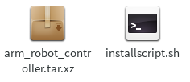Figure 15: Arm robot controller installation file

Step 1: Double-click installscript.sh to install.

II. User's guide

1. Manual tab

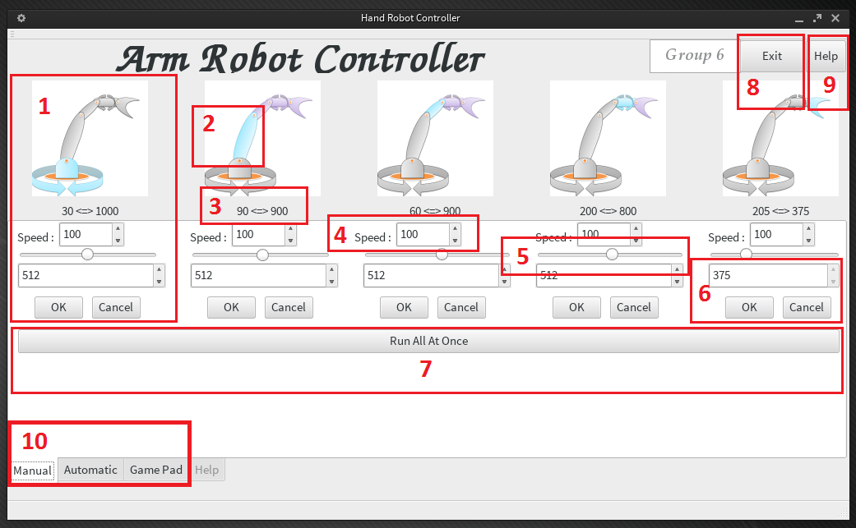Figure 35: Arm robot - Manual user interface

Table 25: Arm robot – Manual user's guide

|  |  |  |
| --- | --- | --- |
| ARM ROBOT – MANUAL USER'S GUIDE | | |
| **No.** | **Name** | **Description** |
| **1** | Motor controller | Include Image, limit value and speed setting, value setting |
| **2** | Where is motor? | Define where is motor (Blue color) will control. |
| **3** | Limit value | The limit value of motor from minimum to maximum |
| **4** | Speed setting | Include a integer box, value in box can change to make speed of that motor increase or decrease |
| **5** | Slider to control | Drag slider to change value of this motor |
| **6** | Controlling by input number | Enter an integer number to box and press [OK] button to execute, or press [Cancel] to cancel |
| **7** | Run All At Once | After change the value of each motor in each integer box, press this button to make all motor run at once |
| **8** | Exit button | Press this button to quit application |
| **9** | Help button | Press this button to display help tab |
| **10** | Tab | Include manual tab, automation tab and game pad tab |

2. Automation tab

2.1 Start

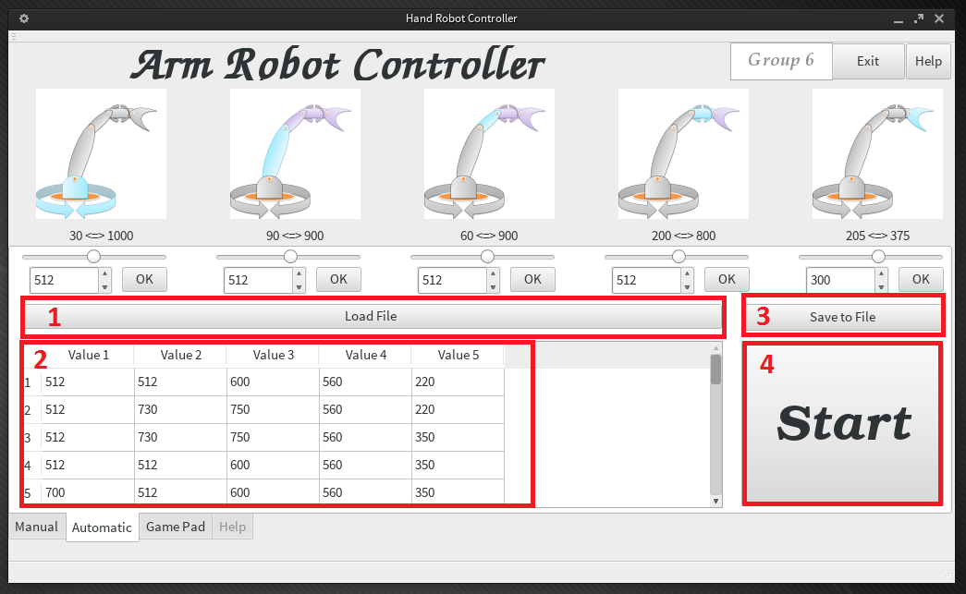Figure 36: Arm robot - Automation user interface - Start

Table 26: Arm robot – Automation user's guide - start

|  |  |  |
| --- | --- | --- |
| ARM ROBOT – AUTOMATION USER'S GUIDE - START | | |
| **No.** | **Name** | **Description** |
| **1** | Load file button | Press this button to load file data list |
| **2** | Table view | This table view show all value from file, include each value of each motor, display step by step |
| **3** | Save to file button | Press this button to save table data after edited |
| **4** | Start button | Press this button to execute the run automation function |

2.2 Load data from file to table

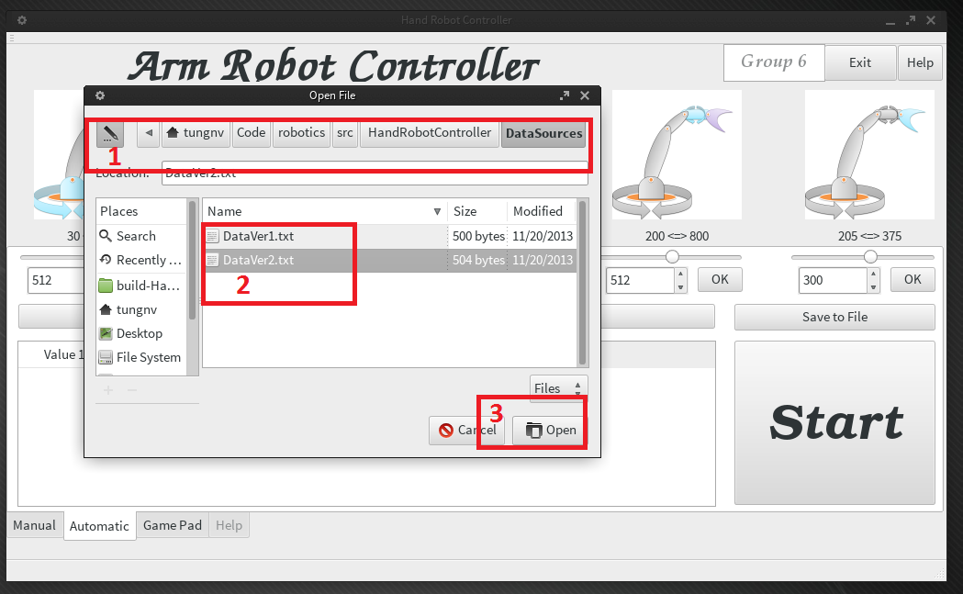Figure 37: Load data user interface

Table 27: Load data user's guide

|  |  |  |
| --- | --- | --- |
| LOAD DATA USER'S GUIDE | | |
| **No.** | **Name** | **Description** |
| **1** | Path to file | The path to file direction |
| **2** | File | The file to load |
| **3** | Open button | Can press this button to load file, or double-click on file to load file |

2.3 Edit value in table

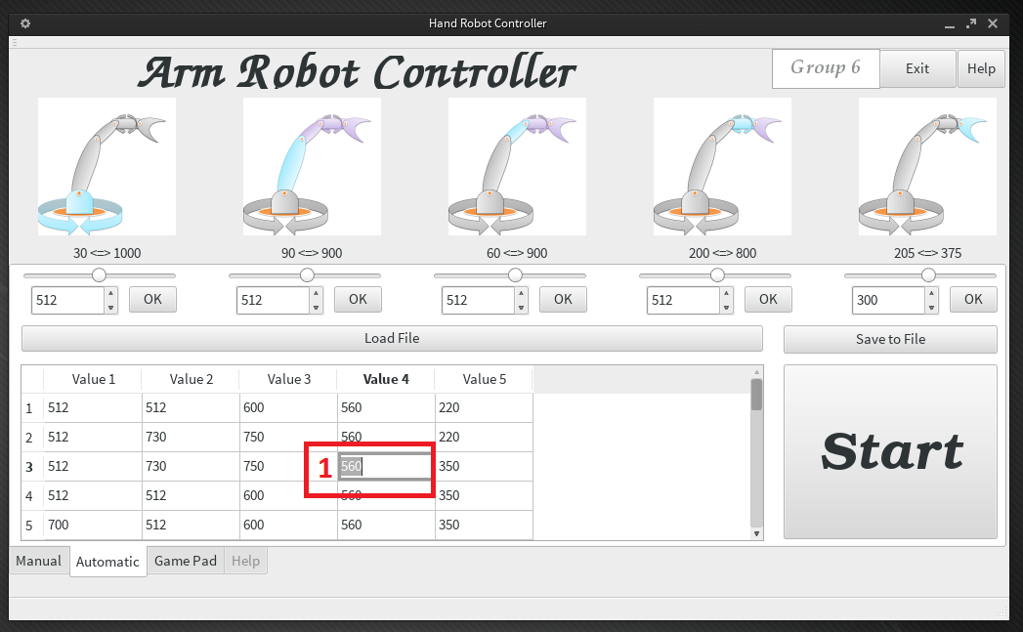Figure 38: Edit value user interface

Table 28: Edit value user's guide

|  |  |  |
| --- | --- | --- |
| EDIT VALUE USER'S GUIDE | | |
| **No.** | **Name** | **Description** |
| **1** | Value cell | Double-click on value cell and edit this value |

2.4 Save data from table to file

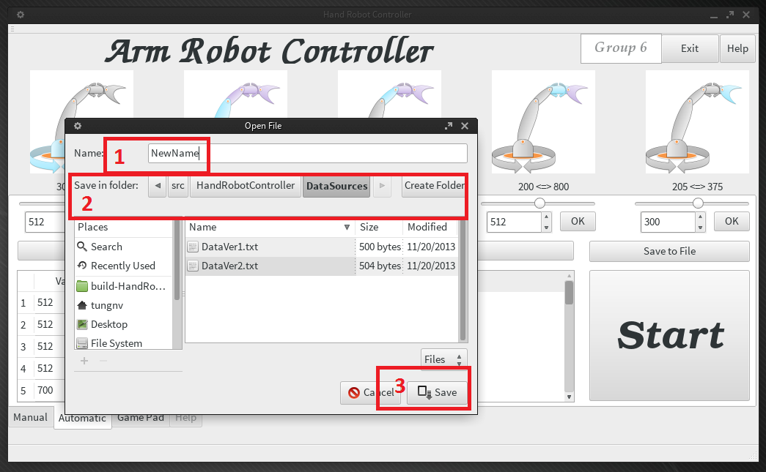Figure 39: Save data user interface

Table 29: Save data user's guide

|  |  |  |
| --- | --- | --- |
| SAVE DATA USER'S GUIDE | | |
| **No.** | **Name** | **Description** |
| **1** | File name | Enter the name for new file data |
| **2** | Path to save file | The path direction to save file data, can change to another location |
| **3** | Save button | Press this button to complete the save function |

2.5 Stop

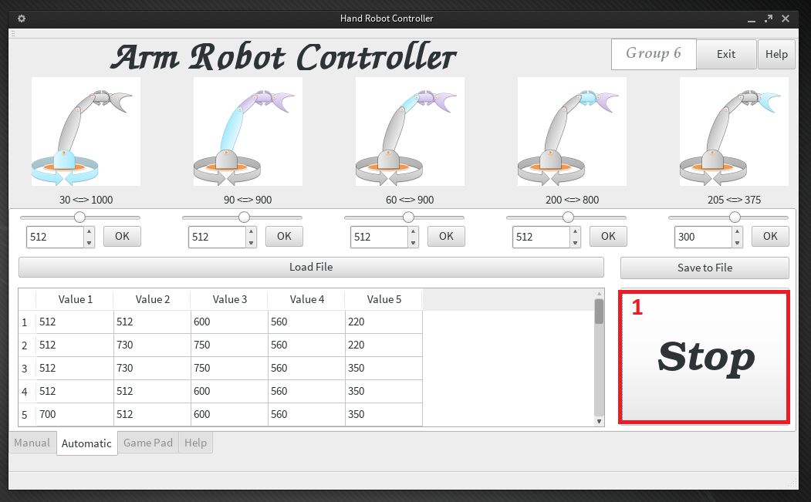Figure 40: Stop automation user interface

Table 30: Stop automation user's guide

|  |  |  |
| --- | --- | --- |
| STOP AUTOMATION USER'S GUIDE | | |
| **No.** | **Name** | **Description** |
| **1** | Stop button | When automation function is executed, press this button to stop function |

3. Game pad tab

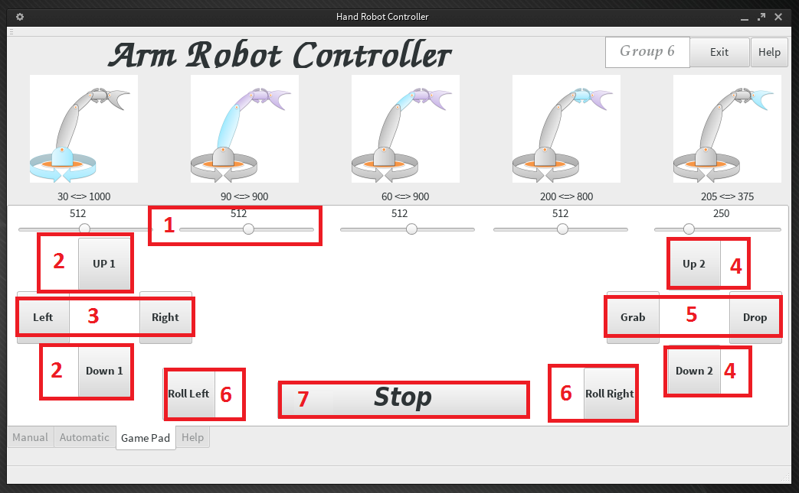Figure 41: Arm robot - Game pad user interface

Table 31: Arm robot – Game pad user's guide

|  |  |  |
| --- | --- | --- |
| ARM ROBOT – GAME PAD USER'S GUIDE | | |
| **No.** | **Name** | **Description** |
| **1** | Current value | The current value of motor |
| **2** | Up1/Down1 | Controlling the motor 2 to Up/Down |
| **3** | Left/Right | Controlling the motor 1 to turn Left/Right |
| **4** | Up2/Down2 | Controlling the motor 3 to Up/Down |
| **5** | Pick/Drop | Controlling the motor 5 to Pick/Drop |
| **6** | Roll left/Roll right | Controlling the motor 4 to roll left/roll right |
| **7** | Stop | Disable the Game pad mode |

ARM ROBOT WITH CAMERA CONTROLLER

Software requirement specification (SRS)

I. User requirement specification

Via an application on the embedded kit, user can:

* Control via touch screen
* Capture image
* Show video
* Add new color
* Get color from any position on image
* Detect item with selected color
* Draw frame for the detected item on video
* Transport the detect object to different space

II. Hardware requirement

The system contains an embedded kit connecting to simulation hardware by UART communication or an USB port.

The simulation Arm robot contains:

* 1 x haft duplex UART connection
* 7 x serve motor.
* 1 x camera

III. Functional requirement

1. Communication protocol

N/A

2. System features (use case)

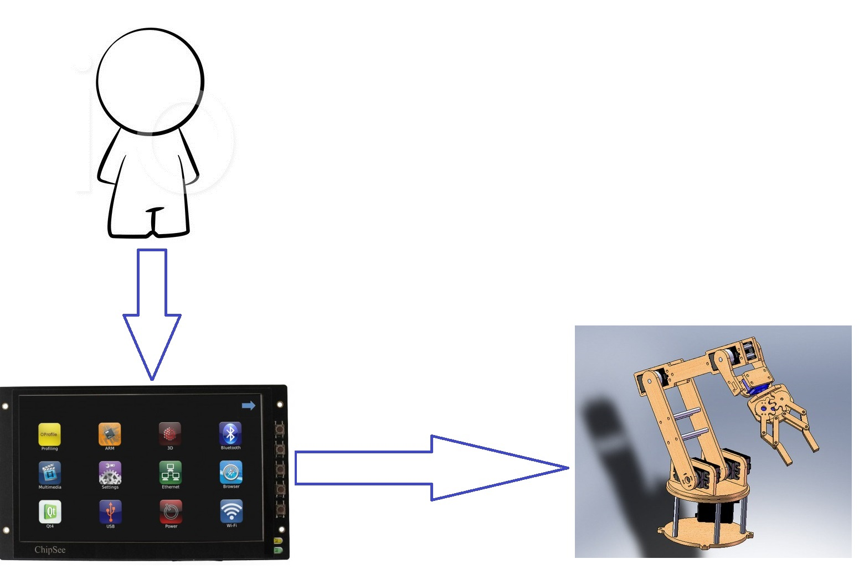Figure 42: Basic control connector

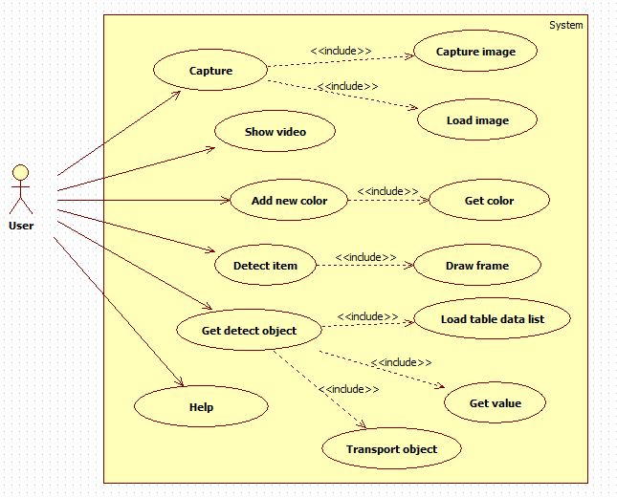Figure 43: Use case diagrams

2.1 Capture image

a) Capture image use case diagram

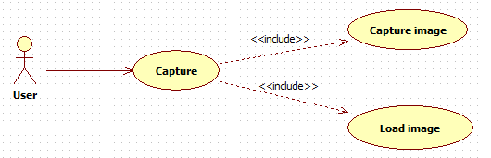Figure 44: Capture image use case diagram

b) Capture image use case specification

Table 32: Capture image use case specification

|  |  |  |  |  |
| --- | --- | --- | --- | --- |
| CAPTURE IMAGE USE CASE SPECIFICATION | | | | |
| **Use-case No.** | UC001 | **Use-case Version** | | 1.0 |
| **Use-case Name** | Capture Image | | | |
| **Author** | TungNV | | | |
| **Date** | 10/11/2013 | **Priority** | Normal | |
| **Actor:**  User  **Requirement:**  This use case allows user to use camera to take a picture  **Goal:**  Take a picture and show it on “capture box”  **Triggers**  User use [Capture] button to capture  **Preconditions:**  Arm Robot with Camera application is opened successfully  The Arm Robot with Camera and Linux KIT are connected  **Post Conditions:**  The Object put in the space that Arm Robot with Camera can operate  **Main Success Scenario:**   |  |  |  | | --- | --- | --- | | **Step** | **Action** | **Result** | | **1** | Press [Capture] button | The picture is displayed on [capture box] |   **Alternative Scenario:** N/A  **Exceptions:** N/A  **Relationships:**  Capture Image use case  **Business Rules:** N/A | | | | |
| Description:   |  |  |  | | --- | --- | --- | | **Field name** | **Data type And Constraints** | **Required** | | Image Object | QImage | Yes | | | | | |

2.2 Show video

a) Show video use case diagram

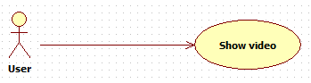Figure 45: Show video use case diagram

b) Show video use case specification

Table 33: Show video use case specification

|  |  |  |  |  |
| --- | --- | --- | --- | --- |
| SHOW VIDEO USE CASE SPECIFICATION | | | | |
| **Use-case No.** | UC002 | **Use-case Version** | | 1.0 |
| **Use-case Name** | Show Video | | | |
| **Author** | TungNV | | | |
| **Date** | 10/11/2013 | **Priority** | Normal | |
| **Actor:**  User and Arm Robot with Camera  **Requirement:**  This use case allows user accept to show video on “video box”  **Goal:**  Show video on “video box”  **Triggers**  User use [Video] button to execute this function  **Preconditions:**  Arm Robot with Camera application is opened successfully  The Arm Robot with Camera and Linux KIT are connected  **Post Conditions:**  The Object put in the space that Arm Robot with Camera can operate  **Main Success Scenario:**   |  |  |  | | --- | --- | --- | | **Step** | **Action** | **Result** | | **1** | Press [Video] button | Video is displayed successfully on “video box” |   **Alternative Scenario:** N/A  **Exceptions:** N/A  **Relationships:**  Show video use case  **Business Rules:** N/A | | | | |
| **Description:** N/A | | | | |

2.3 Add new color

a) Add new color use case diagram

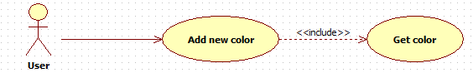Figure 46: Add new color use case diagram

b) Add new color use case specification

Table 34: Add new color use case specification

|  |  |  |  |  |
| --- | --- | --- | --- | --- |
| ADD NEW COLOR USE CASE SPECIFICATION | | | | |
| **Use-case No.** | UC003 | **Use-case Version** | | 1.0 |
| **Use-case Name** | Add New Color | | | |
| **Author** | TungNV | | | |
| **Date** | 10/11/2013 | **Priority** | Normal | |
| **Actor:**  User  **Summary:**  This use case allows user to add new color to “color selection” box  **Goal:**  Add new color to “selection” box  **Triggers**  User click left mouse on the position has color that color want to select from capture image  **Preconditions:**  Arm Robot with Camera application is opened successfully  The Arm Robot with Camera and Linux KIT are connected  The image is displayed on “capture box”  **Post Conditions:** N/A  **Main Success Scenario:**   |  |  |  | | --- | --- | --- | | **Step** | **Action** | **Result** | | **1** | Left mouse click on position has color on image | The custom color on “color selection” box is change to new color |   **Alternative Scenario:** N/A  **Exceptions:** N/A  **Relationships:**  Add new color use case  **Business Rules:** N/A | | | | |
| Description:   |  |  |  | | --- | --- | --- | | **Field name** | **Data type And Constraints** | **Required** | | **Color** | Convert to HSV | Yes | | | | | |

2.4 Detect item

a) Detect item use case diagram

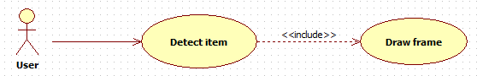Figure 47: Detect item use case diagram

b) Detect item use case specification

Table 35: Detect item use case specification

|  |  |  |  |  |
| --- | --- | --- | --- | --- |
| DETECT ITEM USE CASE SPECIFICATION | | | | |
| **Use-case No.** | UC004 | **Use-case Version** | | 1.0 |
| **Use-case Name** | Detect Item | | | |
| **Author** | TungNV | | | |
| **Date** | 10/11/2013 | **Priority** | Normal | |
| **Actor:**  User  **Summary:**  This use case allows user accept to Arm Robot with Camera can detect item has color same as the selection color  **Goal:**  Detect the item has color same as the selection color  **Triggers**  User show video then select color that want to detect  **Preconditions:**  Arm Robot with Camera application is opened successfully  The Arm Robot with Camera and Linux KIT are connected  The video is displayed on “video box”  The select color is selected  **Post Conditions:**  The Object put in the space that Arm Robot with Camera can operate  **Main Success Scenario:**   |  |  |  | | --- | --- | --- | | **Step** | **Action** | **Result** | | **1** | Press [Video] button | The detected item is displayed on video |   **Alternative Scenario:** N/A  **Exceptions:** N/A  **Relationships:**  Detect item use case  **Business Rules:** N/A | | | | |
| **Description:** N/A | | | | |

2.5 Get detect object

a) Get detect object use case diagram

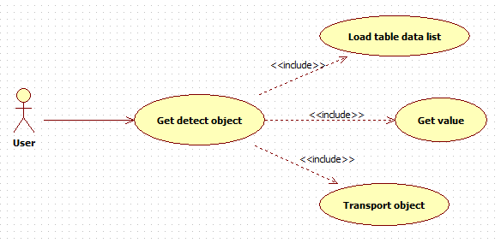Figure 48: Get detect object use case diagram

b) Get detect object use case specification

Table 36: Get detect object use case specification

|  |  |  |  |  |
| --- | --- | --- | --- | --- |
| GET DETECT OBJECT USE CASE SPECIFICATION | | | | |
| **Use-case No.** | UC005 | **Use-case Version** | | 1.0 |
| **Use-case Name** | Get Detect Object | | | |
| **Author** | TungNV | | | |
| **Date** | 10/11/2013 | **Priority** | Normal | |
| **Actor:**  User  **Summary:**  This use case allows user accept to Arm Robot with Camera get detect object out of current space  **Goal:**  Pick the detect object and move it to another space  **Triggers**  Use [Get Detect Object] button to execute this function  **Preconditions:**  Arm Robot with Camera application is opened successfully  The Arm Robot with Camera and Linux KIT are connected  The video is displayed on “video box”  The color to detect is selected  **Post Conditions:**  The object is put in the space that Arm Robot with Camera can operate  **Main Success Scenario:**   |  |  |  | | --- | --- | --- | | **Step** | **Action** | **Result** | | **1** | Press [Get Detect Object] button | Arm Robot with Camera pick and move detect object to another space |   **Alternative Scenario:** N/A  **Exceptions:** N/A  **Relationships:**  Get Detect Object use case | | | | |

IV. Activity diagram

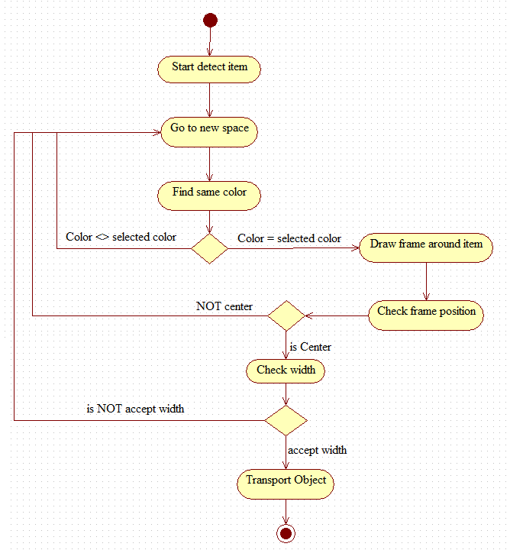Figure 16: Detect objects activity diagram

V. Main flow

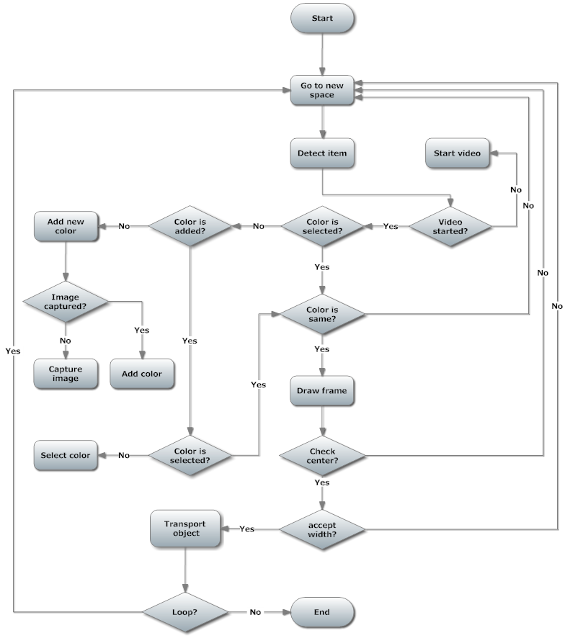Figure 17: Arm Robot automation with camera

VI. Non-functional requirement

Reliability

* All Controller Applications are easily to upgrade firmware.
* All Controller Applications can be replaced easily by loaded into chip if the controller has problem.
* All Controller Applications are guarantee by quality testing in:
  + Stability constraints.
  + Functionality.
  + Reliability.
* It’s mostly depending on hardware reliability.

Availability

* The embedded kit is every where to buy, or can buy ones which have similar function.

Security

N/A

Maintainability

* Easy to upgrade or replace hardware.
* Easy to update software.

Portability

* The embedded kit is small to be moved easily.

Performance

* Arm Robot Controller can control multiple motors at the same time .
* Video is loaded fast and good quality .

Software design description (SDD)

I. Design overview

This document describes the technical, board design and UI design of the Linux Driver Controller project. It includes the introduction of AM335x 1Ghz ARM Cortex A-8, BeagleBone Black, Dynamixel Arm Robot. It also includes sequence diagrams of the main use cases and overall design of user interface.

II. Hardware description

1. AM335x ARM® Cortex-A8 Microprocessor

Refer to section “1. AM335x ARM® Cortex-A8 Microprocessor” page 52.

2. BeagleBone black embedded development kit

Refer to section “2. BeagleBone black embedded development kit” page 53.

3. The simulation arm robot

Refer to section “3. The simulation arm robot” page 57.

4. UART half duplex converted board

Refer to section “4. UART half duplex converted board” page 58.

5. USB Web cam – Colorvis ND40

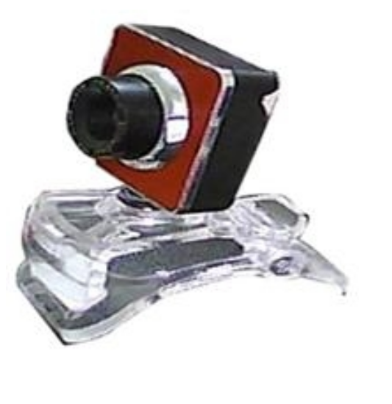Figure 18: USB Web cam Colorvis ND40

**Specification:**

* 1300 K Pixelsc
* Video capture resolutions: up to 640 x 480
* Color digits: 24 bit
* Sensor Type CMOS 1300K
* Interface: USB
* Video frame rate: up to 38 frames

Software test document (STD)

I. Introduction

1. System overview

2. Test approach

2.1 Test goals

To discover system defects as much as possible before releasing.

To increase system’s reliability.

2.2 Test type

Black Box

2.3 Test level

II. Test plan

1. Features to be tested

* User’s interface
* Add new color
* Detect item by color
* Get detect object
  + At detect space 1
  + At detect space 2
  + At detect space 3
  + At detect space 4
  + At detect space 5
* Do not put object to detect pace
* Help

2. Features not to be tested

N/A

3 Test Tools and Environment

3.1. Test tools

GDB

3.2. Environment

Linux KIT

UART connection

III. Test case

Table 37: Detect item test case

|  |  |  |  |  |  |  |
| --- | --- | --- | --- | --- | --- | --- |
| DETECT ITEM TEST CASE | | | | | | |
| **ID** | **Test Case Description** | **Pre-Condition** | **Test Case Procedure** | **Expected Output** | **Result** | **Day** |
| **[Dectect-1]** | Test user’s interface | 1. Linux Kit, Arm Robot and camera is connect by UART | 1. Run Robot with Camera Controller | 1. All images, buttons, fonts is displayed successfully, do not have any error occur |  |  |
| **[Dectect-2]** | Test function: Capture image | 1. Linux Kit, Arm Robot and camera is connect by UART  2. Robot with Camera application is opened | 1. Press [Start] button  2. Press [Capture] button | 2. The capture image is displayed normally |  |  |
| **[Dectect-3]** | Test function: add new color by click left mouse on image | 1. Linux Kit, Arm Robot and camera is connect by UART  2. Robot with Camera application is opened | 1. Press [Start] button  2. Press [Capture] button  3. Left click on the color of item in capture image | 3. The item will be detect in camera screen |  |  |
| **[Dectect-4]** | Test function: Get detect object at space 1 | 1. Linux Kit, Arm Robot and camera is connect by UART  2. Robot with Camera application is opened  3. Put detect object in space 1 | 1. Press on [Get Detect Object] button | 1. The Robot is run to find and get detect object out of detect space 1 |  |  |
| **[Dectect-5]** | Test function: Get detect object at space 2 | 1. Linux Kit, Arm Robot and camera is connect by UART  2. Robot with Camera application is opened  3. Put detect object in space 2 | 1. Press on [Get Detect Object] button | 1. The Robot is run to find and get detect object out of detect space 2 |  |  |
| **[Dectect-6]** | Test function: Get detect object at space 3 | 1. Linux Kit, Arm Robot and camera is connect by UART  2. Robot with Camera application is opened  3. Put detect object in space 3 | 1. Press on [Get Detect Object] button | 1. The Robot is run to find and get detect object out of detect space 3 |  |  |
| **[Dectect-7]** | Test function: Get detect object at space 4 | 1. Linux Kit, Arm Robot and camera is connect by UART  2. Robot with Camera application is opened  3. Put detect object in space 4 | 1. Press on [Get Detect Object] button | 1. The Robot is run to find and get detect object out of detect space 4 |  |  |
| **[Dectect-8]** | Test function: Get detect object | 1. Linux Kit, Arm Robot and camera is connect by UART  2. Robot with Camera application is opened  3. Do not put detect object in any space | 1. Press on [Get Detect Object] button | 1. The Robot is run to find detect object. Does not found detect object |  |  |
| **[Dectect-9]** | Test function: Help | 1. Linux Kit, Arm Robot and camera is connect by UART  2. Robot with Camera application is opened | 1. Press on [Help] button | 1. “Help” tab is opened successful |  |  |
| **[Dectect-10]** | Test function: Exit | 1. Linux Kit, Arm Robot and camera is connect by UART  2. Robot with Camera application run over 5 minutes | 1. Press on [Exit] button | 1. The Robot with Camera application is exit successful |  |  |

IV. Check lists

1. Check list of Validation

N/A

2. Submit check list

N/A

V. Other material (is any) (Including Appended)

N/A

User's manual

I. Installation guide

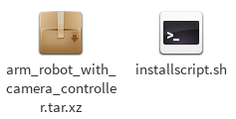Figure 19: Arm robot with camera controller installation file

Step 1: Double click installscript.sh file to install

II. User's guide

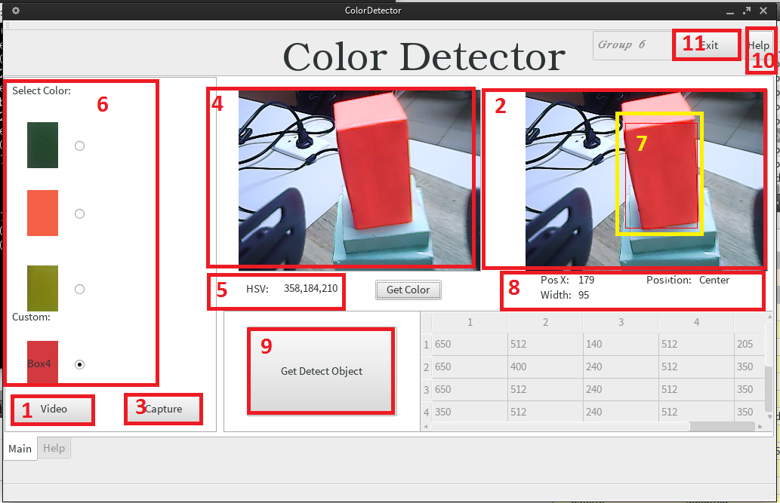Figure 53: Arm robot with camera user interface

Table 38: Arm robot with camera – User's guide

|  |  |  |
| --- | --- | --- |
| ARM ROBOT WITH CAMERA – USER'S GUIDE | | |
| **No.** | **Name** | **Description** |
| **1** | Video | Start video frame |
| **2** | Video frame | Showing the video |
| **3** | Capture | Execute capture function |
| **4** | Capture image frame | Display captured image |
| **5** | HSV color | Showing the HSV color when left click on captured image to select new color |
| **6** | Select color box | Showing some color to choice |
| **7** | Define detect item | Detect item is defined by a rectangle |
| **8** | Detect item Information | Some information of detect item, include Position and width |
| **9** | Get detect object button | Press this button to execute get detect object function |
| **10** | Help button | Press this button to display help |
| **11** | Exit button | Press this button to quit application |

GPIO CONTROLLER

Software requirement specification (SRS)

I. User requirement specification

* Control GPIO port through embedded kit.
* Can see status of GPIO port in screen.
* Can set time to open/close GPIO port.
* Through control GPIO port, can turn on/off the device.

II. Functional requirement

1. System features overview (Use case)

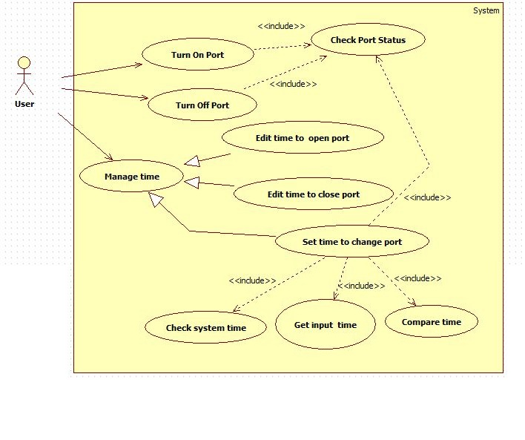Figure 54: System features overview

1.1 Turn on port

a) Use case diagram

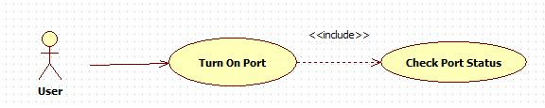Figure 55: Turn on port use case diagram

b) Use case specification

|  |  |  |  |
| --- | --- | --- | --- |
| TURN ON PORT USE CASE SPECIFICATION | | | |
| **Use-case No.** | UC001 | **Use-case Version** | 1.0 |
| **Use-case Name** | Turn On Port | | |
| **Author** | TuongNN | | |
| **Date** | 09/11/2013 | **Priority** | Normal |
| **Actor:**  User  **Requirement:**  This use case allows user turn On Port  **Goal:**  User can be turn On Port which they want  **Triggers**  When use press Image correspond with port  **Preconditions:**  Program is opened and run normal  **Post Conditions:**   * Success: Port is chose open, Image is switch to open status * Failure: Port is chose can’t open or image doesn’t change   **Main Success Scenario:**   |  |  |  | | --- | --- | --- | | **Step** | **Action** | **Result** | | **1** | Press Image correspond with port in main screen | Port which is chose On  Image change and light is lighted |   **Alternative Scenario:**  **Exceptions:**  **Relationships:**  Edit value use case  **Business Rules:** N/A | | | |
| **Description:** | | | |

1.2 Turn off port

a) Use case diagram

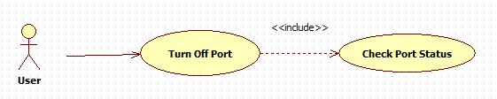Figure 56: Turn off port use case diagram

b) Use case specification

Table 39: Turn off port use case specification

|  |  |  |  |  |
| --- | --- | --- | --- | --- |
| TURN OFF PORT USE CASE SPECIFICATION | | | | |
| **Use-case No.** | UC002 | **Use-case Version** | | 1.0 |
| **Use-case Name** | Turn Off Port | | | |
| **Author** | TuongNN | | | |
| **Date** | 09/11/2013 | **Priority** | Normal | |
| **Actor:**  User  **Requirement:**  This use case allows user turn Off Port  **Goal:**  User can be turn Off Port which they want  **Triggers**  When use press Image correspond with port  **Preconditions:**  Program is opened and run normal  **Post Conditions:**   * Success: Port is chose off, Image is switch to off status * Failure: Port is chose can’t off or image doesn’t change   **Main Success Scenario:**   |  |  |  | | --- | --- | --- | | **Step** | **Action** | **Result** | | **1** | Press Image correspond with port in main screen | Port which is chose Off  Image change and light is off |   **Alternative Scenario:**  **Exceptions:**  **Relationships:**  Edit value use case  **Business Rules:** N/A | | | | |
| **Description:** | | | | |

1.3 Edit time to open port

a) Use case diagram

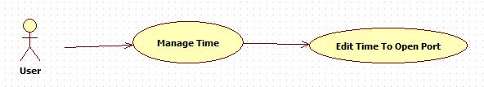Figure 57: Edit time to open port use case diagram

b) Use case specification

Table 40: Edit time to open Port

|  |  |  |  |  |
| --- | --- | --- | --- | --- |
| EDIT TIME TO OPEN PORT USE CASE SPECIFICATION | | | | |
| **Use-case No.** | UC003 | **Use-case Version** | | 1.0 |
| **Use-case Name** | Edit Time To Open Port | | | |
| **Author** | TuongNN | | | |
| **Date** | 09/11/2013 | **Priority** | Normal | |
| **Actor:**  User  **Requirement:**  This use case allows enable set time to open Port  **Goal:**  User allow enable set time open for port  **Triggers**  When use press Enable button, they can edit time they want port open  **Preconditions:**  Program is opened and run normal. Port is closed  **Post Conditions:**   * Success: User can edit time in edit box. * Failure: Edit box is still disable   **Main Success Scenario:**   |  |  |  | | --- | --- | --- | | **Step** | **Action** | **Result** | | **1** | Press in Enable button on main screen | Edit time box is enable to edit | | **2** | Change time user want port open in time edit box | Time edit box is accept time |   **Alternative Scenario:**  **Exceptions:**  **Relationships:**  **Business Rules:** N/A | | | | |
| **Description:** | | | | |

1.4 Edit time to close port

a) Use case diagram

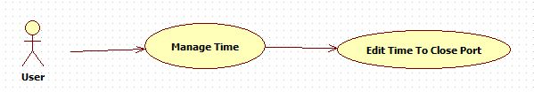Figure 58: Edit time to close port

b) Use case specification

Table 41: Edit time to close port

|  |  |  |  |  |
| --- | --- | --- | --- | --- |
| EDIT TIME TO CLOSE PORT USE CASE SPECIFICATION | | | | |
| **Use-case No.** | UC004 | **Use-case Version** | | 1.0 |
| **Use-case Name** | Edit Time To Close Port | | | |
| **Author** | TuongNN | | | |
| **Date** | 09/11/2013 | **Priority** | Normal | |
| **Actor:**  User  **Requirement:**  This use case allows enable set time to close Port  **Goal:**  User allow enable set time close for port  **Triggers**  When use press Enable button, they can edit time they want port close  **Preconditions:**  Program is opened and run normal. Port is opened.  **Post Conditions:**   * Success: User can edit time in edit box. * Failure: Edit box is still disable   **Main Success Scenario:**   |  |  |  | | --- | --- | --- | | **Step** | **Action** | **Result** | | **1** | Press in Enable button on main screen | Edit time box is enable to edit | | **2** | Change time user want port open in time edit box | Time edit box is accept time |   **Alternative Scenario:**  N/A  **Exceptions:**  N/A  **Relationships:**  **Business Rules:** N/A | | | | |
| **Description:** | | | | |

1.5 Set time to change port status

a) Use case diagram

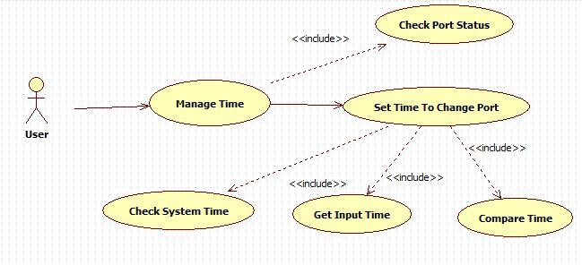Figure 59: Set time to change port status

b) Use case specification

Table 42: Set time to change port status

|  |  |  |  |  |
| --- | --- | --- | --- | --- |
| SET TIME TO CHANGE PORT STATUS USE CASE SPECIFICATION | | | | |
| **Use-case No.** | UC005 | **Use-case Version** | | 1.0 |
| **Use-case Name** | Set time to change port status | | | |
| **Author** | TuongNN | | | |
| **Date** | 09/11/2013 | **Priority** | Normal | |
| **Actor:**  User  **Requirement:**  This use case allows set time change port status  **Goal:**  User set time to change port status  **Triggers**  When use press set button, port will change status in time.  **Preconditions:**  Program is opened and run normal  **Post Conditions:**   * Success: When reach time user chose port is change * Failure: When reach time, port isn’t change status   **Main Success Scenario:**   |  |  |  | | --- | --- | --- | | **Step** | **Action** | **Result** | | **1** | Choose time want change port status |  | | **2** | Press Set button to active it | Image change and light is change depend on status of this port |   **Alternative Scenario:**  N/A  **Exceptions:**  N/A  **Relationships:**  **Business Rules:** N/A | | | | |
| **Description:** | | | | |

2. Sequence diagram

2.1 Turn on port

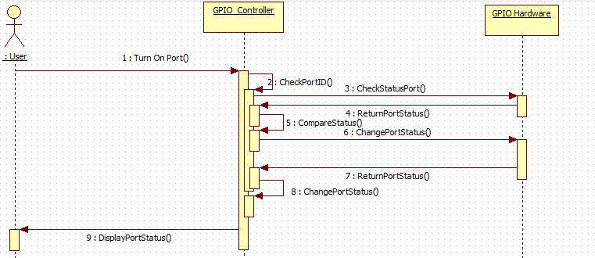Figure 60: Turn on port sequence diagram

2.2 Turn off port

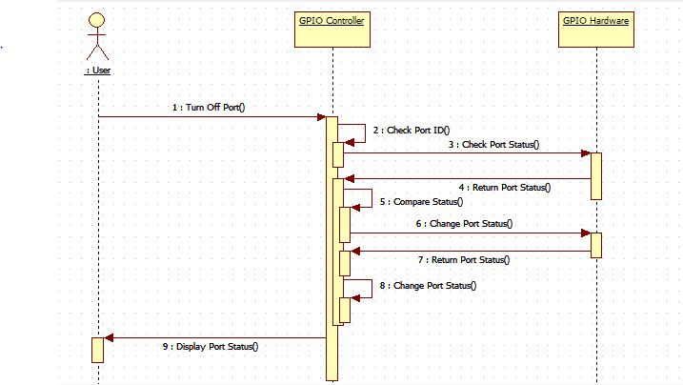Figure 61: Turn off port sequence diagram

2.3 Manage time to change port status

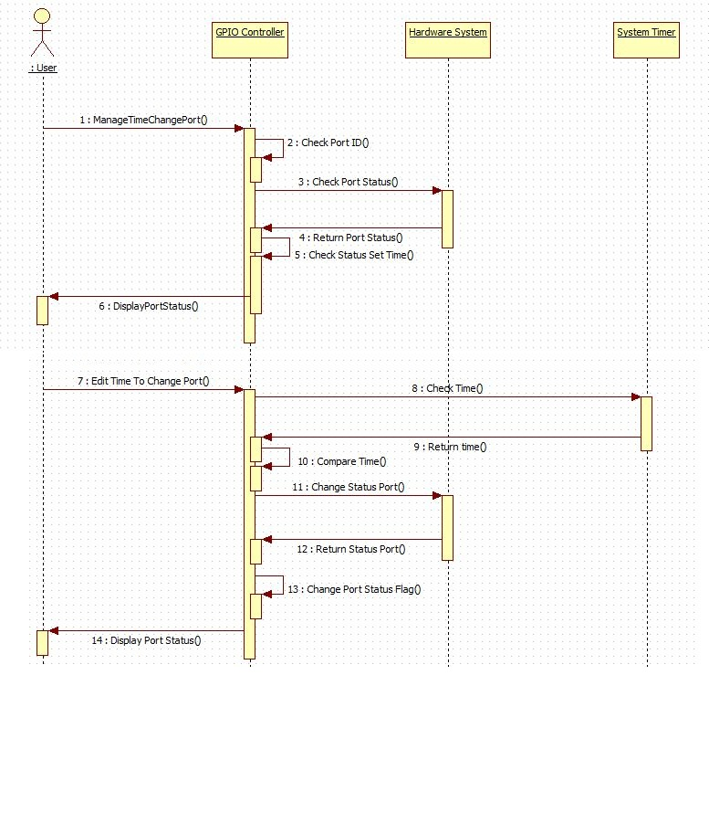Figure 62: Manage time to change port status sequence diagram

III. Activity diagram

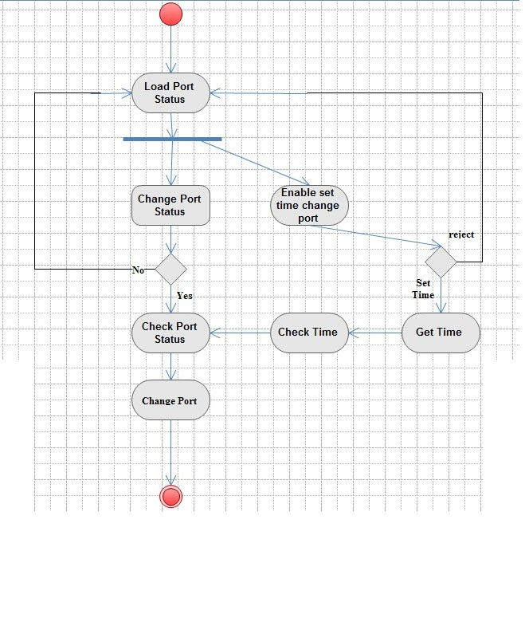Figure 20: GPIO control activity diagram

III. Main flow

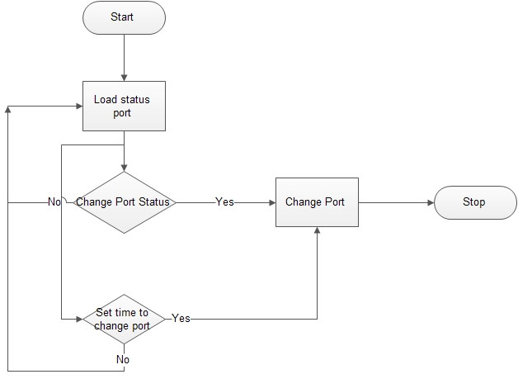Figure 64: GPIO main flow

IV. Non-functional requirement

Reliability

* Application easy to upgrade
* Applications are guarantee by quality testing in:
  + Stability constraints.
* It’s timing exactly to change immediately .

Availability

* The embedded kit is every where to buy, or can buy ones which have similar function.

Security

N/A

Maintainability

* Easy to upgrade or replace hardware.
* Easy to update software.

Portability

* The embedded kit is small to be moved easily.

Performance

* GPIO Control can control all port exactly and execute immediately.

Software design description (SDD)

I. Design overview

This document describes the technical, board design and UI design of the Linux Driver Controller project. It includes the introduction of AM335x 1Ghz ARM Cortex A-8, BeagleBone Black, GPIO relay board. It also includes sequence diagrams of the main use cases and overall design of user interface.

II. Hardware description

1. AM335x ARM® Cortex-A8 Microprocessor

Refer to section “1. AM335x ARM® Cortex-A8 Microprocessor” page 52.

2. BeagleBone black embedded development kit

Refer to section “2. BeagleBone black embedded development kit” page 53.

3. GPIO board

The GPIO board can be used to convert signal from embedded kit to control the high voltage components.

3.1 IC 7414

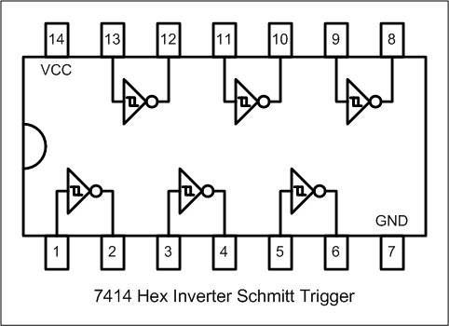Figure 21: IC 7414 schematic

**Description:**

* Operation From Very Slow Edges
* Improved Line-Receiving Characteristics
* High Noise Immunity

**The implementation of IC 7414 in GPIO board:**

3.2 IC ULN2803

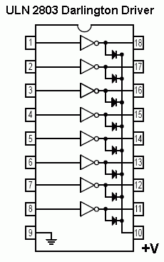Figure 22: IC ULN2803 schematic

**Description:**

* 500-mA Rated Collector Current (Single Output)
* High-Voltage Outputs . . . 50 V
* Output Clamp Diodes
* Inputs Compatible With Various Types of Logic
* Relay Driver Applications
* Compatible with ULN2800A Series

**The implementation of IC ULN2803 in GPIO board:**

3.3 IC TLP521-4

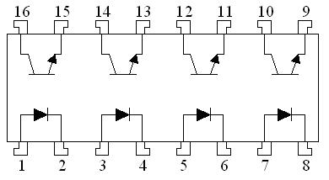Figure 23: IC TLP521-4 schematic

**Description:**

The TLP521-4 are quad channel optocouplers. Each channel is composed of a Gallium Arsenide infra-red emitting diode and a silicon phototransistor. Package style for this devices is 16 pin, with surface mount, butt cut and gull wing options available.

* Performance guaranteed over -55°C to +125°C temperature range
* High current transfer ratio
* 7500V electrical isolation

**The implementation of IC TLP521-4 in GPIO board:**

3.4 RY12W-K

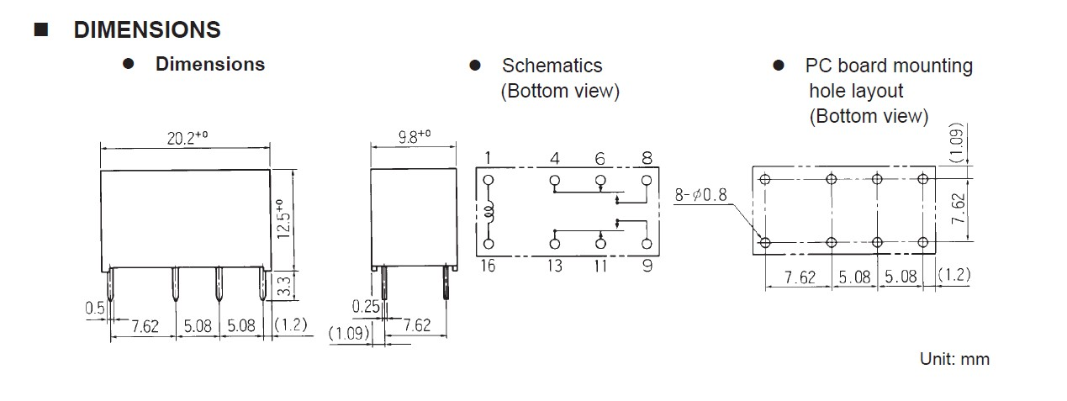Figure 24: Relay RY12W-K schematic

**Description:**

* Ultra high sensitivity
* Conforms to FCC rules and regulations Part 68 —Surge strength 1,500 V
* High dielectric strength type available (RY-WF type)
* Contact arrangement MBB type available (RY-D type)
* High reliability-bifurcated contacts

**The implementation of RY12W-K in GPIO board:**

3.5 GPIO schematic design

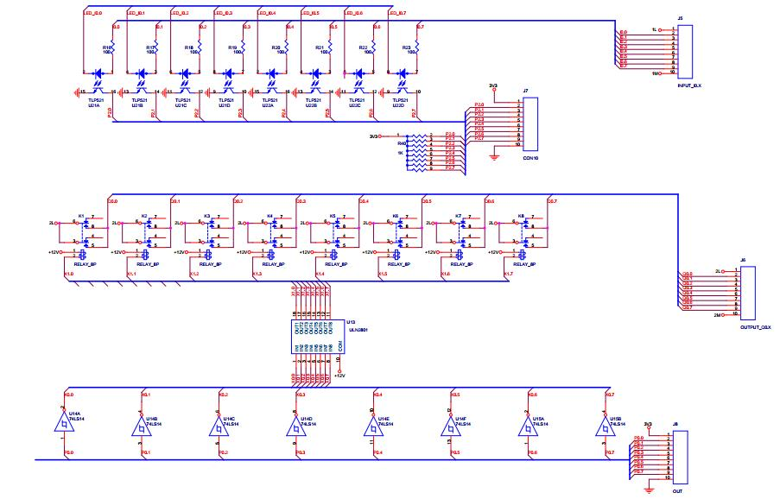Figure 25: GPIO board schematic

3.6 GPIO board layout design

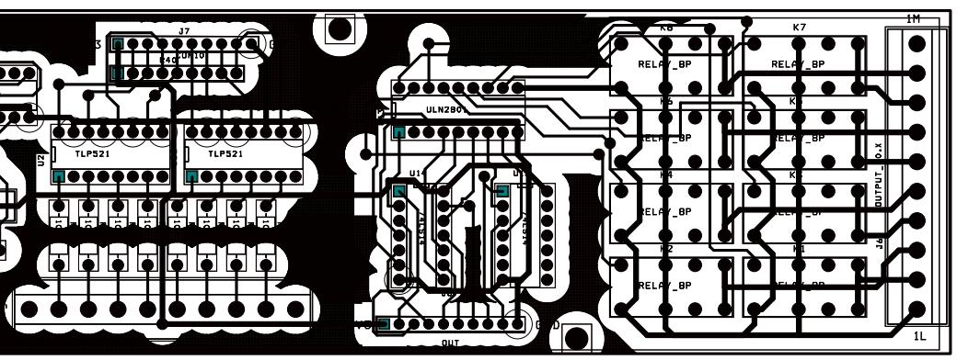Figure 26: GPIO board layout design

Software test document (STD)

I. Introduction

1. System overview

This document describes the technical, board design and UI design of the Linux Driver Controller project. It includes the introduction of AM335x 1Ghz ARM Cortex A-8, BeagleBone Black, Dynamixel Arm Robot. It also includes sequence diagrams of the main use cases and overall design of user interface.

2. Test approach

2.1 Test goals

To discover system defects as much as possible before releasing.

To increase system’s reliability.

2.2 Test type

Black box

2.3 Test level

II. Test plan

1. Features to be tested

1.1 Manual mode

User’s interface

Light 1

* Turn on
* Turn off
* Set time

Light 2

* Turn on
* Turn off
* Set time

Light 3

* Turn on
* Turn off
* Set time

Light 4

* Turn on
* Turn off
* Set time

Light 5

* Turn on
* Turn off
* Set time

Light 6

* Turn on
* Turn off
* Set time

Light 7

* Turn on
* Turn off
* Set time

Light 8

* Turn on
* Turn off
* Set time

1.2 Automation mode

User’s interface

Load status port

Change status port

Set time to change status of port

2. Features not to be tested

N/A

3. Test tools and environment

3.1 Test tool

GDB

3.2 Environment

Linux kit

UART connection

III. Test case

1. Manual mode

Table 43: Manual mode test case

|  |  |  |  |  |  |  |
| --- | --- | --- | --- | --- | --- | --- |
| MANUAL MODE TEST CASE | | | | | | |
| **ID** | **Test case description** | **Pre-condition** | **Test case procedure** | **Expected result** | **Result** | **Date** |
| **OPT01** | Open port  correspond with image | 1. Linux kit connect to external board with relay system  2. GPIO control program is open.  3. All port is closed status | 1. Press image correspond user want open | 1. Port correspond which this imagine is open and change image from close to open.  2. Light is on |  |  |
| **OPT02** | Set time to open or close port | 1. Linux kit connect to external board with relay system  2. GPIO control program is open | 1. Press enable to enable edit value to set time  2. Change value which port user want set time and press Set button | 1. At this time user set, port will change status |  |  |
| **OPT03** | Close port correspond with image | 1. Linux kit connect to external board with relay system  2. GPIO control program is open  3. All port is opened status | 1. Press image correspond with port user want to close | 1. Port correspond with this image will close and change image to close  2. Light is off |  |  |
| **OPT04** | Enable and Disable time edit box value | 1. Linux kit connect to external board with relay system  2. GPIO control program is open | 1. Press Enable button to change status of time edit box value | 1. Edit box value status is change depend on enable or disable button |  |  |
| **OPT05** | Time set is running normal | 1. Linux kit connect to external board with relay system  2. GPIO control program is open | 1. Press set time and wait to reach time user choose | 1. Port and image correspond with this port is change when reach time user set.  2. Light is turn on or off too |  |  |
| **OPT06** | Open port 1 to turn on light | 1. Linux kit connect to external board with relay system  2. GPIO control program is open | 1. Press image show status of port 1 | 1. Image in port 1 position will change to light on.  2. Port 1 is open and light 1 is turned on |  |  |
| **OPT07** | Open port 2 to turn on light | 1. Linux kit connect to external board with relay system  2. GPIO control program is open  3. Port 2 is closed status | 1. Press image show status of port 2 | 1. Image in port 2 position will change to light on.  2. Port 2 is open and light 2 is turned on |  |  |
| **OPT08** | Open port 3 to turn on light | 1. Linux kit connect to external board with relay system  2. GPIO control program is open  3. Port 3 is closed status | 1. Press image show status of port 3 | 1. Image in port 3 position will change to light on.  2. Port 3 is open and light 3 is turned on |  |  |
| **OPT09** | Open port 4 to turn on light | 4. Linux kit connect to external board with relay system  5. GPIO control program is open  6. Port 4 is closed status | 1. Press image show status of port 4 | 1. Image in port 4 position will change to light on.  2. Port 4 is open and light 4 is turned on |  |  |
| **OPT10** | Open port 5 to turn on light | 1. Linux kit connect to external board with relay system  2. GPIO control program is open  3. Port 5 is closed status | 1. Press image show status of port 5 | 1. Image in port 5 position will change to light on.  2. Port 5 is open and light 5 is turned on |  |  |
| **OPT11** | Open port 6 to turn on light | 1. Linux kit connect to external board with relay system  2. GPIO control program is open  3. Port 6 is closed status | 1. Press image show status of port 6 | 1. Image in port 6 position will change to light on.  2. Port 6 is open and light 6 is turned on |  |  |
| **OPT12** | Open port 7 to turn on light | 1. Linux kit connect to external board with relay system  2. GPIO control program is open  3. Port 7 is closed status | 1. Press image show status of port 7 | 1. Image in port 7 position will change to light on.  2. Port 7 is open and light 7 is turned on |  |  |
| **OPT13** | Open port 8 to turn on light | 1. Linux kit connect to external board with relay system  2. GPIO control program is open  3. Port 8 is closed status | 1. Press image show status of port 8 | 1. Image in port 8 position will change to light on.  2. Port 8 is open and light 8 is turned on |  |  |
| **OPT14** | Close port 1 to turn on light | 1. Linux kit connect to external board with relay system  2. GPIO control program is open  3. Port 1 is opened status | 1. Press image show status of port 1 | 1. Image in port 1 position will change to light off.  2. Port 1 is closed and light 1 is turned off |  |  |
| **OPT15** | Close port 2 to turn off light | 1. Linux kit connect to external board with relay system  2. GPIO control program is open  3. Port 2 is opened status | 1. Press image show status of port 2 | 1. Image in port 2 position will change to light off.  2. Port 2 is closed and light 2 is turned off |  |  |
| **OPT16** | Close port 3 to turn off light | 1. Linux kit connect to external board with relay system  2. GPIO control program is open  3. Port 3 is opened status | 1. Press image show status of port 3 | 1. Image in port 3 position will change to light off.  2. Port 3 is closed and light 3 is turned off |  |  |
| **OPT17** | Close port 4 to turn off light | 1. Linux kit connect to external board with relay system  2. GPIO control program is open  3. Port 4 is opened status | 1. Press image show status of port 4 | 1. Image in port 4 position will change to light off.  2. Port 4 is closed and light 4 is turned off |  |  |
| **OPT18** | Close port 5 to turn off light | 1. Linux kit connect to external board with relay system  2. GPIO control program is open  3. Port 5 is opened status | 1. Press image show status of port 5 | 1. Image in port 5 position will change to light off.  2. Port 5 is closed and light 5 is turned off |  |  |
| **OPT19** | Close port 6 to turn off light | 1. Linux kit connect to external board with relay system  2. GPIO control program is open  3. Port 6 is opened status | 1. Press image show status of port 6 | 1. Image in port 6 position will change to light off.  2. Port 6 is closed and light 6 is turned off |  |  |
| **OPT20** | Close port 7 to turn off light | 1. Linux kit connect to external board with relay system  2. GPIO control program is open  3. Port 7 is opened status | 1. Press image show status of port 7 | 1. Image in port 7 position will change to light off.  2. Port 7 is closed and light 7 is turned off |  |  |
| **OPT21** | Close port 8 to turn off light | 1. Linux kit connect to external board with relay system  2. GPIO control program is open  3. Port 8 is opened status | 1. Press image show status of port 8 | 1. Image in port 8 position will change to light off.  2. Port 8 is closed and light 8 is turned off |  |  |
| **OPT22** | Set time to open port 1 and light auto turn on | 1. Linux kit connect to external board with relay system  2. GPIO control program is open  3. Port 1 is closed status | 1. Press enable set time button.  2. Change time want to open port 1 in time edit box.  3. Press set time button to accept port 1 will open in this time | 1. Time edit box port 1 will enable.  2. After accept time, time edit box will disable.  3. When time reach in time we accept, port 1 will open and light 1 auto turn on. |  |  |
| **OPT23** | Set time to open port 2 and light auto turn on | 1. Linux kit connect to external board with relay system  2. GPIO control program is open  3. Port 2 is closed status | 1. Press enable set time button.  2. Change time want to open port 2 in time edit box.  3. Press set time button to accept port 2 will open in this time | 1. Time edit box port 2 will enable.  2. After accept time, time edit box will disable.  3. When time reach in time we accept, port 2 will open and light 2 auto turn on. |  |  |
| **OPT24** | Set time to open port 3 and light auto turn on | 1. Linux kit connect to external board with relay system  2. GPIO control program is open  3. Port 3 is closed status | 1. Press enable set time button.  2. Change time want to open port 3 in time edit box.  3. Press set time button to accept port 3 will open in this time | 1. Time edit box port 3 will enable.  2. After accept time, time edit box will disable.  3. When time reach in time we accept, port 3 will open and light 3 auto turn on. |  |  |
| **OPT25** | Set time to open port 4 and light auto turn on | 1. Linux kit connect to external board with relay system  2. GPIO control program is open  3. Port 4 is closed status | 1. Press enable set time button.  2. Change time want to open port 4 in time edit box.  3. Press set time button to accept port 4 will open in this time | 1. Time edit box port 4 will enable.  2. After accept time, time edit box will disable.  3. When time reach in time we accept, port 4 will open and light 4 auto turn on. |  |  |
| **OPT26** | Set time to open port 5 and light auto turn on | 1. Linux kit connect to external board with relay system  2. GPIO control program is open  3. Port 5 is closed status | 1. Press enable set time button.  2. Change time want to open port 5 in time edit box.  3. Press set time button to accept port 5 will open in this time | 1. Time edit box port 5 will enable.  2. After accept time, time edit box will disable.  3. When time reach in time we accept, port 5 will open and light 5 auto turn on. |  |  |
| **OPT27** | Set time to open port 6 and light auto turn on | 1. Linux kit connect to external board with relay system  2. GPIO control program is open  3. Port 6 is closed status | 1. Press enable set time button.  2. Change time want to open port 6 in time edit box.  3. Press set time button to accept port 6 will open in this time | 1. Time edit box port 6 will enable.  2. After accept time, time edit box will disable.  3. When time reach in time we accept, port 6 will open and light 6 auto turn on. |  |  |
| **OPT28** | Set time to open port 7 and light auto turn on | 1. Linux kit connect to external board with relay system  2. GPIO control program is open  3. Port 7 is closed status | 1. Press enable set time button.  2. Change time want to open port 7 in time edit box.  3. Press set time button to accept port 7 will open in this time | 1. Time edit box port 7 will enable.  2. After accept time, time edit box will disable.  3. When time reach in time we accept, port 7 will open and light 7 auto turn on. |  |  |
| **OPT29** | Set time to open port 8 and light auto turn on | 1. Linux kit connect to external board with relay system  2. GPIO control program is open  3. Port 8 is closed status | 1. Press enable set time button.  2. Change time want to open port 1 in time edit box.  3. Press set time button to accept port 8 will open in this time | 1. Time edit box port 8 will enable.  2. After accept time, time edit box will disable.  3. When time reach in time we accept, port 8 will open and light 8 auto turn on. |  |  |
| **OPT30** | Set time to close port 1 and light 1 auto turn off | 1. Linux kit connect to external board with relay system  2. GPIO control program is open  3. Port 1 is opened status | 1. Press enable set time button.  2. Change time want to closed port 1 in time edit box.  3. Press set time button to accept port 1 will close in this time. | 1. Time edit box port 1 will enable.  2. After accept time, time edit box will disable.  3. When time reach in time we accept, port 1 will open and light 1 auto turn off. |  |  |
| **OPT31** | Set time to close port 2 and light 2 auto turn off | 1. Linux kit connect to external board with relay system  2. GPIO control program is open  3. Port 2 is opened status | 1. Press enable set time button.  2. Change time want to closed port 1 in time edit box.  3. Press set time button to accept port 2 will close in this time. | 1. Time edit box port 2 will enable.  2. After accept time, time edit box will disable.  3. When time reach in time we accept, port 2 will closed and light 2 auto turn off. |  |  |
| **OPT32** | Set time to close port 3 and light 3 auto turn off | 1. Linux kit connect to external board with relay system  2. GPIO control program is open  3. Port 3 is opened status | 1. Press enable set time button.  2. Change time want to closed port 3 in time edit box.  3. Press set time button to accept port 3 will close in this time. | 1. Time edit box port 8 will enable.  2. After accept time, time edit box will disable.  3. When time reach in time we accept, port 3 will closed and light 3 auto turn off. |  |  |
| **OPT33** | Set time to close port 4 and light 4 auto turn off | 1. Linux kit connect to external board with relay system  2. GPIO control program is open  3. Port 4 is opened status | 1. Press enable set time button.  2. Change time want to closed port 4 in time edit box.  3. Press set time button to accept port 4 will close in this time. | 1. Time edit box port 4 will enable.  2. After accept time, time edit box will disable.  3. When time reach in time we accept, port 4 will closed and light 4 auto turn off. |  |  |
| **OPT34** | Set time to close port 5 and light 5 auto turn off | 1. Linux kit connect to external board with relay system  2. GPIO control program is open  3. Port 5 is opened status | 1. Press enable set time button.  2. Change time want to closed port 5 in time edit box.  3. Press set time button to accept port 5 will close in this time. | 1. Time edit box port 5 will enable.  2. After accept time, time edit box will disable.  3. When time reach in time we accept, port 5 will closed and light 5 auto turn off. |  |  |
| **OPT35** | Set time to close port 6 and light 6 auto turn off | 1. Linux kit connect to external board with relay system  2. GPIO control program is open  3. Port 6 is opened status | 1. Press enable set time button.  2. Change time want to closed port 6 in time edit box.  3. Press set time button to accept port 6 will close in this time. | 1. Time edit box port 6 will enable.  2. After accept time, time edit box will disable.  3. When time reach in time we accept, port 6 will closed and light 6 auto turn off. |  |  |
| **OPT36** | Set time to close port 7 and light 7 auto turn off | 1. Linux kit connect to external board with relay system  2. GPIO control program is open  3. Port 7 is opened status | 1. Press enable set time button.  2. Change time want to closed port 7 in time edit box.  3. Press set time button to accept port 7 will close in this time. | 1. Time edit box port 7 will enable.  2. After accept time, time edit box will disable.  3. When time reach in time we accept, port 7 will closed and light 7 auto turn off. |  |  |
| **OPT37** | Set time to close port 8 and light 8 auto turn off | 1. Linux kit connect to external board with relay system  2. GPIO control program is open  3. Port 8 is opened status | 1. Press enable set time button.  2. Change time want to closed port 8 in time edit box.  3. Press set time button to accept port 8 will close in this time. | 1. Time edit box port 8 will enable.  2. After accept time, time edit box will disable.  3. When time reach in time we accept, port 8 will closed and light 8 auto turn off. |  |  |
| **OPT38** | Set time to open port 1 and open port 2 same time, light 1 and light 2 will turn on same time. | 1. Linux kit connect to external board with relay system  2. GPIO control program is open  3. Port 1 and port 2 is closed status | 1. Press enable set time button.  2. Set time want to open port 1 and port 2 in time edit box  3. Press set time button to accept time port 1 and port 2 will open in this time | 1. Time edit box will enable.  2. After accept time, time edit box will disable.  3. When time reach in time we accept, port 1 and port 2 will open and light 1 and light 2 auto turn on. |  |  |
| **OPT39** | Set time to open port 2 and open port 3 same time, light 2 and light 3 will turn on same time. | 1. Linux kit connect to external board with relay system  2. GPIO control program is open  3. Port 2 and port 3 is closed status | 1. Press enable set time button.  2. Set time want to open port 2 and port 3 in time edit box  3. Press set time button to accept time port 2 and port 3 will open in this time | 1. Time edit box will enable.  2. After accept time, time edit box will disable.  3. When time reach in time we accept, port 2 and port 3 will open and light 2 and light 3 auto turn on. |  |  |
| **OPT40** | Set time to open port 3 and open port 4 same time, light 3 and light 4 will turn on same time. | 1. Linux kit connect to external board with relay system  2. GPIO control program is open  3. Port 3 and port 4 is closed status | 1. Press enable set time button.  2. Set time want to open port 3 and port 4 in time edit box  3. Press set time button to accept time port 3 and port 4 will open in this time | 1. Time edit box will enable.  2. After accept time, time edit box will disable.  3. When time reach in time we accept, port 3 and port 4 will open and light 3 and light 4 auto turn on. |  |  |
| **OPT41** | Set time to open port 4 and open port 5 same time, light 4 and light 5 will turn on same time. | 1. Linux kit connect to external board with relay system  2. GPIO control program is open  3. Port 4 and port 5 is closed status | 1. Press enable set time button.  2. Set time want to open port 4 and port 5 in time edit box  3. Press set time button to accept time port 4 and port 5 will open in this time | 1. Time edit box will enable.  2. After accept time, time edit box will disable.  3. When time reach in time we accept, port 4 and port 5 will open and light 4 and light 5 auto turn on. |  |  |
| **OPT42** | Set time to open port 5 and open port 6 same time, light 5 and light 6 will turn on same time. | 1. Linux kit connect to external board with relay system  2. GPIO control program is open  3. Port 5 and port 6 is closed status | 1. Press enable set time button.  2. Set time want to open port 5 and port 6 in time edit box  3. Press set time button to accept time port 5 and port 6 will open in this time | 1. Time edit box will enable.  2. After accept time, time edit box will disable.  3. When time reach in time we accept, port 5 and port 6 will open and light 5 and light 6 auto turn on. |  |  |
| **OPT43** | Set time to open port 6 and open port 7 same time, light 6 and light 7 will turn on same time. | 1. Linux kit connect to external board with relay system  2. GPIO control program is open  3. Port 6 and port 7 is closed status | 1. Press enable set time button.  2. Set time want to open port 6 and port 7 in time edit box  3. Press set time button to accept time port 6 and port 7 will open in this time | 1. Time edit box will enable.  2. After accept time, time edit box will disable.  3. When time reach in time we accept, port 6 and port 7 will open and light 6 and light 7 auto turn on. |  |  |
| **OPT44** | Set time to open port 7 and open port 8 same time, light 7 and light 8 will turn on same time. | 1. Linux kit connect to external board with relay system  2. GPIO control program is open  3. Port 7 and port 8 is closed status | 1. Press enable set time button.  2. Set time want to open port 7 and port 8 in time edit box  3. Press set time button to accept time port 7 and port 8 will open in this time | 1. Time edit box will enable.  2. After accept time, time edit box will disable.  3. When time reach in time we accept, port 7 and port 8 will open and light 7 and light 8 auto turn on. |  |  |
| **OPT45** | Set time to open port 1 and open port 8 same time, light 1 and light 8 will turn on same time. | 1. Linux kit connect to external board with relay system  2. GPIO control program is open  3. Port 1 and port 8 is closed status | 1. Press enable set time button.  2. Set time want to open port 1 and port 8 in time edit box  3. Press set time button to accept time port 1 and port 8 will open in this time | 1. Time edit box will enable.  2. After accept time, time edit box will disable.  3. When time reach in time we accept, port 1 and port 8 will open and light 1 and light 8 auto turn on. |  |  |
| **OPT46** | Set time to open port 1, port 2 and open port 3 same time, light 1, light 2 and light 3 will turn on same time. | 1. Linux kit connect to external board with relay system  2. GPIO control program is open  3. Port 1, port 2 and port 3 is closed status | 1. Port 1,port 2 and port 3 is closed status. Press Enable Set Time button  2. Set time in time edit box correspond with port 1, port 2 and port 3  3. Press Set Time button to accept time port 1,port 2 and port 3 will open in this time | 1. Time edit box is enable  2. After accept time, time edit box will disable.  3. When time reach in time we accept, port 1,port 2 and port 3 will open and light 1,light 2 and light 3 auto turn on. |  |  |
| **OPT47** | Set time to open port 1, port 2 and open port 4 same time, light 1, light 2 and light 4 will turn on same time. | 1. Linux kit connect to external board with relay system  2. GPIO control program is open  3. Port 1, port 2 and port 4 is closed status | 1. Port 1,port 2 and port 4 is closed status. Press Enable Set Time button  2. Set time in time edit box correspond with port 1, port 2 and port 4  3. Press Set Time button to accept time port 1,port 2 and port 4 will open in this time | 1. Time edit box is enable  2. After accept time, time edit box will disable.  3. When time reach in time we accept, port 1,port 2 and port 4 will open and light 1,light 2 and light 4 auto turn on. |  |  |
| **OPT48** | Set time to open port 1, port 2 and open port 4 same time, light 1, light 2 and light 4 will turn on same time. | 1. Linux kit connect to external board with relay system  2. GPIO control program is open  3. Port 1, port 2 and port 4 is closed status | 1. Port 1,port 2 and port 4 is closed status. Press Enable Set Time button  2. Set time in time edit box correspond with port 1, port 2 and port 4  3. Press Set Time button to accept time port 1,port 2 and port 4 will open in this time | 1. Time edit box is enable  2. After accept time, time edit box will disable.  3. When time reach in time we accept, port 1,port 2 and port 4 will open and light 1,light 2 and light 4 auto turn on. |  |  |
| **OPT49** | Set time to open port 1, port 2 and open port 5 same time, light 1, light 2 and light 5 will turn on same time. | 1. Linux kit connect to external board with relay system  2. GPIO control program is open  3. Port 1, port 2 and port 5 is closed status | 1. Port 1,port 2 and port 5 is closed status. Press Enable Set Time button  2. Set time in time edit box correspond with port 1, port 2 and port 5  3. Press Set Time button to accept time port 1,port 2 and port 5 will open in this time | 1. Time edit box is enable  2. After accept time, time edit box will disable.  3. When time reach in time we accept, port 1,port 2 and port 5 will open and light 1,light 2 and light 5 auto turn on. |  |  |
| **OPT50** | Set time to open port 1, port 2 and open port 6 same time, light 1, light 2 and light 6 will turn on same time. | 1. Linux kit connect to external board with relay system  2. GPIO control program is open  3. Port 1, port 2 and port 6 is closed status | 1. Port 1,port 2 and port 6 is closed status. Press Enable Set Time button  2. Set time in time edit box correspond with port 1, port 2 and port 6  3. Press Set Time button to accept time port 1,port 2 and port 6 will open in this time | 1. Time edit box is enable  2. After accept time, time edit box will disable.  3. When time reach in time we accept, port 1,port 2 and port 6 will open and light 1,light 2 and light 6 auto turn on. |  |  |
| **OPT51** | Set time to open port 1, port 2 and open port 7 same time, light 1, light 2 and light 7 will turn on same time. | 1. Linux kit connect to external board with relay system  2. GPIO control program is open  3. Port 1, port 2 and port 7 is closed status | 1. Port 1,port 2 and port 7 is closed status. Press Enable Set Time button  2. Set time in time edit box correspond with port 1, port 2 and port 7  3. Press Set Time button to accept time port 1,port 2 and port 7 will open in this time | 1. Time edit box is enable  2. After accept time, time edit box will disable.  3. When time reach in time we accept, port 1,port 2 and port 7 will open and light 1,light 2 and light 7 auto turn on. |  |  |
| **OPT52** | Set time to open port 1, port 2 and open port 8 same time, light 1, light 2 and light 8 will turn on same time. | 1. Linux kit connect to external board with relay system  2. GPIO control program is open  3. Port 1, port 2 and port 8 is closed status | 1. Port 1,port 2 and port 8 is closed status. Press Enable Set Time button  2. Set time in time edit box correspond with port 1, port 2 and port 8  3. Press Set Time button to accept time port 1,port 2 and port 8 will open in this time | 1. Time edit box is enable  2. After accept time, time edit box will disable.  3. When time reach in time we accept, port 1,port 2 and port 8 will open and light 1,light 2 and light 8 auto turn on. |  |  |
| **OPT53** | Set time to open port 2, port 3 and open port 6 same time, light 2, light 3 and light 6 will turn on same time. | 1. Linux kit connect to external board with relay system  2. GPIO control program is open  3. Port 2, port 3 and port 6 is closed status | 1. Port 2,port 3 and port 6 is closed status. Press Enable Set Time button  2. Set time in time edit box correspond with port 2, port 3 and port 6  3. Press Set Time button to accept time port 2,port 3 and port 6 will open in this time | 1. Time edit box is enable  2. After accept time, time edit box will disable.  3. When time reach in time we accept, port 2,port 3 and port 6 will open and light 2,light 3 and light 6 auto turn on. |  |  |
| **OPT54** | Set time to open port 1, port 2,por 3 and open port 4 same time, light 1, light 2,light 3 and light 4 will turn on same time. | 1. Linux kit connect to external board with relay system.  2. GPIO control program is open.  3. Port 1, port 2, port 3 and port 4 is closed status | 1. Port 1,port 2,port 3 and port 4 is closed status. Press Enable Set Time button  2. Set time in time edit box correspond with port 1, port 2,port 3 and port 4  3. Press Set Time button to accept time port 1,port 2,port 3 and port 4 will open in this time | 1. Time edit box is enable  2. After accept time, time edit box will disable.  3. When time reach in time we accept, port 1,port 2,port 3 and port 4 will open and light 1,light 2,light 3 and light 4 auto turn on. |  |  |
| **OPT55** | Set time to open port 1, port 2,por 3 and open port 5 same time, light 1, light 2,light 3 and light 5 will turn on same time. | 1. Linux kit connect to external board with relay system.  2. GPIO control program is open.  3. Port 1, port 2, port 3 and port 5 is closed status. | 1. Port 1,port 2,port 3 and port 5 is closed status. Press Enable Set Time button  2. Set time in time edit box correspond with port 1, port 2,port 3 and port 5  3. Press Set Time button to accept time port 1,port 2,port 3 and port 5 will open in this time | 1. Time edit box is enable  2. After accept time, time edit box will disable.  3. When time reach in time we accept, port 1,port 2,port 3 and port 5 will open and light 1,light 2,light 3 and light 5 auto turn on. |  |  |
| **OPT56** | Set time to open port 1, port 2,por 3 and open port 6 same time, light 1, light 2,light 3 and light 6 will turn on same time. | 1. Linux kit connect to external board with relay system.  2. GPIO control program is open.  3. Port 1, port 2, port 3 and port 6 is closed status. | 1. Port 1,port 2,port 3 and port 6 is closed status. Press Enable Set Time button  2. Set time in time edit box correspond with port 1, port 2,port 3 and port 6  3. Press Set Time button to accept time port 1,port 2,port 3 and port 6 will open in this time | 1. Time edit box is enable  2. After accept time, time edit box will disable.  3. When time reach in time we accept, port 1,port 2,port 3 and port 6 will open and light 1,light 2,light 3 and light 6 auto turn on. |  |  |
| **OPT57** | Set time to open port 1, port 2,por 3 and open port 8 same time, light 1, light 2,light 3 and light 8 will turn on same time. | 1. Linux kit connect to external board with relay system.  2. GPIO control program is open.  3. Port 1, port 2, port 3 and port 8 is closed status. | 1. Port 1,port 2,port 3 and port 8 is closed status. Press Enable Set Time button  2. Set time in time edit box correspond with port 1, port 2,port 3 and port 8  3. Press Set Time button to accept time port 1,port 2,port 3 and port 8 will open in this time | 1. Time edit box is enable  2. After accept time, time edit box will disable.  3. When time reach in time we accept, port 1,port 2,port 3 and port 8 will open and light 1,light 2,light 3 and light 8 auto turn on. |  |  |
| **OPT58** | Set time to open port 1, port 3,por 5 and open port 7 same time, light 1, light 3,light 5 and light 7 will turn on same time. | 1. Linux kit connect to external board with relay system.  2. GPIO control program is open.  3. Port 1, port 3, port 5 and port 7 is closed status. | 1. Port 1,port 3,port 5 and port 7 is closed status. Press Enable Set Time button  2. Set time in time edit box correspond with port 1, port 3,port 5 and port 7  3. Press Set Time button to accept time port 1,port 3,port 5 and port 7 will open in this time | 1. Time edit box is enable  2. After accept time, time edit box will disable.  3. When time reach in time we accept, port 1,port 3,port 5 and port 7 will open and light 1,light 3,light 5 and light 7 auto turn on. |  |  |
| **OPT59** | Set time to open port 2, port 4,por 6 and open port 8 same time, light 2, light 4,light 6 and light 8 will turn on same time. | 1. Linux kit connect to external board with relay system.  2. GPIO control program is open.  3. Port 2, port 4, port 6 and port 8 is closed status. | 1. Port 2,port 4,port 6 and port 8 is closed status. Press Enable Set Time button  2. Set time in time edit box correspond with port 2, port 4,port 6 and port 8  3. Press Set Time button to accept time port 2,port 4,port 6 and port 8 will open in this time | 1. Time edit box is enable  2. After accept time, time edit box will disable.  3. When time reach in time we accept, port 2,port 4,port 6 and port 8 will open and light 2,light 4,light 6 and light 8 auto turn on. |  |  |
| **OPT60** | Set time to open port 1, port 5,por 6 and open port 7 same time, light 1, light 5,light 6 and light 7 will turn on same time. | 1. Linux kit connect to external board with relay system.  2. GPIO control program is open.  3. Port 1, port 5, port 6 and port 7 is closed status. | 1. Port 1,port 5,port 6 and port 4 is closed status. Press Enable Set Time button  2. Set time in time edit box correspond with port 1, port 5,port 6 and port 7  3. Press Set Time button to accept time port 1,port 5,port 6 and port 7 will open in this time | 1. Time edit box is enable  2. After accept time, time edit box will disable.  3. When time reach in time we accept, port 1,port 5,port 6 and port 7 will open and light 1,light 5,light 6 and light 7 auto turn on. |  |  |
| **OPT61** | Set time to open port 1, port 4,por 5 and open port 8 same time, light 1, light 4,light 5 and light 8 will turn on same time. | 1. Linux kit connect to external board with relay system.  2. GPIO control program is open.  3. Port 1, port 4, port 5 and port 8 is closed status. | 1. Port 1,port 4,port 5 and port 8 is closed status. Press Enable Set Time button  2. Set time in time edit box correspond with port 1, port 4,port 5 and port 8  3. Press Set Time button to accept time port 1,port 4,port 5 and port 8 will open in this time | 1. Time edit box is enable  2. After accept time, time edit box will disable.  3. When time reach in time we accept, port 1,port 4,port 5 and port 8 will open and light 1,light 4,light 5 and light 8 auto turn on. |  |  |
| **OPT62** | Set time to open port 1, port 2,por 3,port 4 and open port 5 same time, light 1, light 2,light 3,light 4 and light 5 will turn on same time. | 1. Linux kit connect to external board with relay system.  2. GPIO control program is open.  3. Port 1, port 2, port 3, port 4 and port 5 is closed status. | 1. Port 1,port 2,port 3, port 4 and port 5 is closed status. Press Enable Set Time button.  2. Set time in time edit box correspond with port 1, port 2,port 3, port 4 and port 5.  3. Press Set Time button to accept time port 1,port 2,port 3, port 4 and port 5 will open in this time. | 1. Time edit box is enable  2. After accept time, time edit box will disable.  3. When time reach in time we accept, port 1,port 2,port 3,port 4 and port 5 will open and light 1,light 2,light 3, light 4 and light 5 auto turn on. |  |  |
| **OPT63** | Set time to open port 1, port 2,por 3,port 4 and open port 6 same time, light 1, light 2,light 3,light 4 and light 6 will turn on same time. | 1. Linux kit connect to external board with relay system.  2. GPIO control program is open.  3. Port 1, port 2, port 3, port 4 and port 6 is closed status. | 1. Port 1,port 2,port 3, port 4 and port 6 is closed status. Press Enable Set Time button.  2. Set time in time edit box correspond with port 1, port 2,port 3, port 4 and port 6.  3. Press Set Time button to accept time port 1,port 2,port 3, port 4 and port 6 will open in this time. | 1. Time edit box is enable  2. After accept time, time edit box will disable.  3. When time reach in time we accept, port 1,port 2,port 3,port 4 and port 6 will open and light 1,light 2,light 3, light 4 and light 6 auto turn on. |  |  |
| **OPT64** | Set time to open port 1, port 2,por 3,port 4 and open port 7 same time, light 1, light 2,light 3,light 4 and light 7 will turn on same time. | 1. Linux kit connect to external board with relay system.  2. GPIO control program is open.  3. Port 1, port 2, port 3, port 4 and port 7 is closed status. | 1. Port 1,port 2,port 3, port 4 and port 7 is closed status. Press Enable Set Time button.  2. Set time in time edit box correspond with port 1, port 2,port 3, port 4 and port 7.  3. Press Set Time button to accept time port 1,port 2,port 3, port 4 and port 7 will open in this time. | 1. Time edit box is enable  2. After accept time, time edit box will disable.  3. When time reach in time we accept, port 1,port 2,port 3,port 4 and port 7 will open and light 1,light 2,light 3, light 4 and light 7 auto turn on. |  |  |
| **OPT65** | Set time to open port 1, port 2,por 3,port 4 and open port 8 same time, light 1, light 2,light 3,light 4 and light 8 will turn on same time. | 1. Linux kit connect to external board with relay system.  2. GPIO control program is open.  3. Port 1, port 2, port 3, port 4 and port 8 is closed status. | 1. Port 1,port 2,port 3, port 4 and port 8 is closed status. Press Enable Set Time button.  2. Set time in time edit box correspond with port 1, port 2,port 3, port 4 and port 8.  3. Press Set Time button to accept time port 1,port 2,port 3, port 4 and port 8 will open in this time. | 1. Time edit box is enable  2. After accept time, time edit box will disable.  3. When time reach in time we accept, port 1,port 2,port 3,port 4 and port 8 will open and light 1,light 2,light 3, light 4 and light 8 auto turn on. |  |  |
| **OPT66** | Set time to open port 1, port 3,port 4,port 5 and open port 7 same time, light 1, light 3,light 4,light 5 and light 7 will turn on same time. | 1. Linux kit connect to external board with relay system.  2. GPIO control program is open.  3. Port 1, port 3, port 4, port 5 and port 7 is closed status. | 1. Port 1,port 3,port 4, port 5 and port 7 is closed status. Press Enable Set Time button.  2. Set time in time edit box correspond with port 1, port 3,port 4, port 5 and port 7.  3. Press Set Time button to accept time port 1,port 3,port 4, port 5 and port 7 will open in this time. | 1. Time edit box is enable  2. After accept time, time edit box will disable.  3. When time reach in time we accept, port 1,port 3,port 4,port 5 and port 7 will open and light 1,light 3,light 4, light 5 and light 7 auto turn on. |  |  |
| **OPT67** | Set time to open port 2, port 3,por 4,port 6 and open port 8 same time, light 2, light 3,light 4,light 6 and light 8 will turn on same time. | 1. Linux kit connect to external board with relay system.  2. GPIO control program is open.  3. Port 2, port 3, port 4, port 6 and port 8 is closed status. | 1. Port 2,port 3,port 4, port 6 and port 8 is closed status. Press Enable Set Time button.  2. Set time in time edit box correspond with port 2, port 3,port 4, port 6 and port 8.  3. Press Set Time button to accept time port 2,port 3,port 4, port 6 and port 8 will open in this time. | 1. Time edit box is enable  2. After accept time, time edit box will disable.  3. When time reach in time we accept, port 2,port 3,port 4,port 6 and port 8 will open and light 2,light 3,light 4, light 6 and light 8 auto turn on. |  |  |
| **OPT68** | Set time to open port 1, port 2,por 3,port 4,port 5 and open port 6 same time, light 1, light 2,light 3,light 4,light 5 and light 6 will turn on same time. | 1. Linux kit connect to external board with relay system.  2. GPIO control program is open.  3. Port 1, port 2, port 3, port 4, port 5 and port 6 is closed status. | 1. Port 1,port 2,port 3, port 4, port 5 and port 6 is closed status. Press Enable Set Time button.  2. Set time in time edit box correspond with port 1, port 2,port 3, port 4,port 5 and port 6.  3. Press Set Time button to accept time port 1,port 2,port 3, port 4,port 5 and port 6 will open in this time. | 1. Time edit box is enable.  2. After accept time, time edit box will disable.  3. When time reach in time we accept, port 1,port 2,port 3,port 4, port 5 and port 6 will open and light 1,light 2,light 3, light 4, light 5 and light 6 auto turn on. |  |  |
| **OPT69** | Set time to open port 1, port 2,por 3,port 4,port 5 and open port 7 same time, light 1, light 2,light 3,light 4,light 5 and light 7 will turn on same time. | 1. Linux kit connect to external board with relay system.  2. GPIO control program is open.  3. Port 1, port 2, port 3, port 4, port 5 and port 7 is closed status. | 1. Port 1,port 2,port 3, port 4, port 5 and port 7 is closed status. Press Enable Set Time button.  2. Set time in time edit box correspond with port 1, port 2,port 3, port 4,port 5 and port 7.  3. Press Set Time button to accept time port 1,port 2,port 3, port 4,port 5 and port 7 will open in this time. | 1. Time edit box is enable.  2. After accept time, time edit box will disable.  3. When time reach in time we accept, port 1,port 2,port 3,port 4, port 5 and port 7 will open and light 1, light 2, light 3, light 4, light 5 and light 7 auto turn on. |  |  |
| **OPT70** | Set time to open port 1, port 2,por 3,port 4,port 5 and open port 8 same time, light 1, light 2,light 3,light 4,light 5 and light 8 will turn on same time. | 1. Linux kit connect to external board with relay system.  2. GPIO control program is open.  3. Port 1, port 2, port 3, port 4, port 5 and port 8 is closed status. | 1. Port 1,port 2,port 3, port 4, port 5 and port 8 is closed status. Press Enable Set Time button.  2. Set time in time edit box correspond with port 1, port 2,port 3, port 4,port 5 and port 8.  3. Press Set Time button to accept time port 1,port 2,port 3, port 4,port 5 and port 8 will open in this time. | 1. Time edit box is enable.  2. After accept time, time edit box will disable.  3. When time reach in time we accept, port 1,port 2,port 3,port 4, port 5 and port 8 will open and light 1, light 2, light 3, light 4, light 5 and light 8 auto turn on. |  |  |
| **OPT71** | Set time to open port 1, port 3,por 5,port 6,port 7 and open port 8 same time, light 1, light 3,light 5,light 6,light 7 and light 8 will turn on same time. | 1. Linux kit connect to external board with relay system.  2. GPIO control program is open.  3. Port 1, port 3, port 5, port 6, port 7 and port 8 is closed status. | 1. Port 1,port 3,port 5, port 6, port 7 and port 8 is closed status. Press Enable Set Time button.  2. Set time in time edit box correspond with port 1, port 3,port 5, port 6,port 7 and port 8.  3. Press Set Time button to accept time port 1,port 3,port 5, port 6,port 7 and port 8 will open in this time. | 1. Time edit box is enable.  2. After accept time, time edit box will disable.  3. When time reach in time we accept, port 1,port 3,port 5,port 6, port 7 and port 8 will open and light 1, light 3, light 5, light 6, light 7 and light 8 auto turn on. |  |  |
| **OPT72** | Set time to open port 1, port 3,por 4,port 5,port 6 and open port 7 same time, light 1, light 3,light 4,light 5,light 6 and light 7 will turn on same time. | 1. Linux kit connect to external board with relay system.  2. GPIO control program is open.  3. Port 1, port 3, port 4, port 5, port 6 and port 7 is closed status. | 1. Port 1,port 3,port 4, port 5, port 6 and port 7 is closed status. Press Enable Set Time button.  2. Set time in time edit box correspond with port 1, port 3,port 4, port 5,port 6 and port 7.  3. Press Set Time button to accept time port 1,port 3,port 4, port 5,port 6 and port 7 will open in this time. | 1. Time edit box is enable.  2. After accept time, time edit box will disable.  3. When time reach in time we accept, port 1,port 3,port 4,port 5, port 6 and port 7 will open and light 1,light 3, light 4, light 5, light 6 and light 7 auto turn on. |  |  |
| **OPT73** | Set time to open port 1, port 3,por 4,port 5,port 6 and open port 8 same time, light 1, light 3,light 4,light 5,light 6 and light 8 will turn on same time. | 1. Linux kit connect to external board with relay system.  2. GPIO control program is open.  3. Port 1, port 3, port 4, port 5, port 6 and port 8 is closed status. | 1. Port 1,port 3,port 4, port 5, port 6 and port 8 is closed status. Press Enable Set Time button.  2. Set time in time edit box correspond with port 1, port 3,port 4, port 5,port 6 and port 8.  3. Press Set Time button to accept time port 1,port 3,port 4, port 5,port 6 and port 8 will open in this time. | 1. Time edit box is enable.  2. After accept time, time edit box will disable.  3. When time reach in time we accept, port 1,port 3,port 4,port 5, port 6 and port 8 will open and light 1,light 3, light 4, light 5, light 6 and light 8 auto turn on. |  |  |
| **OPT74** | Set time to open port 3, port 4,por 5,port 6,port 7 and open port 8 same time, light 3, light 4,light 5,light 6,light 7 and light 8 will turn on same time. | 1. Linux kit connect to external board with relay system.  2. GPIO control program is open.  3. Port 3, port 4, port 5, port 6, port 7 and port 8 is closed status. | 1. Port 3,port 4,port 5, port 6, port 7 and port 8 is closed status. Press Enable Set Time button.  2. Set time in time edit box correspond with port 3, port 4,port 5, port 6,port 7 and port 8.  3. Press Set Time button to accept time port 3,port 4,port 5, port 6,port 7 and port 8 will open in this time. | 1. Time edit box is enable.  2. After accept time, time edit box will disable.  3. When time reach in time we accept, port 3,port 4,port 5,port 6, port 7 and port 8 will open and light 3,light 4, light 5, light 6, light 7 and light 8 auto turn on. |  |  |
| **OPT75** | Set time to open port 2, port 4,por 5,port 6,port 7 and open port 8 same time, light 2, light 4,light 5,light 6,light 7 and light 8 will turn on same time. | 1. Linux kit connect to external board with relay system.  2. GPIO control program is open.  3. Port 2, port 4, port 5, port 6, port 7 and port 8 is closed status. | 1. Port 2,port 4,port 5, port 6, port 7 and port 8 is closed status. Press Enable Set Time button.  2. Set time in time edit box correspond with port 2, port 3,port 5, port 6,port 7 and port 8.  3. Press Set Time button to accept time port 2,port 3,port 5, port 6,port 7 and port 8 will open in this time. | 1. Time edit box is enable.  2. After accept time, time edit box will disable.  3. When time reach in time we accept, port 2,port 4,port 5,port 6, port 7 and port 8 will open and light 2,light 4, light 5, light 6, light 7 and light 8 auto turn on. |  |  |
| **OPT76** | Set time to open port 1,port 2, port 3,por 4,port 5,port 6 and open port 7 same time, light 1, light 2,light 3,light 4,light 5, light 6 and light 7 will turn on same time. | 1. Linux kit connect to external board with relay system.  2. GPIO control program is open.  3. Port 1, port 2, port 3, port 4, port 5, port 6 and port 7 is closed status. | 1. Port 1,port 2,port 3, port 4, port 5,port 6 and port 7 is closed status. Press Enable Set Time button.  2. Set time in time edit box correspond with port 1, port 2,port 3, port 4,port 5, port 6 and port 7.  3. Press Set Time button to accept time port 1,port 2,port 3, port 4,port 5, port 6 and port 7 will open in this time. | 1. Time edit box is enable.  2. After accept time, time edit box will disable.  3. When time reach in time we accept, port 1,port 2,port 3,port 4, port 5, port 6 and port 7 will open and light 1,light 2,light 3, light 4, light 5, light 6 and light 7 auto turn on. |  |  |
| **OPT77** | Set time to open port 1,port 2, port 3,por 4,port 5,port 6 and open port 8 same time, light 1, light 2,light 3,light 4,light 5, light 6 and light 8 will turn on same time. | 1. Linux kit connect to external board with relay system.  2. GPIO control program is open.  3. Port 1, port 2, port 3, port 4, port 5, port 6 and port 8 is closed status. | 1. Port 1,port 2,port 3, port 4, port 5,port 6 and port 8 is closed status. Press Enable Set Time button.  2. Set time in time edit box correspond with port 1, port 2,port 3, port 4,port 5, port 6 and port 8.  3. Press Set Time button to accept time port 1,port 2,port 3, port 4,port 5, port 6 and port 8 will open in this time. | 1. Time edit box is enable.  2. After accept time, time edit box will disable.  3. When time reach in time we accept, port 1,port 2,port 3,port 4, port 5, port 6 and port 8 will open and light 1,light 2,light 3, light 4, light 5, light 6 and light 8 auto turn on. |  |  |
| **OPT77** | Set time to open port 2,port 3, port 4,por 5,port 6,port 7 and open port 8 same time, light 2, light 3,light 4,light 5,light 6, light 7 and light 8 will turn on same time. | 1. Linux kit connect to external board with relay system.  2. GPIO control program is open.  3. Port 2, port 3, port 4, port 5, port 6, port 7 and port 8 is closed status. | 1. Port 2,port 3,port 4, port 5, port 6,port 7 and port 8 is closed status. Press Enable Set Time button.  2. Set time in time edit box correspond with port 2, port 3,port 4, port 5,port 6, port 7 and port 8.  3. Press Set Time button to accept time port 2,port 3,port 4, port 5,port 6, port 7 and port 8 will open in this time. | 1. Time edit box is enable.  2. After accept time, time edit box will disable.  3. When time reach in time we accept, port 2,port 3,port 4,port 5, port 6, port 7 and port 8 will open and light 2,light 3,light 4, light 5, light 6, light 7 and light 8 auto turn on. |  |  |
| **OPT78** | Set time to open port 1,port 3, port 4,por 5,port 6,port 7 and open port 8 same time, light 1, light 3,light 4,light 5,light 6, light 7 and light 8 will turn on same time. | 1. Linux kit connect to external board with relay system.  2. GPIO control program is open.  3. Port 1, port 3, port 4, port 5, port 6, port 7 and port 8 is closed status. | 1. Port 1,port 3,port 4, port 5, port 6,port 7 and port 8 is closed status. Press Enable Set Time button.  2. Set time in time edit box correspond with port 1, port 3,port 4, port 5,port 6, port 7 and port 8.  3. Press Set Time button to accept time port 1,port 3,port 4, port 5,port 6, port 7 and port 8 will open in this time. | 1. Time edit box is enable.  2. After accept time, time edit box will disable.  3.When time reach in time we accept, port 1,port 3,port 4,port 5, port 6, port 7 and port 8 will open and light 1,light 3,light 4, light 5, light 6, light 7 and light 8 auto turn on. |  |  |
| **OPT79** | Set time to open port 1,port 2, port 3,por 4,port 5,port 6, port 7 and open port 8 same time, light 1, light 2, light 3, light 4,light 5,light 6, light 7 and light 8 will turn on same time. | 1. Linux kit connect to external board with relay system.  2. GPIO control program is open.  3. Port 1, port 2, port 3, port 4, port 5, port 6, port 7 and port 8 is closed status. | 1. Port 1,port 2,port 3,port 4, port 5, port 6,port 7 and port 8 is closed status. Press Enable Set Time button.  2. Set time in time edit box correspond with port 1,port 2, port 3,port 4, port 5,port 6, port 7 and port 8.  3. Press Set Time button to accept time port 1,port 2,port 3,port 4, port 5,port 6, port 7 and port 8 will open in this time. | 1. Time edit box is enable.  2. After accept time, time edit box will disable.  3. When time reach in time we accept, port 1,port 2,port 3,port 4, port 5, port 6,port 7 and port 8 will open and light 1,light 2,light 3, light 4, light 5, light 6,light 7 and light 8 auto turn on. |  |  |
| **OPT80** | Set time to close port 5 and close port 7 same time, light 5 and light 7 will turn off same time. | 1. Linux kit connect to external board with relay system.  2. GPIO control program is open.  3. Port 5 and port 7 is opened status. | 1. Port 5 and port 7 is opened status. Press Enable Set Time button.  2. Set time in time edit box correspond with port 5 and port 7.  3. Press Set Time button to accept time port 5 and port 7 will close in this time. | 1. Time edit box is enable.  2. After accept time, time edit box will disable.  3. When time reach in time we accept, port 5 and port 7 will open and light 5 and light 7 auto turn off. |  |  |
| **OPT81** | Set time to close port 4 and close port 8 same time, light 4 and light 8 will turn off same time. | 1. Linux kit connect to external board with relay system.  2. GPIO control program is open.  3. Port 4 and port 8 is opened status. | 1. Port 4 and port 8 is opened status. Press Enable Set Time button.  2. Set time in time edit box correspond with port 4 and port 8.  3. Press Set Time button to accept time port 4 and port 8 will close in this time. | 1. Time edit box is enable.  2. After accept time, time edit box will disable.  3. When time reach in time we accept, port 4 and port 8 will open and light 4 and light 8 auto turn off. |  |  |
| **OPT82** | Set time to close port 3 and close port 6 same time, light 3 and light 6 will turn off same time. | 1. Linux kit connect to external board with relay system.  2. GPIO control program is open.  3. Port 3 and port 6 is opened status. | 1. Port 3 and port 6 is opened status. Press Enable Set Time button.  2. Set time in time edit box correspond with port 3 and port 6.  3. Press Set Time button to accept time port 3 and port 6 will close in this time. | 1. Time edit box is enable.  2. After accept time, time edit box will disable.  3. When time reach in time we accept, port 3 and port 6 will open and light 3 and light 6 auto turn off. |  |  |
| **OPT83** | Set time to close port 2 and close port 7 same time, light 2 and light 7 will turn off same time. | 1. Linux kit connect to external board with relay system.  2. GPIO control program is open.  3. Port 2 and port 7 is opened status. | 1. Port 2 and port 7 is opened status. Press Enable Set Time button.  2. Set time in time edit box correspond with port 2 and port 7.  3. Press Set Time button to accept time port 2 and port 7 will close in this time. | 1. Time edit box is enable.  2. After accept time, time edit box will disable.  3. When time reach in time we accept, port 2 and port 7 will open and light 2 and light 7 auto turn off. |  |  |
| **OPT84** | Set time to close port 3, port 5 and close port 7 same time, light 3, light 5 and light 7 will turn off same time. | 1. Linux kit connect to external board with relay system.  2. GPIO control program is open.  3. Port 3, port 5 and port 7 is opened status. | 1. Port 3, port 5 and port 7 is opened status. Press Enable Set Time button.  2. Set time in time edit box correspond with port 3,port 5 and port 7.  3. Press Set Time button to accept time port 3,port 5 and port 7 will close in this time. | 1. Time edit box is enable.  2. After accept time, time edit box will disable.  3. When time reach in time we accept, port 3, port 5 and port 7 will open and light 3,light 5 and light 7 auto turn off. |  |  |
| **OPT85** | Set time to close port 4, port 6 and close port 8 same time, light 4, light 6 and light 8 will turn off same time. | 1. Linux kit connect to external board with relay system.  2. GPIO control program is open.  3. Port 4, port 6 and port 8 is opened status. | 1. Port 4, port 6 and port 8 is opened status. Press Enable Set Time button.  2. Set time in time edit box correspond with port 4,port 6 and port 8.  3. Press Set Time button to accept time port 4,port 6 and port 8 will close in this time. | 1. Time edit box is enable.  2. After accept time, time edit box will disable.  3. When time reach in time we accept, port 4, port 6 and port 8 will open and light 4,light 6 and light 8 auto turn off. |  |  |
| **OPT86** | Set time to close port 3, port 4 and close port 5 same time, light 3, light 4 and light 5 will turn off same time. | 1. Linux kit connect to external board with relay system.  2. GPIO control program is open.  3. Port 3, port 4 and port 5 is opened status. | 1. Port 3, port 4 and port 5 is opened status. Press Enable Set Time button.  2. Set time in time edit box correspond with port 3,port 4 and port 5.  3. Press Set Time button to accept time port 3,port 4 and port 5 will close in this time. | 1. Time edit box is enable.  2. After accept time, time edit box will disable.  3. When time reach in time we accept, port 3, port 4 and port 5 will open and light 3,light 4 and light 5 auto turn off. |  |  |
| **OPT87** | Set time to close port 2, port 4 and close port 6 same time, light 2, light 4 and light 6 will turn off same time. | 1. Linux kit connect to external board with relay system.  2. GPIO control program is open.  3. Port 2, port 4 and port 6 is opened status. | 1. Port 2, port 4 and port 6 is opened status. Press Enable Set Time button.  2. Set time in time edit box correspond with port 2,port 4 and port 6.  3. Press Set Time button to accept time port 2,port 4 and port 6 will close in this time. | 1. Time edit box is enable.  2. After accept time, time edit box will disable.  3. When time reach in time we accept, port 2, port 4 and port 6 will open and light 2,light 4 and light 6 auto turn off. |  |  |
| **OPT88** | Set time to close port 1, port 3, port 5 and close port 7 same time, light 1, light 3,light 5 and light 7 will turn off same time. | 1. Linux kit connect to external board with relay system.  2. GPIO control program is open.  3. Port 1, port 3, port 5 and port 7 is opened status. | 1. Port 1, port 3, port 5 and port 7 is opened status. Press Enable Set Time button.  2. Set time in time edit box correspond with port 1,port 3,port 5 and port 7.  3. Press Set Time button to accept time port 1,port 3,port 5 and port 7 will close in this time. | 1. Time edit box is enable.  2. After accept time, time edit box will disable.  3. When time reach in time we accept, port 1, port 3, port 5 and port 7 will open and light 1,light 3, light 5 and light 7 auto turn off. |  |  |
| **OPT89** | Set time to close port 2, port 4, port 6 and close port 8 same time, light 2, light 4,light 6 and light 8 will turn off same time. | 1. Linux kit connect to external board with relay system.  2. GPIO control program is open.  3. Port 2, port 4, port 6 and port 8 is opened status. | 1. Port 2, port 4, port 6 and port 8 is opened status. Press Enable Set Time button.  2. Set time in time edit box correspond with port 2,port 4,port 6 and port 8.  3. Press Set Time button to accept time port 2,port 4,port 6 and port 8 will close in this time. | 1.Time edit box is enable.  2.After accept time, time edit box will disable.  3.When time reach in time we accept, port 2, port 4, port 6 and port 8 will open and light 2,light 4, light 6 and light 8 auto turn off. |  |  |
| **OPT90** | Set time to close port 1, port 4, port 6 and close port 8 same time, light 1, light 4,light 6 and light 8 will turn off same time. | 1. Linux kit connect to external board with relay system.  2. GPIO control program is open.  3. Port 1, port 4, port 6 and port 8 is opened status. | 1. Port 1, port 4, port 6 and port 8 is opened status. Press Enable Set Time button.  2. Set time in time edit box correspond with port 1,port 4,port 6 and port 8.  3. Press Set Time button to accept time port 1,port 4,port 6 and port 8 will close in this time. | 1. Time edit box is enable.  2. After accept time, time edit box will disable.  3. When time reach in time we accept, port 1, port 4, port 6 and port 8 will open and light 1,light 4, light 6 and light 8 auto turn off. |  |  |
| **OPT91** | Set time to close port 2, port 5, port 7 and close port 8 same time, light 2, light 5,light 7 and light 8 will turn off same time. | 1. Linux kit connect to external board with relay system.  2. GPIO control program is open.  3. Port 2, port 5, port 7 and port 8 is opened status. | 1. Port 2, port 5, port 7 and port 8 is opened status. Press Enable Set Time button.  2. Set time in time edit box correspond with port 2,port 5,port 7 and port 8.  3. Press Set Time button to accept time port 2,port 5,port 7 and port 8 will close in this time. | 1. Time edit box is enable.  2. After accept time, time edit box will disable.  3. When time reach in time we accept, port 2, port 5, port 7 and port 8 will open and light 2,light 5, light 7 and light 8 auto turn off. |  |  |
| **OPT92** | Set time to close port 1, port 3, port 4, port 5 and close port 8 same time, light 1, light 3,light 4,light 5 and light 8 will turn off same time. | 1. Linux kit connect to external board with relay system.  2. GPIO control program is open.  3. Port 1, port 3, port 4, port 5 and port 8 is opened status. | 1. Port 1, port 3, port 4, port 5 and port 8 is opened status. Press Enable Set Time button.  2. Set time in time edit box correspond with port 1,port 3,port 4, port 5 and port 8.  3. Press Set Time button to accept time port 1,port 3,port 4,port 5 and port 8 will close in this time. | 1. Time edit box is enable.  2. After accept time, time edit box will disable.  3. When time reach in time we accept, port 1, port 3, port 4, port 5 and port 8 will open and light 1,light 3, light 4, light 5 and light 8 auto turn off. |  |  |
| **OPT93** | Set time to close port 2, port 4, port 6, port 7 and close port 8 same time, light 2, light 4,light 6,light 7 and light 8 will turn off same time. | 1. Linux kit connect to external board with relay system.  2. GPIO control program is open.  3. Port 2, port 4, port 6, port 7 and port 8 is opened status. | 1. Port 2, port 4, port 6, port 7 and port 8 is opened status. Press Enable Set Time button.  2. Set time in time edit box correspond with port 2,port 4,port 6, port 7 and port 8.  3. Press Set Time button to accept time port 2,port 4,port 6,port 7 and port 8 will close in this time. | 1. Time edit box is enable.  2. After accept time, time edit box will disable.  3. When time reach in time we accept, port 2, port 4, port 6, port 7 and port 8 will open and light 2,light 4, light 6, light 7 and light 8 auto turn off. |  |  |
| **OPT94** | Set time to close port 1, port 2, port 3, port 7 and close port 8 same time, light 1, light 2,light 3,light 7 and light 8 will turn off same time. | 1. Linux kit connect to external board with relay system.  2. GPIO control program is open.  3. Port 1, port 2, port 3, port 7 and port 8 is opened status. | 1. Port 1, port 2, port 3, port 7 and port 8 is opened status. Press Enable Set Time button.  2. Set time in time edit box correspond with port 1,port 2,port 3, port 7 and port 8.  3. Press Set Time button to accept time port 1,port 2,port 3,port 7 and port 8 will close in this time. | 1. Time edit box is enable.  2. After accept time, time edit box will disable.  3. When time reach in time we accept, port 1, port 2, port 3, port 7 and port 8 will open and light 1,light 2, light 3, light 7 and light 8 auto turn off. |  |  |
| **OPT95** | Set time to close port 2, port 3, port 4, port 5 and close port 6 same time, light 2, light 3,light 4,light 5 and light 6 will turn off same time. | 1. Linux kit connect to external board with relay system.  2. GPIO control program is open.  3. Port 2, port 3, port 4, port 5 and port 6 is opened status. | 1. Port 2, port 3, port 4, port 5 and port 6 is opened status. Press Enable Set Time button.  2. Set time in time edit box correspond with port 2,port 3,port 4, port 5 and port 6.  3. Press Set Time button to accept time port 2,port 3,port 4,port 5 and port 6 will close in this time. | 1. Time edit box is enable.  2. After accept time, time edit box will disable.  3. When time reach in time we accept, port 2, port 3, port 4, port 5 and port 6 will open and light 2,light 3, light 4, light 5 and light 6 auto turn off. |  |  |
| **OPT96** | Set time to close port 1, port 2, port 3, port 4, port 5 and close port 6 same time, light 1, light 2, light 3,light 4,light 5 and light 6 will turn off same time. | 1. Linux kit connect to external board with relay system.  2. GPIO control program is open.  3. Port 1, port 2, port 3, port 4, port 5 and port 6 is opened status. | 1. Port 1, port 2, port 3, port 4, port 5 and port 6 is opened status. Press Enable Set Time button.  2. Set time in time edit box correspond with port 1, port 2,port 3,port 4, port 5 and port 6.  3. Press Set Time button to accept time port 1, port 2, port 3,port 4,port 5 and port 6 will close in this time. | 1. Time edit box is enable.  2. After accept time, time edit box will disable.  3. When time reach in time we accept, port 1, port 2, port 3, port 4, port 5 and port 6 will open and light 1,light 2, light 3,light 4, light 5 and light 6 auto turn off. |  |  |
| **OPT97** | Set time to close port 2, port 3, port 4, port 5, port 6 and close port 7 same time, light 2, light 3,light 4,light 5, light 6 and light 7 will turn off same time. | 1. Linux kit connect to external board with relay system.  2. GPIO control program is open.  3. Port 2, port 3, port 4, port 5, port 6 and port 7 is opened status. | 1. Port 2, port 3, port 4, port 5, port 6 and port 7 is opened status. Press Enable Set Time button.  2. Set time in time edit box correspond with port 2, port 3,port 4 ,port 5, port 6 and port 7.  3. Press Set Time button to accept time port 2, port 3, port 4,port 5, port 6 and port 7 will close in this time. | 1. Time edit box is enable.  2. After accept time, time edit box will disable.  3. When time reach in time we accept, port 2, port 3, port 4, port 5, port 6 and port 7 will open and light 2,light 3, light 4,light 5, light 6 and light 7 auto turn off. |  |  |
| **OPT98** | Set time to close port 3, port 4, port 5,port 6, port 7 and close port 8 same time, light 3,light 4,light 5,light 6,light 7 and light 8 will turn off same time. | 1. Linux kit connect to external board with relay system.  2. GPIO control program is open.  3. Port 3, port 4, port 5, port 6, port 7 and port 8 is opened status. | 1. Port 3, port 4, port 5, port 6, port 7 and port 8 is opened status. Press Enable Set Time button.  2. Set time in time edit box correspond with port 3, port 4,port 5 ,port 6, port 7 and port 8.  3. Press Set Time button to accept time port 3, port 4, port 5,port 6, port 7 and port 8 will close in this time. | 1. Time edit box is enable.  2. After accept time, time edit box will disable.  3. When time reach in time we accept, port 3, port 4, port 5, port 6, port 7 and port 8 will open and light 3,light 4, light 5,light 6, light 7 and light 8 auto turn off. |  |  |
| **OPT99** | Set time to close port 1,port 2, port 3, port 4, port 5 and close port 8 same time, light 1, light 2, light 3,light 4,light 5 and light 8 will turn off same time. | 1. Linux kit connect to external board with relay system.  2. GPIO control program is open.  3. Port 1, port 2, port 3, port 4, port 5 and port 8 is opened status. | 1. Port 1, port 2, port 3, port 4, port 5 and port 8 is opened status. Press Enable Set Time button.  2. Set time in time edit box correspond with port 1, port 2,port 3 ,port 4, port 5 and port 8.  3. Press Set Time button to accept time port 1, port 2, port 3,port 4, port 5 and port 8 will close in this time. | 1. Time edit box is enable.  2. After accept time, time edit box will disable.  3. When time reach in time we accept, port 1, port 2, port 3, port 4, port 5 and port 8 will open and light 1,light 2, light 3,light 4, light 5 and light 8 auto turn off. |  |  |
| **OPT100** | Set time to close port 1,port 2, port 3, port 4, port 5, port 6 and close port 8 same time, light 1, light 2, light 3,light 4,light 5, light 6 and light 8 will turn off same time. | 1. Linux kit connect to external board with relay system.  2. GPIO control program is open.  3. Port 1, port 2, port 3, port 4, port 5, port 6 and port 8 is opened status. | 1. Port 1, port 2, port 3, port 4, port 5, port 6 and port 8 is opened status. Press Enable Set Time button.  2. Set time in time edit box correspond with port 1, port 2,port 3 ,port 4, port 5,port 6 and port 8.  3. Press Set Time button to accept time port 1, port 2, port 3,port 4, port 5, port 6 and port 8 will close in this time. | 1. Time edit box is enable.  2. After accept time, time edit box will disable.  3. When time reach in time we accept, port 1, port 2, port 3, port 4, port 5, port 6 and port 8 will open and light 1,light 2, light 3,light 4, light 5, light 6 and light 8 auto turn off. |  |  |
| **OPT101** | Set time to close port 1,port 2, port 3, port 4, port 5, port 6 and close port 7 same time, light 1, light 2, light 3,light 4,light 5, light 6 and light 7 will turn off same time. | 1. Linux kit connect to external board with relay system.  2. GPIO control program is open.  3. Port 1, port 2, port 3, port 4, port 5, port 6 and port 7 is opened status. | 1. Port 1, port 2, port 3, port 4, port 5, port 6 and port 8 is opened status. Press Enable Set Time button.  2. Set time in time edit box correspond with port 1, port 2,port 3 ,port 4, port 5,port 6 and port 7.  3. Press Set Time button to accept time port 1, port 2, port 3,port 4, port 5, port 6 and port 7 will close in this time. | 1. Time edit box is enable.  2. After accept time, time edit box will disable.  3. When time reach in time we accept, port 1, port 2, port 3, port 4, port 5, port 6 and port 7 will open and light 1,light 2, light 3,light 4, light 5, light 6 and light 7 auto turn off. |  |  |
| **OPT102** | Set time to close port 1,port 2, port 3, port 4, port 5, port 6, port 7 and close port 8 same time, light 1, light 2, light 3,light 4,light 5, light 6, light 7 and light 8 will turn off same time. | 1. Linux kit connect to external board with relay system.  2. GPIO control program is open.  3. Port 1, port 2, port 3, port 4, port 5, port 6, port 7 and port 8 is opened status. | 1. Port 1, port 2, port 3, port 4, port 5, port 6, port 7 and port 8 is opened status. Press Enable Set Time button.  2. Set time in time edit box correspond with port 1, port 2,port 3 ,port 4, port 5,port 6, port 7 and port 8.  3. Press Set Time button to accept time port 1, port 2, port 3,port 4, port 5, port 6, port 7 and port 8 will close in this time. | 1. Time edit box is enable.  2. After accept time, time edit box will disable.  3. When time reach in time we accept, port 1, port 2, port 3, port 4, port 5, port 6, port 7 and port 8 will open and light 1,light 2, light 3,light 4, light 5, light 6, light 7 and light 8 auto turn off. |  |  |

User's manual

I. Installation guide

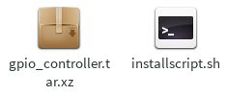Figure 27: GPIO controller installation file

Step 1: Double-click installscript.sh to install

II. User's guide

1. GPIO controller

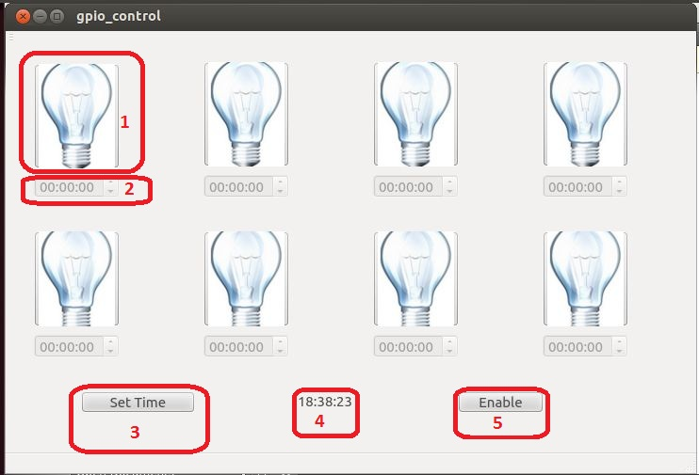Figure 72: GPIO user interface

Table 44: GPIO controller user's guide

|  |  |  |
| --- | --- | --- |
| GPIO CONTROLLER USER'S GUIDE | | |
| **No.** | **Name** | **Description** |
| **1** | Status image | Image to show current port status, click image to change status |
| **2** | Time edit box | Change time to change port |
| **3** | Set time | Accept time to change port status |
| **4** | Time | Current time system |
| **5** | Enable | Enable set time to set time to change port |

2. Change port status

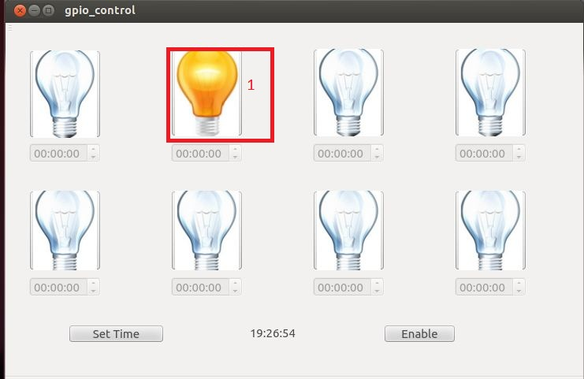Figure 73: Change port status user interface

Table 45: Change port status user's guide

|  |  |
| --- | --- |
| CHANGE PORT STATUS USER'S GUIDE | |
| **Step no.** | **Description** |
| **1** | User just only click image, port will change status |

3. Set time to change port status

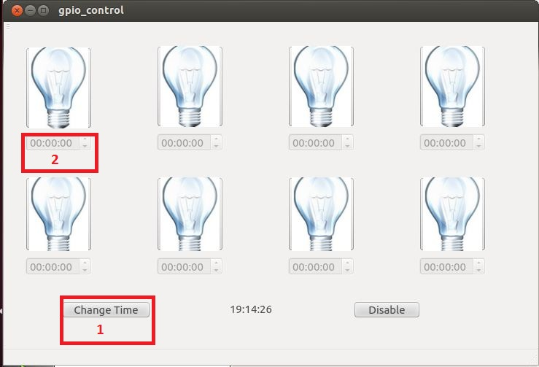Figure 74: Set time to change port status user interface

Table 46: Set time to change port status user's guide

|  |  |
| --- | --- |
| SET TIME TO CHANGE PORT STATUS USER'S GUIDE | |
| **Step no.** | **Description** |
| **1** | User click enable button to active time edit box, enable button will change to disable button |
| **2** | User change time want to change port status in time edit box |
| **3** | User click set time to accept time port will change |

4. Change time to change port

Figure 75: Change time to change port user interface

After user set time successful, and want to change time change port status

Table 47: Change time to change port user's guide

|  |  |
| --- | --- |
| CHANGE TIME TO CHANGE PORT USER'S GUIDE | |
| **Step no.** | **Description** |
| **1** | User click change time button to active time edit box |
| **2** | User change time want to change port status in time edit box |
| **3** | User click set time to accept time port will change |

5. Disable time to change port status

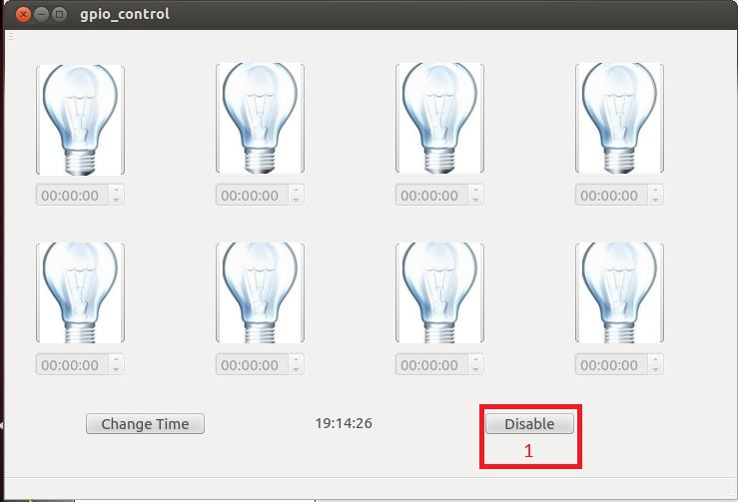Figure 76: Enabling setting time user interface

After enabling setting time

Table 48: Enabling setting time user's guide

|  |  |
| --- | --- |
| ENABLING SETTING TIME USER'S GUIDE | |
| **Step no.** | **Description** |
| **1** | User can click anytime disable button to disable set time to change port |

Reference

1. [http://www.google.com](http://www.google.com/)

2. [http://wikipedia.org](http://en.wikipedia.org/)

3. <http://qt-project.org/>

4. [http://gnome.developer.org](http://gnome.developer.org/)

5. [https://www.kernel.org](https://www.kernel.org/)

1. 1 man-month equals to 22 man-day